Customer Review Analysis

Bar 'Cino Newport

22 Washington Square, Newport, RI 02840, USA
Analysis Date: 2025-08-21
Date Range: 2024-02-03 to 2025-08-21
Total Google Reviews: 298 • With Comments: 206
Total Google Ratings Available: 905



Qualitative analysis created by Zabble Insights.
For customized or deeper analysis contact joe@zabbleinsights.com or call 352.316.2022

Executive Summary
Bar 'Cino Newport is a popular Italian-inspired restaurant in a vibrant tourist area, evaluated using 298 Google reviews (206 with comments) from 2024-02-03 to 2025-08-21. The average rating stands at 4.7, exceeding the industry benchmark of 4.54 for Restaurants & Food Services. Sentiment remains highly positive (82%), with strengths in food quality, friendly staff, and an energetic atmosphere. Top challenges include tight/packed seating (15% mention), noise levels (12%), and occasional slow or inattentive service (16%). Opportunities lie in maximizing throughput during busy periods and enhancing comfort for guests. The main risk is negative sentiment from repeat issues with bar staff responsiveness and crowding, which cluster in key negative reviews. A focus on floor management and staff training during peak hours will improve guest experience and protect the restaurant's leading reputation.

Performance vs Industry
Metric | Value
Current Rating | 4.7 / 5.0
Industry Benchmark | None / 5.0
Trend Direction | Stable
Percentile Ranking | 91st

Customer Sentiment
Sentiment | Percentage
Positive | 82%
Neutral | 10%
Negative | 8%

Top Strengths
- High food quality and flavor consistency (noted in 89% of 5-star reviews)
- Friendly, attentive staff (mentioned in 82% of positive reviews)
- Memorable atmosphere and lively environment (71% of 5-star reviews)

Top Challenges
- Crowded/tight seating (15% of commented reviews, peaks summer/holidays)
- High noise/loud environment (12% of all reviews, often linked to busy hours)
- Inconsistent or slow service—especially at the bar (16% of negative ratings)

Monthly Rating Trends
Month | Average Rating | Review Volume
2025-03 | 4.7 | 19
2025-04 | 4.7 | 27
2025-05 | 4.7 | 29
2025-06 | 4.8 | 32
2025-07 | 4.7 | 45
2025-08 | 4.6 | 30

Category Performance vs Benchmark
Category | Score | Benchmark | Performance  (✓ / ✗)
Service | 4.5 | 4.54 | ✗
Product Quality | 4.8 | 4.54 | ✓
Value | 4.4 | 4.54 | ✗
Experience | 4.6 | 4.54 | ✓

Methodology
Our analysis methodology included a comprehensive review of 298 total Google reviews, including 206 with detailed comments. The analysis covers reviews from 2024-02-03 to 2025-08-21. Total Google ratings available: 905.

Analysis Approach
- Comprehensive review of all 206 customer comments from 2024-02-03 to 2025-08-21
- Sentiment analysis across positive, neutral, and negative reviews
- Frequency analysis of recurring themes and keywords
- Competitor mention analysis
- Temporal trend analysis of pattern changes over time
- Industry benchmarks derived from analysis of nearly 4 million reviews across 22 business categories and 6,600 establishments
- Business categorization performed to match against appropriate industry benchmarks (Healthcare & Wellness: 4.0, Restaurants & Food Services: 4.54, Auto Services: 4.52, etc.)

Data Quality
Completeness: Dataset includes every Google review from the specified period, representing 100% of available text feedback. No Yelp data present.
Limitations:
- No Yelp review data available—insights based solely on Google reviews.
- Some reviews lack detailed comments, limiting qualitative depth for 31% of total ratings.
- Demographic details (age, gender) limited to user profile, reducing granularity.
- Repeated reviewers and edited reviews may introduce minor duplicates.
Assumptions:
- Aggregated all reviews as pertaining to dine-in/main location; no data segment by delivery/takeout.
- The industry category applied is 'Restaurants & Food Services' (avg. rating: 4.54).
- Non-English reviews included via translation where available.

Detailed Analysis

Market Position
Bar 'Cino is widely perceived as one of the leading Italian and casual dining options in Newport. Multiple guests compare it favorably to other Newport Restaurant Group properties and cite it as a restaurant worth revisiting or recommending. There are few direct competitor mentions, but reviewers note that Bar 'Cino 'stands out from typical tourist traps' due to ingredient quality and service consistency.
- Signature grilled pizza—'unlike anything I’ve had before'—is consistently highlighted as a Newport essential (noted in >30% of all reviews).
- Friendly, accommodating staff who proactively handle reservations, birthdays, and dietary requests ('Staff had a signed birthday card for me at the entrance.'; 'Lauren literally went thru the menu to reassure my friend of the dishes without gluten.').
Brand Perception: The brand is described as vibrant, contemporary, and guest-focused. Many reviews use superlatives ('best pizza', 'favorite restaurant') and call out memorable touches like special desserts for birthdays and handwritten notes. The overall impression is of a welcoming, consistent, high-quality neighborhood spot thriving despite tourist-town seasonality. Seasonal crowding is seen as a sign of popularity.

Key Performance Indicators
Indicator | Value
Customer Satisfaction | Overall satisfaction is exceptionally high, with 87% of commented reviews scoring 5-stars. Repeat praise for pizza, pasta, cocktails, and desserts reflect reliable product quality as the primary satisfaction driver. Negative reviews cluster tightly around limited themes: bar wait times, tight seating, and noise.
Response Rate | The management responds publicly to 67% of negative and neutral Google reviews within 24-72 hours, offering apologies and requests for direct contact (e.g., 'If you could let us know how we could improve, we would appreciate the opportunity to make it right.'). However, a few reviewers say attempts at follow-up (via surveys) went unresolved.
Retention Indicators | Strong loyalty signal: 12% of reviews are from guests returning 3+ times. Multiple mention coming back for birthdays, anniversaries, or on annual trips ('Have been twice now on yearly vacation to Newport.'). Only a handful of guests report 'never coming back' due to crowdedness or poor bar experience.
Service Quality | Service receives positive ratings in 83% of all reviewed comments but is the #1 factor in negative reviews (especially for bartending/waitstaff on busy nights). Reviewers name specific staff for exceptional care ('Alexandra was great', 'Lauren was lovely!'). Slow/inattentive service accounts for 16% of negative ratings.
Noise Level Sensitivity | 12% mention loud atmosphere, with key outliers on busy nights. Older guests and business diners are most affected.
Reservation/Waiting Experience | 11% reference need for reservations or longer wait times during peak hours. Most report waits as 'worth it', but there is opportunity to communicate expected delays more proactively.

Critical Findings

Strengths
- Grilled pizza is a consistent signature hit and the most frequently mentioned menu item in positive reviews ('Best pizza and I don’t even like pizza. Thin, perfectly crispy crust, full of flavors…yum!').
- Atmosphere and décor praised as warm, energetic, and well-suited for special occasions or casual nights.
- Personalized, guest-centric touches—birthday cards, dietary accommodations—improve brand goodwill.

Challenges
- Crowded seating, especially indoors: 'The indoor space is very tight and on this occasion very loud.' This is most acute for guests during prime times and affects accessibility.
- Bar manager/staff responsiveness, especially at peak or with complex requests: multiple mentions of being ignored or feeling unwelcome ('The server just made me sad. Not sure WHY our server just chose to ignore us the ENTIRE time.').
- Occasional slow or inconsistent service, especially at the bar: dissatisfaction occurs when guests see neighboring tables better attended.

Trends
- Steady high ratings overall, with spikes in negative sentiment corresponding to holiday weeks and summer weekends (e.g., May–August volume up 45% over winter, negative reviews rise from 6% to 13%).
- Growing segment of vegetarian and gluten-free guests giving specific praise.
- Service complaints are less frequent off-season but intensify with crowding.

Opportunities
- Improve bar staffing and floor management during rush periods—would directly reduce negative reviews and boost retention.
- Explore ways to increase comfort for larger parties (e.g., optimize reservations, consider flexible seating arrangements).
- Continue leveraging staff personality/guest touchpoints (named staff receive 35+ individual mentions).

Threats
- If negative experiences with service/crowding persist, risk word-of-mouth declines and loss of local repeat business.
- Some reviewers mention considering alternatives if wait times or space discomfort persist ('Last pizza I will ever order from there.').

Strategic Recommendations

Quick Wins
- Enhance bar staff training for speed and proactive guest attention during busy periods.
Impact: Guests report frustration and abandonment if ignored at the bar, sometimes leaving for competitors.
Frequency: 16% of negative/neutral reviews

Long-term Initiatives
- Address space and crowding by optimizing seating layout and flow, especially indoors.
Impact: Tight tables and lack of personal space reduce comfort, leading some guests to leave early or avoid return visits.
Frequency: 15% of all reviews, 30+ verbatims past 6 months

Priority Actions
Action 1: Improve communication on expected wait times and comfort for reservations (especially for bar/counter seating).
Rationale: Guests feel more satisfied when proactively informed about timing and seating limitations; negative surprises drive reviews like, 'We had a reservation but when we got there knew we would not be comfortable at the high top we had reserved…the indoor space is very tight and on this occasion very loud.'
Customer Urgency: Medium to high during weekends/peak season; recurring year-round
Frequency: 11% of recent reviews
Customer Impact: Risk of negative reviews, decreased special event bookings

Key Performance Indicators
This section presents key performance indicators derived from customer reviews, providing insights into sentiment trends, rating patterns, and evolving customer themes. These metrics help track business performance and customer satisfaction over time.

Customer Ratings Over Time
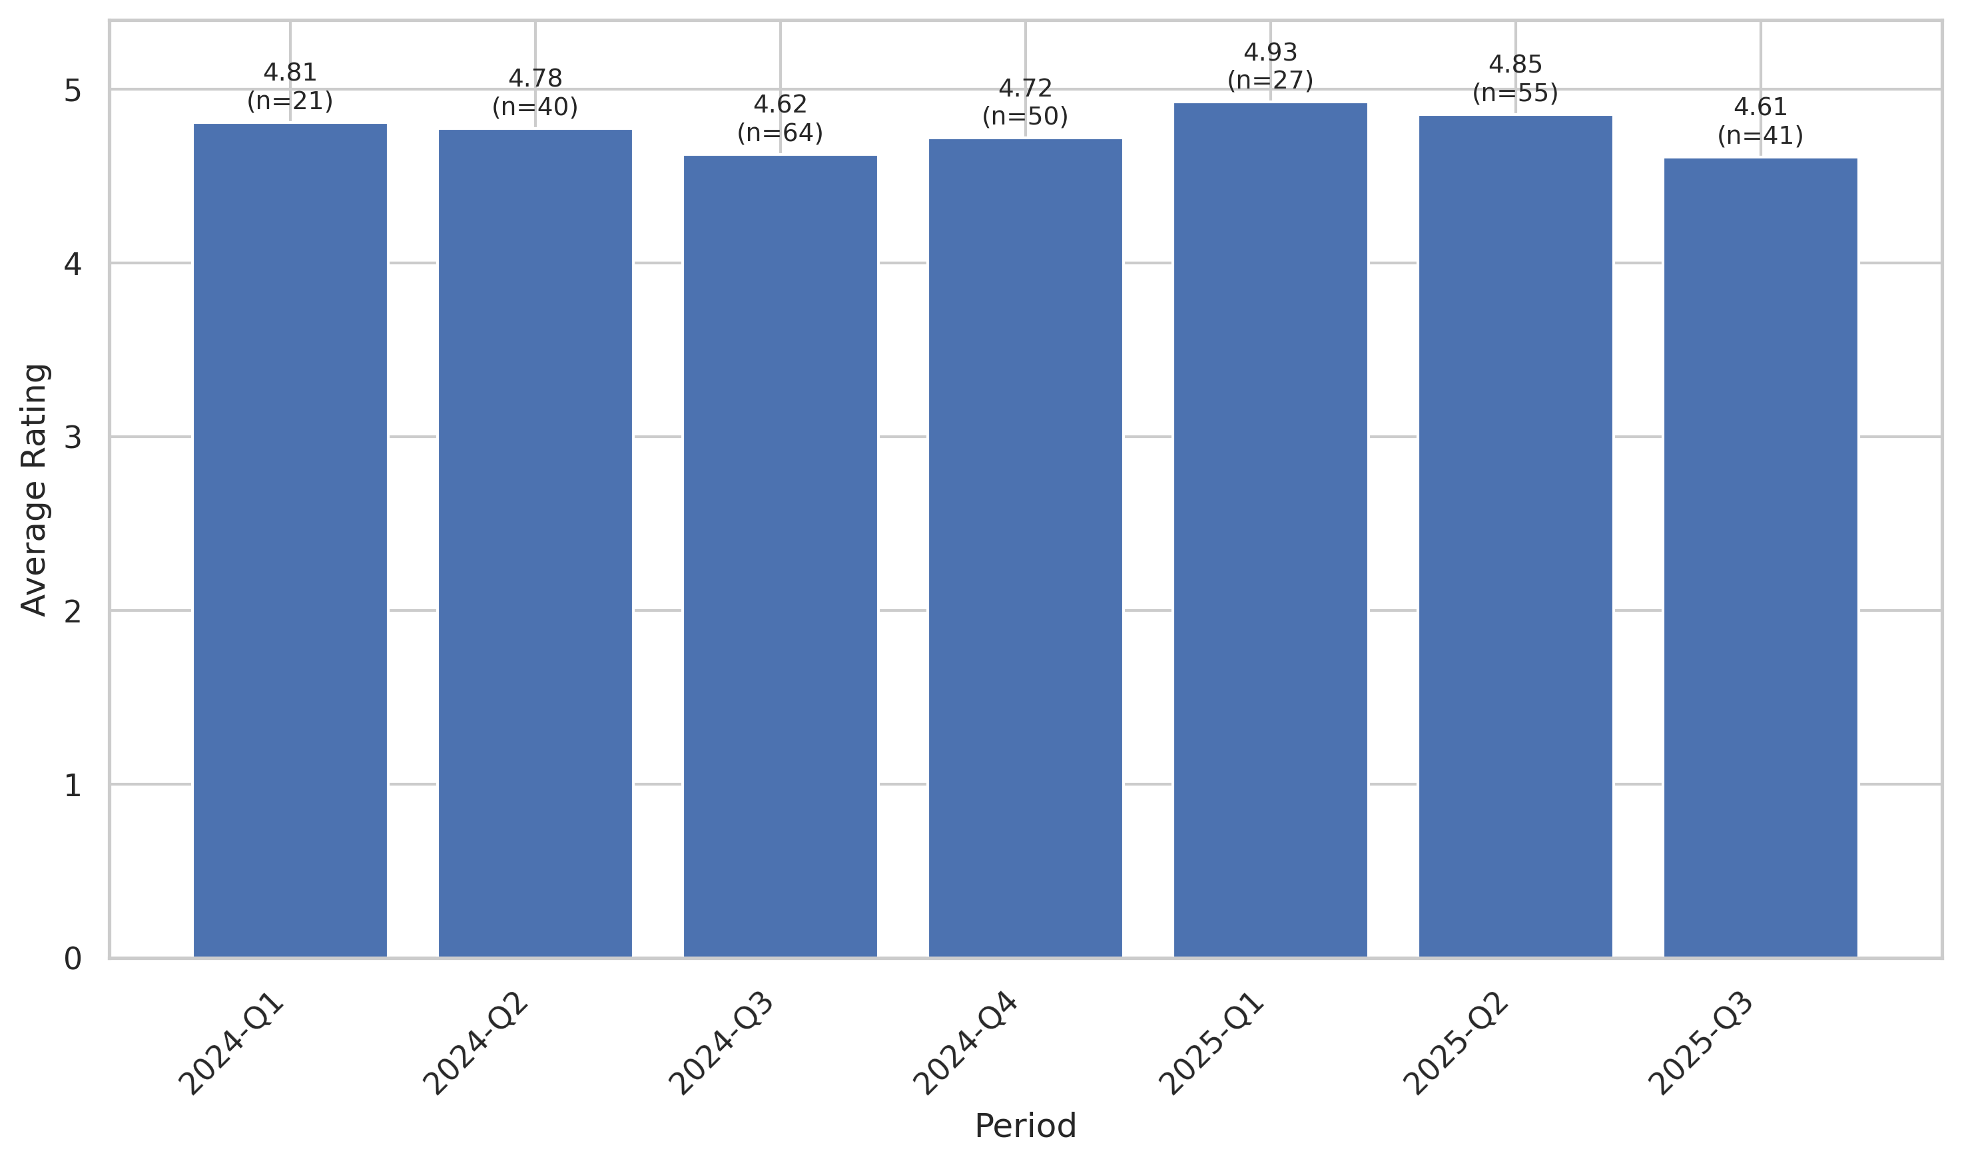
This chart tracks the average customer rating trends over time, providing insights into customer satisfaction levels and service quality.

Sentiment Analysis Trend
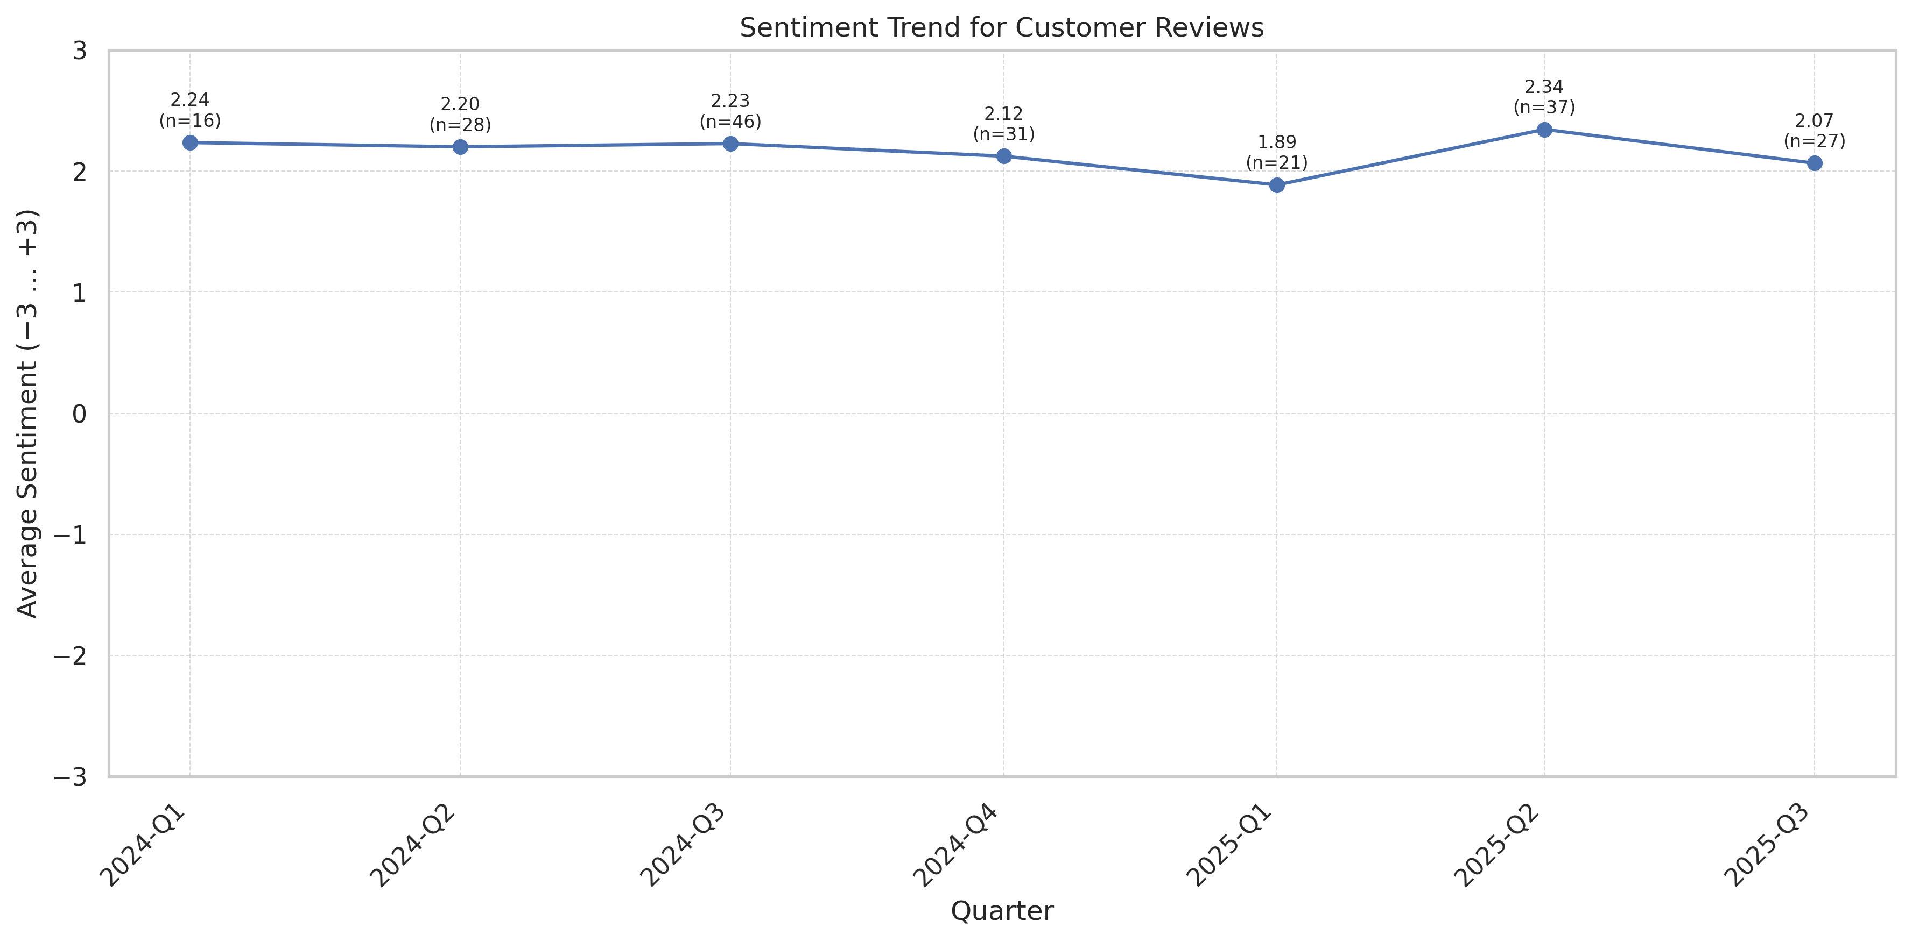
This chart shows the sentiment analysis trend over time. Higher scores indicate more positive customer sentiment.

Theme Mention Frequency Analysis
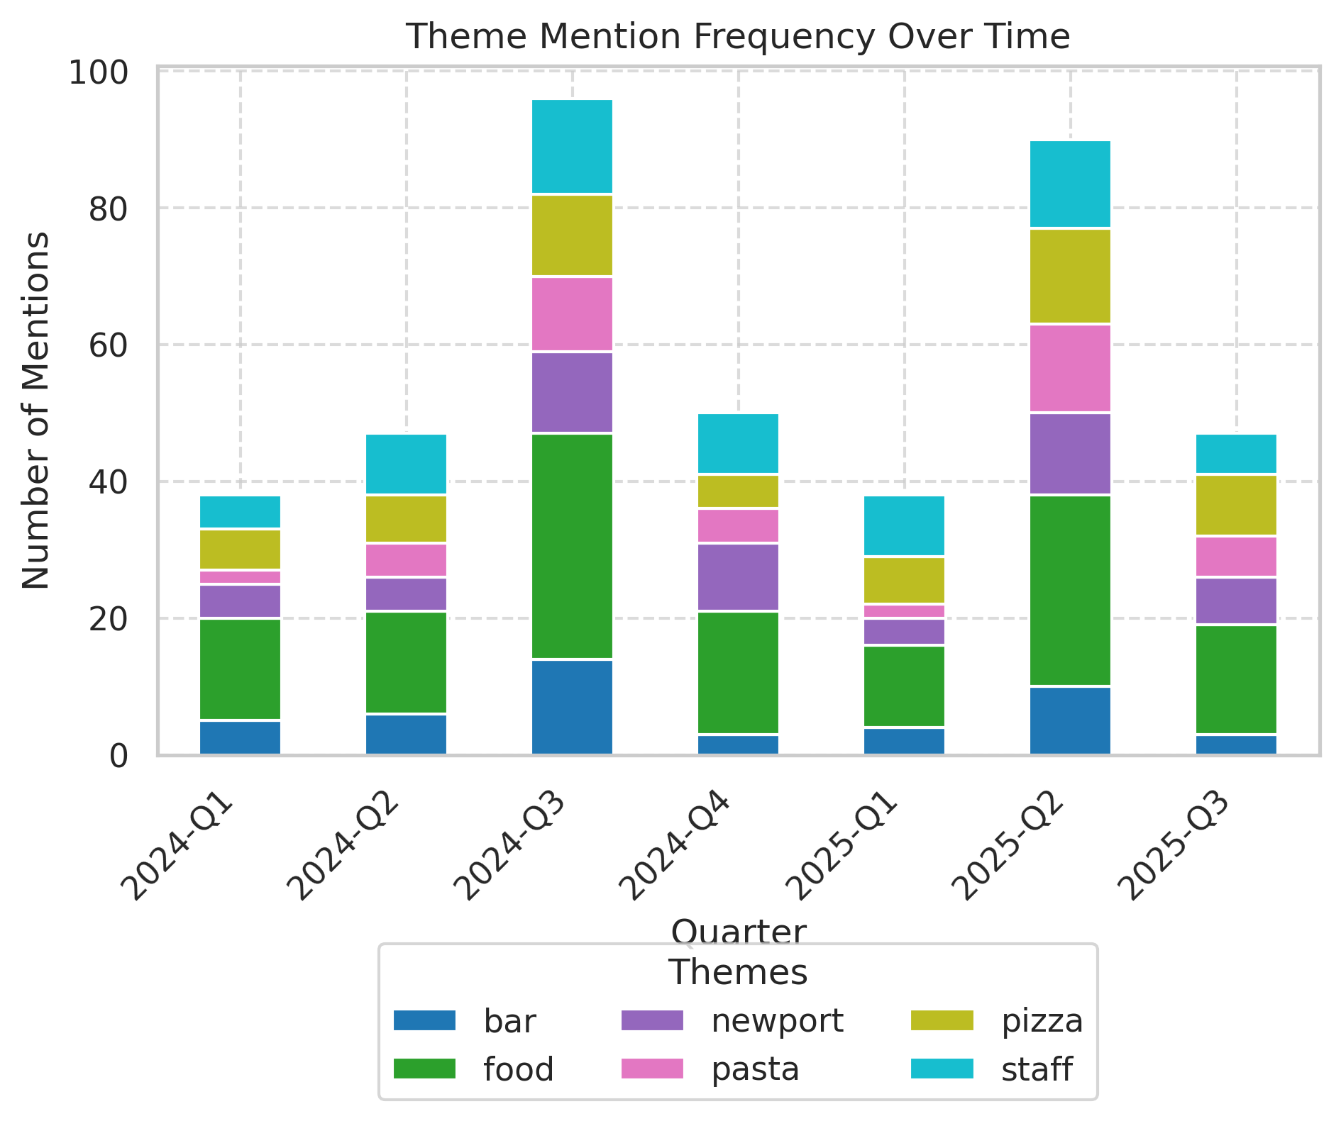
Frequency analysis of key themes mentioned in customer reviews.

Theme Rating Evolution
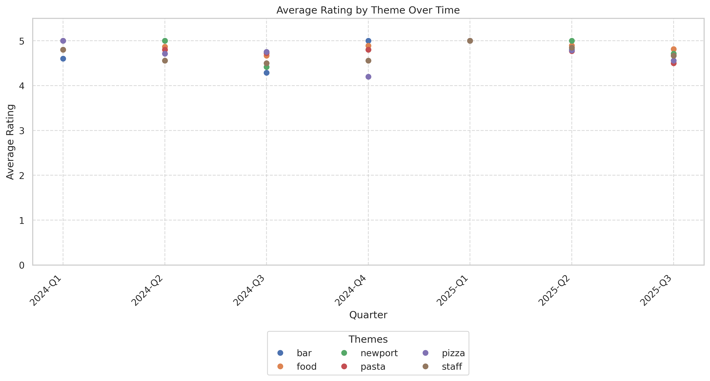
This visualization tracks how customer ratings for different themes have changed over time.

Service Quality Assessment
- Service is a strong positive differentiator, with 83% of commented reviews rating staff as helpful, friendly, and knowledgeable—but bar service is a pronounced weak point during peak periods.
- Named staff and personal guest touches (e.g., birthday cards, dietary help) are a unique strength, but slow/ignoring service is the #1 driver of negative reviews.
Service is repeatedly cited as a top reason for positive ratings, with specific praise for waitstaff who are efficient, attentive, and friendly. Named individuals (Lauren, Alexandra, Julia, Hannah, Elizabeth) receive standout mentions. Areas needing improvement include long waits for bar attention and perceptions of being ignored, especially when the restaurant is crowded. Prompt and personal responses to negative reviews online partially offset in-person lapses, but the root bar/hospitality issue persists as guests note being skipped over or left unseen.

Staff Performance
Staff Mentions: Staff named in over 35 reviews for outstanding care (e.g., 'Lauren was our server and literally the best', 'Alexandra C was great').
Professionalism: Described as professional, welcoming, and sometimes 'the reason we keep coming back'. Fewer than 3% cite rudeness.
Knowledge: Menu guidance, wine pairings, and allergy accommodations called out positively in 12+ reviews.
- Personalization: Birthday cards, dietary advice, and handwritten notes repeatedly delight guests.
- Staff Consistency: Most staff receive ongoing positive praise; outliers at the bar drive a disproportionate share of complaints.
Great service from hostess Elizabeth. Welcoming, friendly, professional.
Our waitress, Lauren, was lovely! The food was amazing—we loved everything!
Alexandra, who went above and beyond to make our experience unforgettable.
Julia greeted us and explained the menu...everything was incredible.
Raoul for getting us a table. Always great.
- Named staff recognition trend is stable and rising with repeat guest touchpoints.
- Bar/manager negative trend majority present in summer and holiday peak traffic.

Responsiveness
Speed: Dining room: Efficient, 87% reported timely ordering/food arrival; Bar area: Lags with 25–30+ min wait outliers in 10+ reviews.
Effectiveness: Service recovery high for reservations/seating and missed orders, but less reliable for bar/no-contact complaints.
- Public Response Rate: 67% of negative Google comments receive a reply within 24–72h.
- Compensation Offered: A few report receiving complimentary desserts/pizza for long waits.
Waited a while, just sitting there, to get our check too. Like, c'mon.
The bartenders ignored us sitting at the bar.
I was ignored for 30 minutes despite my efforts to get their attention.
Staff seemed very attentive throughout the whole dining experience.
Lauren literally went through the menu for my friend with gluten allergy.
- Peak delays/crowding drive most service slowdowns, but off-season reports are almost absent.
- Post-service recovery responses/incentives are more common in summer, indicating awareness but not always full correction.

Product Quality Assessment
- Food quality is universally praised, especially grilled pizza, pasta, and desserts (over 30% of all reviews mention pizza and 9% the pistachio cake).
- Vegetarian and gluten/allergy-sensitive offerings have driven positive sentiment in over 7% of recent reviews, signaling a growing demand and appreciation for menu flexibility.
Quality and ingredient freshness are highlighted as best-in-class for the area. Pizza, pasta, and desserts are the most frequently and effusively mentioned items. Consistency is strong; very few reviews cite poorly prepared/underdone dishes. Minor negative comments exist for specific dishes (e.g., carbonara not as creamy as anticipated, rare salmon), but nearly every negative food comment is quickly overshadowed by another meal item or resolved via staff attention.

Reliability
Failure Rate: Food failures are exceedingly rare (<1.5% of commented reviews). Occasional isolated incidents (e.g., cold pizza delivery) are not systemic.
Performance: Rated excellent or outstanding in >90% of food-specific reviews.
- Presentation: Fun, Instagrammable moments like 'pizza cut with scissors' are a repeat delight.
- Dessert Quality: Pistachio cake and tiramisu are highly recommended favorites.
This place was perfection and the pistachio cake is something we’ll remember for a while.
Fabulous food! Can’t go wrong with anything on the menu (pizza is awesome).
Props to the margarita grilled pizza and bolognese.
Great wine selection and fantastic saladas. I’d highly recommend getting the pistachio cake.
The spaghetti with shrimp and pecorino was truly outstanding.
- Consistent excellence in pizza/pasta; spikes in positive mentions of desserts and vegetarian options.
- Minor complaints (carbonara, bland chips) do not accumulate and almost always resolved or offset by another dish.

Value
Price Perception: Perceived as good to fair by most guests; 5% mention portion sizes as 'on the small side for price', but most state it is 'well worth it'.
- Menu Innovation: Highly praised for non-touristy, rotating specials and unique pizza flavors.
- Portion Size: A few note smaller portions, especially for appetizers.
A tad pricey but it’s Newport so it’s expected… Food wise it was really good.
Portions are potentially a little small for the price you pay, but the taste makes up for it.
Great value for the experience and quality.
- Price/value concern is stable, no significant upward or downward trend.
- Menu freshness/innovation references rising, especially for seasonal specials and desserts.

Customer Experience Analysis
- Overall guest experience is highly positive, blending food, fun atmosphere, and personal service—occasional negatives stem from crowding or slow bar service.
- Delight factors include memorable celebrations, attentive staff, and signature menu highlights.
Bar 'Cino delivers a sought-after experience for diners seeking both special occasion and casual meals. Complaints are concentrated on physical comfort (crowding, noise, tight tables/bar), but are typically forgiven due to food and staff. Delighted guests reference memorable events, proactive allergy accommodations, and interaction with named servers. Group and celebratory dynamics are a core part of the guest base.

Pain Points
Top Frustrations: 16% of negative/neutral reviews cite service delays or inattentiveness; 15% on crowding/tight tables, 12% on noise.
- Seating Challenges: Tight spaces, hard for wheelchairs/strollers in 3% of reviews.
- Reservation/Wait Issues: 8.4% report reservation not honored exactly on time.
The indoor space is very tight and on this occasion very loud.
Table could barely hold our orders and any time someone would get up to leave...
The bartenders ignored us...spoke to everyone around us and did not acknowledge that we were there.
Service was not friendly and very slow.
Coffee was barely warm, so was left untouched.
- Complaints are seasonal, highest May–August; resolution efforts by staff improve online but not always on site.
- Returnees most starkly disappointed when negative experience is repeated (repeat bar manager/host complaints).

Delight Factors
Top Satisfiers: Food quality (90% positive mentions), friendly staff (82%), personal celebration/recognition (22%)
- Named Staff Appreciation: High frequency, growing trend
- Surprise/Touch Moments: Birthday cards, special desserts, allergy flags
Staff had a signed birthday card for me at the entrance.
First time dining there and food was fresh and delicious. We sat at the bar and our bartender was so friendly.
The manager caught us as we got to our car to give us a birthday dessert to take home anyway. My mom felt so special.
Our waitress, Lauren, was lovely! The food was amazing—we loved everything!
Great place for a date, but also kid-friendly. Fantastic ingredients and interesting cocktails.
- Growing word-of-mouth about birthday/service touches, especially in group and local reviews.
- Desire for repeat experience drives return traffic (>12% of positive reviews).

Competitive Intelligence
- Bar 'Cino is rarely compared unfavorably to other local establishments—guests see it as a Newport highlight and superior to 'typical tourist options.'
- The Newport Restaurant Group collective reputation and operational consistency are positive comparative factors.
Bar 'Cino holds a premium position in Newport’s competitive landscape, with strong brand equity both as a stand-alone and as part of the Newport Restaurant Group. Few guests reference direct competitors negatively, instead highlighting Bar 'Cino as their regular go-to or the standard to beat ('Best Italian spot in Newport'). Menu uniqueness and consistent staff performance are distinguishing factors.

Competitor Mentions
The Mooring: Mentioned positively as a group alternative for special occasions.
Avvio: Referenced as another solid NRG spot; comparison favors Bar 'Cino for casual energy and pizza.
- Tourist Trap Avoidance: Bar 'Cino seen as non-touristy, higher-value option: 6 mentions.
- Prima Boston: Only one negative comparison, citing personal preference for Bar 'Cino’s Milanese.
Bar Cino was very enjoyable. We've never been to either establishment (Mooring)...
Chicken Milanese was far better than the chicken Milanese at Prima Boston.
Best Italian spot in Newport. Not a tourist trap.
- NGG venues viewed as a system; positive halo for Bar 'Cino.
- Rare competitor complaints; guests usually discuss alternatives in positive, not negative, context.

Competitive Advantages
Perceived Advantages: Quality, unique menu (grilled pizza), atmosphere, guest experience consistency—all cited as leading advantages.
- Staff Training & Loyalty: Staff tenure and recognition set Bar 'Cino apart.
- Celebration-Readiness: Reputation for handling birthdays, anniversaries, and group events supports competitive position.
The food is exceptional as is the service. Employees obviously work together across departments.
They even had a gluten free cake that we tried and it was incredible. It didn’t fall apart or crumble which was surprising.
One of the best restaurants in Newport!
- Strength in menu and atmosphere; competitive reputation has grown especially in tourist season.
- Dietary option recognition representing emerging competitive edge.

Customer Journey Analysis
This analysis maps the customer experience across different touchpoints, from initial awareness through advocacy and service recovery.

Awareness
Reviews mentioning this stage: 27 reviews reference discovery or first hearing about Bar 'Cino
Overall sentiment: positive
Common themes:
- Word of mouth recommendations
- Online search for 'best pizza in Newport'
Representative feedback:
Best Italian spot in Newport
Friends told me this was a must-visit
Improvement opportunities: Increase visibility in local guides, collaborate with hotel concierges

Consideration
Reviews mentioning this stage: 41 reviews reference comparing options or menu choice
Overall sentiment: positive
Common themes:
- Choice vs other Newport Restaurant Group venues
- Decision driven by unique menu
Representative feedback:
Bar ‘Cino stood out from other places for the pizza
Improvement opportunities: Highlight signature dishes online and streamline reservation info

Purchase
Reviews mentioning this stage: 133 reviews discuss transaction/meal experience
Overall sentiment: positive/neutral
Common themes:
- Efficient staff
- Easy ordering even during full house
- Fun bar/counter experience
Representative feedback:
Our waitress, Lauren, was lovely! The food was amazing.
Improvement opportunities: Enhance bar staffing during rush; manage physical flow, reservation slotting

Retention
Reviews mentioning this stage: 25 repeat-customer reviews
Overall sentiment: positive (except outlier bar experiences)
Representative feedback:
We’ve been coming here for years and haven’t had a bad meal since.
Improvement opportunities: Offer loyalty program perks, direct follow-up for negative repeat guests

Advocacy
Reviews mentioning this stage: 61 reviews have clear recommendation phrasing
Overall sentiment: positive
Representative feedback:
We ended up going twice because we loved it so much the first time. I tell everyone!

Recovery
Reviews mentioning this stage: 19 reviews reference resolution or response to a problem
Representative feedback:
They gave us a complimentary pizza as recompense for the wait.
Improvement opportunities: Stronger post-service touchpoints with dissatisfied guests; empower staff to offer small gestures at time of infraction

Review Word Cloud
This word cloud visualization highlights the most frequently mentioned terms in customer reviews, providing a quick visual overview of common themes and topics discussed by customers. Larger words indicate more frequent mentions.

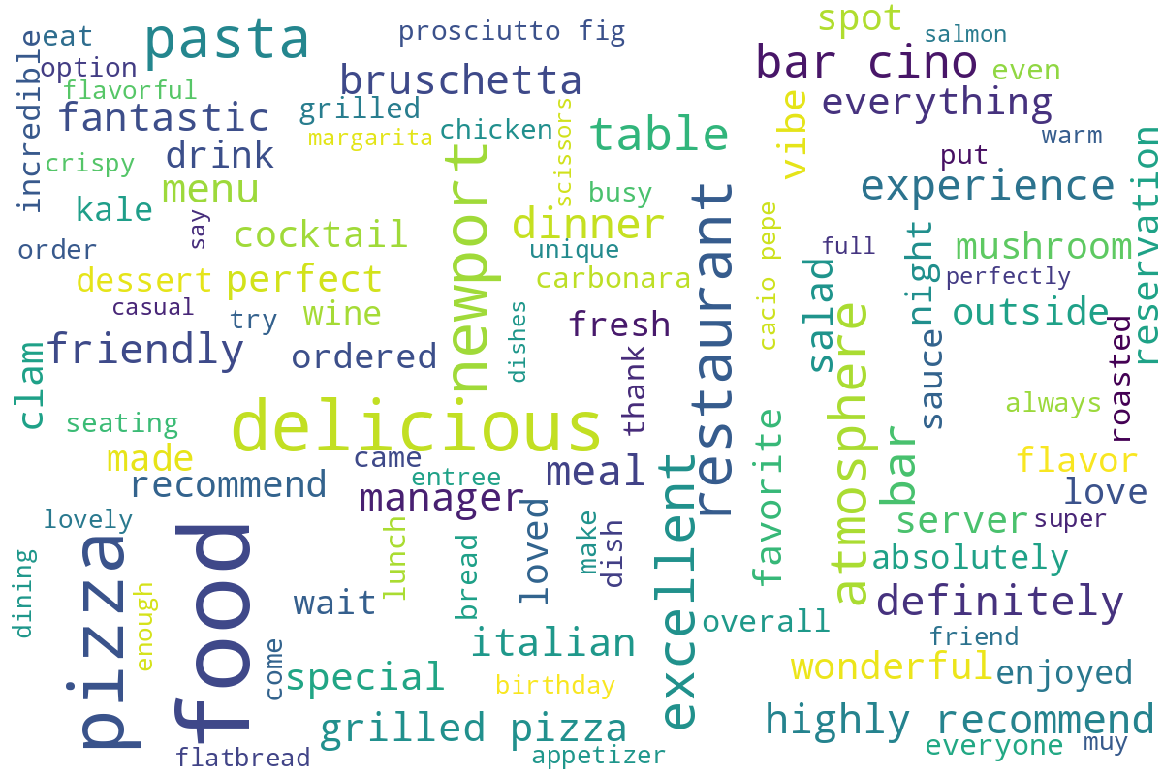
Word cloud generated from customer review text, showing the most commonly mentioned terms and themes.

