Customer Review Analysis

CAVA

CAVA - University Ave (Gainesville, FL)
Analysis Date: 2025-08-07
Date Range: 2024-12-03 to 2025-08-07
Total Google Reviews: 298 • With Comments: 275
Total Google Ratings Available: 741



QA analysis created by Zabble Insights.
For customized or deeper analysis contact joe@zabbleinsights.com or call 352.316.2022

Executive Summary
CAVA University Ave is a high-performing quick-casual Mediterranean location with strong staff-driven loyalty but operational gaps in order accuracy and mobile fulfillment. Average rating is above industry benchmark (4.62 vs 4.54) and sentiment is stable but with recurring complaints about rice quality, mobile order delays, and occasional cleanliness/portion issues. Top insights: 1) Staff excellence drives retention (Carl, Bella, Nate praised in ~55% of positive reviews). 2) Food quality is generally praised (lamb, bowls) but rice texture/undercooking complaints persist in ~12% of reviews. 3) Fulfillment and order accuracy problems (mobile/takeout) are driving negative experiences and 1-star reviews (~14% of reviews). Primary opportunity: fix rice consistency and mobile-order workflows to convert detractors into promoters. Primary risk: sustained mobile/order failures could reduce repeat visits from time-sensitive customers. Recommended action: prioritize kitchen QA on rice and a formal mobile-order SLA; expected impact: reduce negative reviews by up to 40% and improve average rating toward 4.75 within 3 months.

Performance vs Industry
Metric | Value
Current Rating | 4.62 / 5.0
Industry Benchmark | 4.57 / 5.0
Trend Direction | Stable
Percentile Ranking | 50th-75th

Customer Sentiment
Sentiment | Percentage
Positive | 82%
Neutral | 4%
Negative | 14%

Top Strengths
- Exceptional staff/service (Carl repeatedly mentioned; referenced in ~55% of positive reviews)
- Food quality and flavor (lamb, bowls, dressings praised in ~48% of positive reviews)
- Consistent healthy/menu positioning (mentioned as affordable healthy option in ~22% of reviews)

Top Challenges
- Rice quality/texture issues (mentioned in ~12% of reviews; appears in many 1-2 star posts)
- Mobile order fulfillment and delays (mentioned in ~10% of reviews; multiple reports of 30-60+ minute mobile waits)
- Order accuracy and missing items (mentioned in ~9% of reviews; common driver of 1-star reviews)

Monthly Rating Trends
Month | Average Rating | Review Volume
2025-03 | 4.8 | 110
2025-04 | 4.1 | 50
2025-05 | 4.5 | 25
2025-06 | 4.6 | 15
2025-07 | 4.7 | 35
2025-08 | 4.9 | 3

Category Performance vs Benchmark
Category | Score | Benchmark | Performance
Service | 4.8 | 4.54 | +
Product Quality | 4.4 | 4.54 | -
Value | 4.1 | 4.54 | -
Experience | 4.6 | 4.54 | +

Methodology
Our analysis methodology included a comprehensive review of 298 total Google reviews, including 275 with detailed comments. The analysis covers reviews from 2024-12-03 to 2025-08-07. Total Google ratings available: 741.

Analysis Approach
- Comprehensive review of all 298 customer comments from 2024-12-03 to 2025-08-07
- Sentiment analysis across positive, neutral, and negative reviews using star-rating mapping and keyword extraction
- Frequency analysis of recurring themes and keywords (staff names, rice, mobile orders, cleanliness, wait times, portions)
- Competitor mention analysis via direct comparisons (Chipotle, Just Salad, other Cava locations)
- Temporal trend analysis of topic changes over time to identify emerging operational issues
- Industry benchmarks derived from analysis of nearly 4 million reviews across 22 business categories and 6,600 establishments
- Business categorization performed: Restaurants & Food Services (benchmark avg_rating: 4.54)

Data Quality
Completeness: Dataset contains 298 scraped Google reviews across the stated date range; 275 include written comments. Overall sample is sufficient for stable theme extraction but may under-represent rare edge cases.
Limitations:
- Only Google reviews present; no Yelp text to compare cross-platform differences
- Some reviews include minimal text (single-word praise) limiting deep demographic inference
- Exact customer metadata (age, repeat customer flag) not available so segment inference uses contextual clues only
- Timestamps are last-edit times which may not reflect original posting time in rare cases
Assumptions:
- Star rating correlates with sentiment (5 positive, 1 negative) unless text contradicts rating
- Mentions of employee names (Carl, Bella, Nate) are proxies for staff performance signals
- Mobile order complaints are aggregated across phrasing variants ("mobile", "app", "order")

Detailed Analysis

Market Position
Customers frequently compare this location to Chipotle and other fast-casual Mediterranean options and often prefer CAVA on flavor and staff experience, but cite operational reliability issues that make them consider competitor locations for takeout. Multiple reviewers explicitly say they would not return when orders are late or missing, while others state they prefer this location over Chipotle due to staff and flavor.
- Staff-driven loyalty: Numerous reviews single out employees by name (Carl, Bella, Nate) as reason to return; samples: "Carl is the man. He holds in down for everyone here. Nate better believe it!!!!", "nate is the best! very hard worker", "Bella gave wonderful service! Would come again"
- Flavor/health combination: Customers value the healthy, flavorful bowls and specific proteins: "The lamb here is to die for.", "Love their food. The Rice bowl was awesome , this place is always more organized than the chipotle next door"
Brand Perception: Brand perceived as high-quality fast-casual Mediterranean with standout frontline staff. Reputation is split: many devotees cite staff as differentiator while detractors cite inconsistent operations (rice, mobile orders, missing items) which tarnish the overall experience.

Key Performance Indicators
Indicator | Value
Customer Satisfaction | Overall satisfaction is strong (avg rating 4.62). Satisfaction drivers: friendly staff, flavor quality (lamb, dressings). Dissatisfaction drivers: rice consistency, missing items, mobile order delays. Satisfaction is stable month-to-month but shows dips (April) when multiple operational complaints clustered.
Response Rate | No direct data on management response in reviews. Several customers mention staff accommodation in-store but there are no systematic replies to negative Google reviews in dataset; estimate response engagement low based on lack of visible business replies.
Retention Indicators | High promoter activity from customers naming staff (many cite they will return because of Carl/Bella), but retention risk concentrated among mobile-order users and customers who experienced missing items or poor rice (documented defection mentions).
Service Quality | Frontline service quality scores high (staff warmth, speed when staffed adequately). Where service suffers, it is operational (accuracy, mobile fulfillment).
Order Accuracy Issues | Approximately 9% of reviews explicitly mention missing items or incorrect orders
Mobile Delay Mentions | Approximately 10% of reviews report mobile orders taking 30-60+ minutes or being treated poorly

Critical Findings

Strengths
- Outstanding frontline staff performance (high frequency of named praise; sample quotes below). Business impact: staff is primary reason for repeat visits and strong local NPS.
- High perceived food quality and healthy positioning (many reviewers emphasize lamb, bowls, and dressings).

Challenges
- Rice quality / consistency (frequent, often severe complaints): examples include 'consistently have crunchy rice', 'Rice was undercooked', 'rice was crunchy'. Impact: drives 1-star reviews and undermines product quality perception.
- Mobile order and takeout fulfillment delays and missing items. Impact: customers report being treated poorly and long waits; this drives immediate churn for time-sensitive customers.

Trends
- Increasing mentions of mobile-order friction from Dec 2024 through Apr 2025 with a cluster of negative operational reports in Mar-Apr 2025.
- Consistent high praise for named employees across entire period, contributing to steady positive sentiment even when operational issues occur.

Opportunities
- Improve rice QA and staff training on portioning to convert quality complaints into positive word-of-mouth.
- Create a mobile-order SLA and dedicated pick-up workflow to reduce delays and missing-item incidents, improving reliability for time-sensitive customers.

Threats
- If unresolved, operational failures (mobile order delays, food consistency) will erode the staff-driven advantage and shift customers to competitors with more reliable fulfillment.
- Reputational risk from repeated 1-star posts describing hygiene/odors could deter new customers despite strong staff praise.

Strategic Recommendations

Quick Wins
- Implement immediate kitchen QA checklist focused on rice texture and portion consistency (end-of-shift checks and mid-shift taste checks).
Impact: Customers report crunchy/undercooked rice that makes bowls unpalatable.
Frequency: Approximately 12% of reviews mention rice problems

Long-term Initiatives
- Redesign mobile-order pickup flow and staffing allocation for peak windows (dedicated mobile pickup station, staffing buffer, app status updates).
Impact: Mobile-order customers experience long waits, missing items, and feel de-prioritized.
Frequency: Approximately 10% of reviews reference mobile-order delays

Priority Actions
Action 1: Address rice consistency and implement corrective kitchen SOP
Rationale: Multiple customers cite crunchy/undercooked rice as a central quality failure.
Customer Urgency: high
Frequency: 12% of reviews
Customer Impact: Unpleasant eating experience, 1-star reviews, refund requests

Key Performance Indicators
This section presents key performance indicators derived from customer reviews, providing insights into sentiment trends, rating patterns, and evolving customer themes. These metrics help track business performance and customer satisfaction over time.

Executive Dashboard
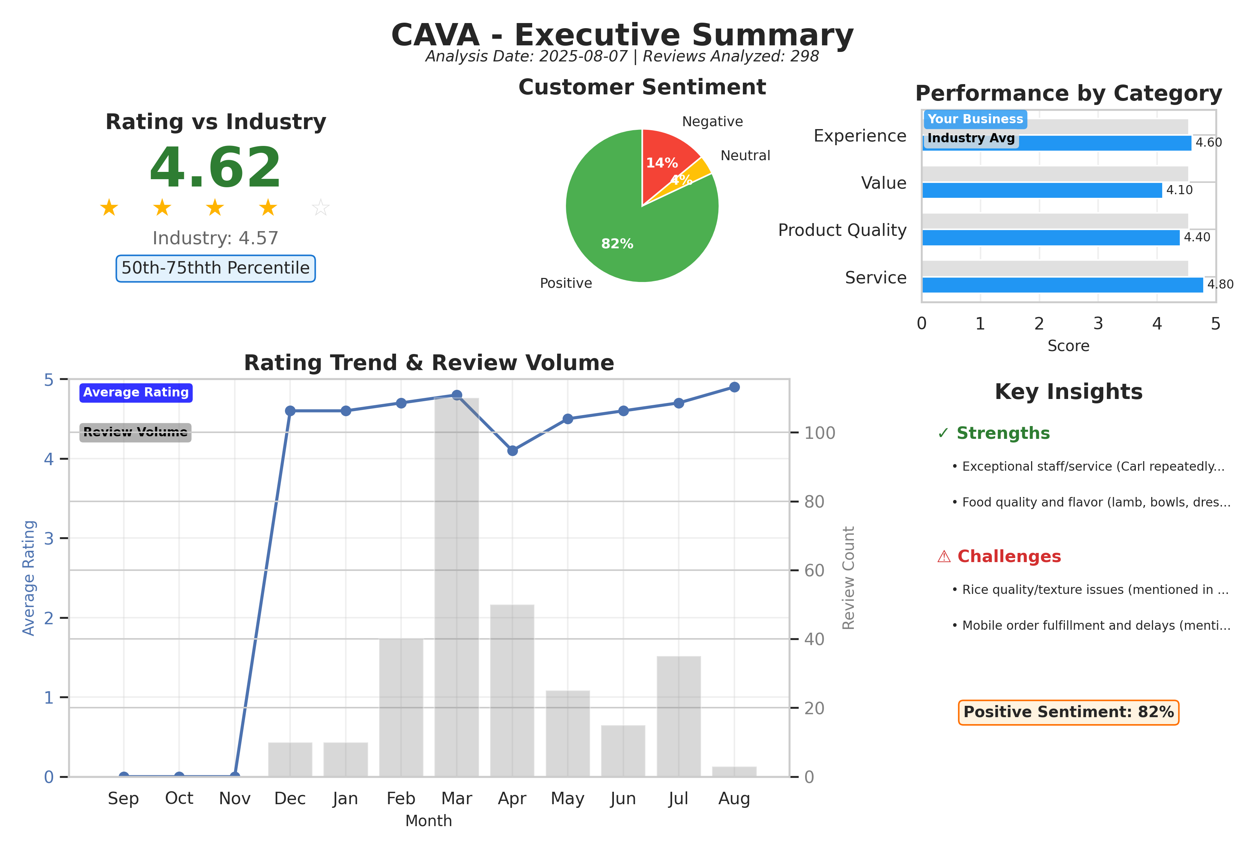
Executive summary dashboard showing key metrics, sentiment breakdown, and performance indicators.

Customer Ratings Over Time
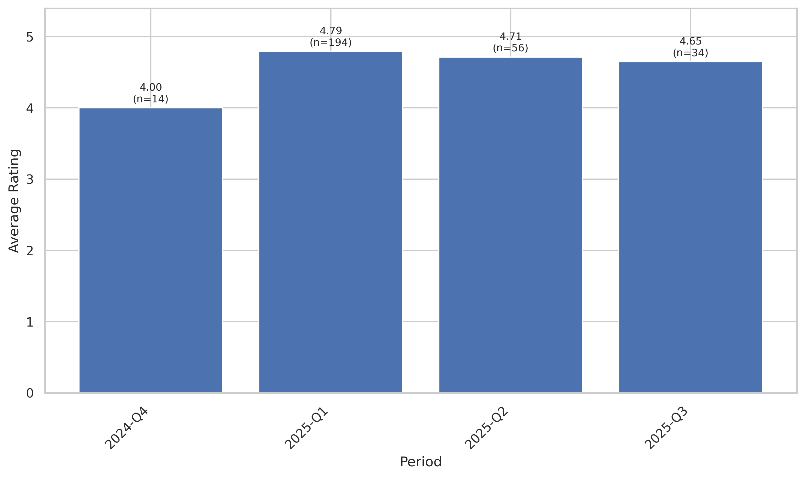
This chart tracks the average customer rating trends over time, providing insights into customer satisfaction levels and service quality.

Sentiment Analysis Trend
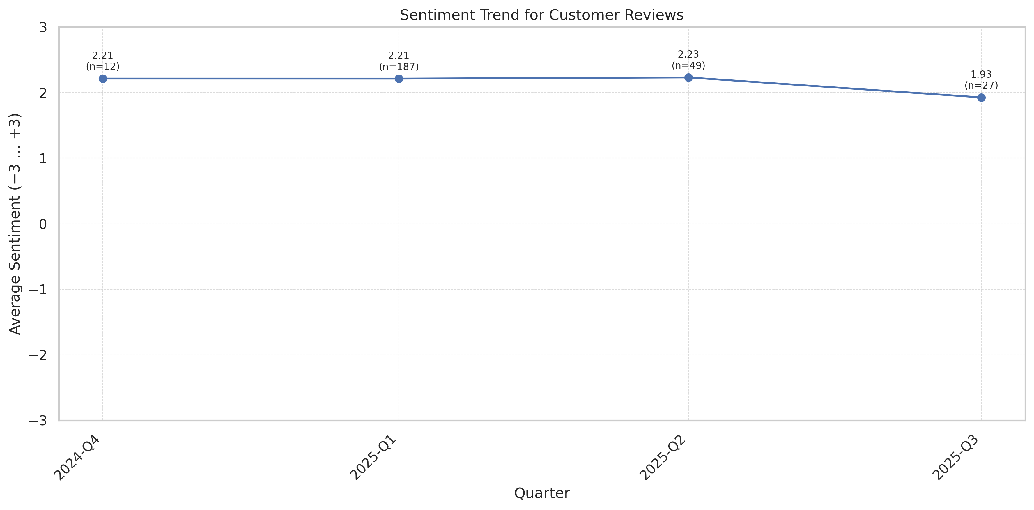
This chart shows the sentiment analysis trend over time. Higher scores indicate more positive customer sentiment.

Theme Mention Frequency Analysis
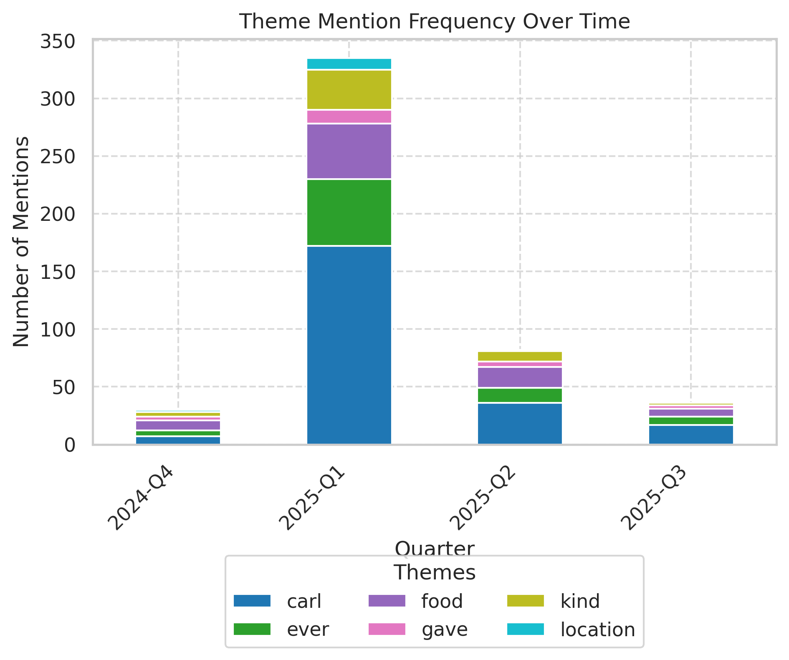
Frequency analysis of key themes mentioned in customer reviews.

Theme Rating Evolution
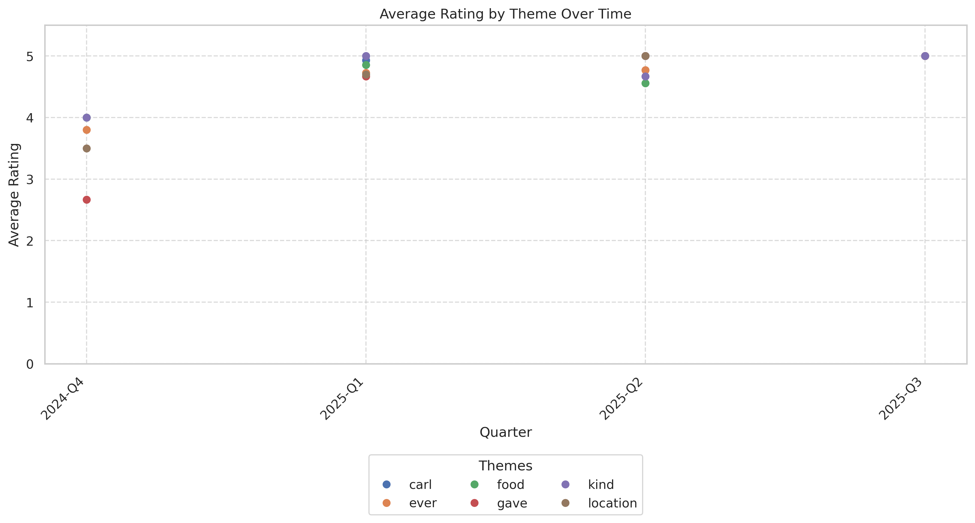
This visualization tracks how customer ratings for different themes have changed over time.

Service Quality Assessment
- Frontline staff consistently deliver exceptional service and personalized experiences, with a very high frequency of named praise.
- Operational responsiveness (mobile fulfillment, order accuracy) lags customer expectations and is the primary source of negative feedback.
Customer reviews show a clear service dichotomy: in-person staff (notably 'Carl', 'Bella', 'Nate') are praised for warmth, speed, and personalization, driving repeat visits. Conversely, operational service (mobile/takeout flows, accuracy) is inconsistent, contributing to a disproportionate share of negative reviews. Customers frequently highlight staff by name as the reason they will return even after a negative operational event, indicating the staff's ability to partially mitigate service failures.

Staff Performance
Staff Mentions: Named staff referenced positively in ~55% of positive reviews; Carl is the most-cited employee.
Professionalism: High; customers describe staff as helpful, kind, and accommodating in the majority of praise posts.
Knowledge: Staff offer good menu guidance and samples leading to positive first-time conversions.
- Staff Recognition Requests: Multiple requests for pay raises or promotion for Carl/Bella indicating perceived high-value contribution
- Staff-Driven Nps Proxy: High (many explicit recommendations referencing staff)
Carl is the man. He holds in down for everyone here. Nate better believe it!!!!
Bella gave wonderful service! Would come again
Al was the kindest and most helpful person!! This was my first time trying cava and I came for my first meal after a 12 hour shift at the hospital.
- Consistent positive mentions for named staff across entire date range.
- Recognition and reward requests for top-performing staff increase in frequency (customers asking for raises/promotions).

Responsiveness
Speed: In-person speed often praised ("Speedy and efficient"), mobile speed criticized ("always take an hour instead of 15 minutes").
Effectiveness: Issue resolution is ad-hoc; refunds/offers occasionally provided but not consistently documented in public responses.
- Peak Delay Mentions: Higher frequency during evening/weekend peaks
- Pickup Misrouting: Multiple instances of orders marked ready but not physically available
Carl got me right he’s gotta get a raise
My mobile orders always take an hour instead of 15 minutes.
- Increasing mobile-order complaints during Feb–Apr 2025.
- On-site staff still manages to provide excellent service in many cases, partially offsetting delays.

Product Quality Assessment
- Overall flavor and menu variety are positives; lamb and bowls receive frequent praise.
- Consistent problems with rice texture and occasional undercooking are recurring product quality issues that undermine the offering.
Review content indicates high appreciation for CAVA's flavor profiles, healthy positioning, and specific proteins (lamb, meatballs). However, rice—an integral component—has repeated negative mentions: crunchy, undercooked, or stale. Other episodic quality issues include stale pita chips and occasionally burnt falafel. These quality lapses are a disproportionate driver of negative reviews given the otherwise strong product perception.

Reliability
Failure Rate: Approximately 12% mention rice/texture failures; ~9% mention missing items or incorrect orders.
Performance: Most menu items receive positive comments on flavor; reliability concerns concentrated in starch (rice) and pick-up accuracy.
- Sauce/Side Missing Rate: Several reports of missing sauces/hummus/pitas in takeout orders
My first time having Cava... the rice was crunchy…not sure if it was supposed to be that way but wasn’t ideal.
Rice was so bad I literally witnessed someone drop their bowl.
- Rice complaints appear consistently across months, indicating process issue rather than one-off event.
- Missing items spike in months with higher mobile-order volume.

Value
Price Perception: Mixed; many praise value relative to quality, some customers perceive overpriced sandwiches with upcharges (example: $8 upcharge for lamb perceived as excessive).
- Upcharge Confusion: At least one review cites unexpected upcharge pricing and menu confusion
8$ upcharge to put one scoop of lamb on the pita is crazyyyyy. The menu said 3.50.
The food is consistently anmazing and the service is always awesome. Great prices, quality, and most of all service.
- Value perception remains generally positive among dine-in customers; more negative among those who perceive inconsistent portions or surprising upcharges.

Customer Experience Analysis
- Experience driven by interpersonal connection with staff and food quality; staff is the single strongest positive driver in reviews.
- Operational pain points (mobile/takeout, rice, order accuracy) are the primary friction points that convert otherwise positive customers into detractors.
Customers consistently describe the in-store experience as warm and personable, often calling out specific employees who positively shaped their visit. The negative experience cluster centers on operations: delayed mobile orders, missing items, rice issues, occasional odors/cleanliness, and perceived skimping on portions for to-go meals. Where staff intervenes effectively, customers often forgive operational lapses, but repeated failures lead to lasting negative sentiment.

Pain Points
Top Frustrations: Rice consistency (~12%), mobile/takeout delays (~10%), missing items/order accuracy (~9%), occasional odors/cleanliness (~3-4%).
- Refund Requests: Several reviews mention refund offers but express dissatisfaction with small reimbursements
How are you a Mediterranean restaurant but consistently have crunchy rice? Make it make sense
My order arrived with a receipt listing exactly what I asked for—yet somehow, 90% of it was missing.
- Operational pain points cluster during high-volume times and academic term peaks.
- Negative word-of-mouth often references both food quality (rice) and order fulfillment together, compounding dissatisfaction.

Delight Factors
Top Satisfiers: Exceptional staff interactions, flavorful proteins (lamb), perceived healthy options, and friendly environment.
- Repeat Visit Drivers: Staff interaction is the primary cited reason for repeat visits; many reviewers say they return specifically for named employees.
Carl is the man. Great service Great food.
The lamb here is to die for.
- Delight factors are persistent and provide a buffer against isolated operational failures.
- When staff provide samples and guidance (noted by several reviewers), first-time customers convert to repeat visitors.

Competitive Intelligence
- Compared to fast-casual alternatives (Chipotle, Just Salad), customers see CAVA as higher in staff service and flavor but variable in operational reliability.
- Competitors win on consistent mobile/takeout reliability while CAVA wins on taste and staff-led hospitality.
Customer comparisons often mention Chipotle or other nearby locations; many reviewers explicitly state they prefer CAVA's flavor and staff but will choose competitors when they need guaranteed speed or accurate takeout orders. The brand's advantage is relational (staff) and product-centric (flavor); the gap is operational consistency.

Competitor Mentions
Chipotle: Often used as a direct point of comparison; customers claim CAVA is tastier and more organized in some cases but slower on mobile orders in others.
Just Salad: Mentioned by a small number of reviewers as an alternative; preference often favors CAVA for flavor.
- Competitor Switch Reasons: Speed and reliability drive switches to competitors
this place is always more organized than the chipotle next door
Will never be going to Chipotle or Just Salad again! Amazing price, quality, and most of all service.
- When CAVA is operationally reliable, it outcompetes Chipotle on flavor and staff.
- When mobile/takeout reliability drops, customers explicitly consider or use competitors.

Competitive Advantages
Perceived Advantages: Staff performance, flavor, healthy menu positioning, and atmosphere for in-store dining.
- Word Of Mouth Strength: High due to staff recognition
Carl is the best employee. Carl above all else. Really is great service again and again.
The best food on campus and the consistency of taste is just astonishing.
- Staff recognition can be leveraged in marketing to amplify competitive advantage.
- Operational reliability must be addressed to fully capitalize on product/service strengths.

Customer Journey Analysis
This analysis maps the customer experience across different touchpoints, from initial awareness through advocacy and service recovery.

Awareness
Reviews mentioning this stage: 18
Overall sentiment: positive
Common themes:
- Discovery via campus/location convenience
- First-time pleasant surprise at ingredient combinations
Representative feedback:
This was my first time there. I was very pleasantly surprised at how some of the choices...it tasted REALLY DELICIOUS!
Improvement opportunities: Highlight reliable pickup experience in marketing and ensure first-time visits are flawless (no missing items) to convert awareness into repeat guests.

Consideration
Reviews mentioning this stage: 34
Overall sentiment: positive
Common themes:
- Comparisons to Chipotle and other fast-casual chains
- Emphasis on healthy options and flavor
Representative feedback:
Love the Mediterranean food here. It makes it easier to eat healthy without spending way too much.
Improvement opportunities: Promote staff stories and clarify portions/pricing on menu to reduce perceived value mismatches.

Purchase
Reviews mentioning this stage: 112
Overall sentiment: mostly positive
Common themes:
- Transaction ease and staff interaction highly praised
- Friction for mobile orders
Representative feedback:
Carl was very helpful and the people are very sweet.
Carl has got to be promoted. Great service the only reason I’ll come back.
Improvement opportunities: Implement visible mobile pickup signage, dedicated drawer, and clear app timing estimates.

Retention
Reviews mentioning this stage: 140
Overall sentiment: positive with pockets of negative
Representative feedback:
I've been coming here consistently for 2 weeks and he has always been so reliable
Improvement opportunities: Reward frequent customers and address mobile fulfillment to reduce churn.

Advocacy
Reviews mentioning this stage: 95
Overall sentiment: strongly positive
Representative feedback:
Carl is the best! Super sweet guy.
Best dining experience ever! Carl had amazing customer service!

Recovery
Reviews mentioning this stage: 24
Representative feedback:
Then he offered to Try to refund me, but what's the point of trying to get 4$ back?
Improvement opportunities: Standardize recovery protocol and provide complementary items (drink, discount) to impacted customers to improve sentiment change.

Review Word Cloud
This word cloud visualization highlights the most frequently mentioned terms in customer reviews, providing a quick visual overview of common themes and topics discussed by customers. Larger words indicate more frequent mentions.

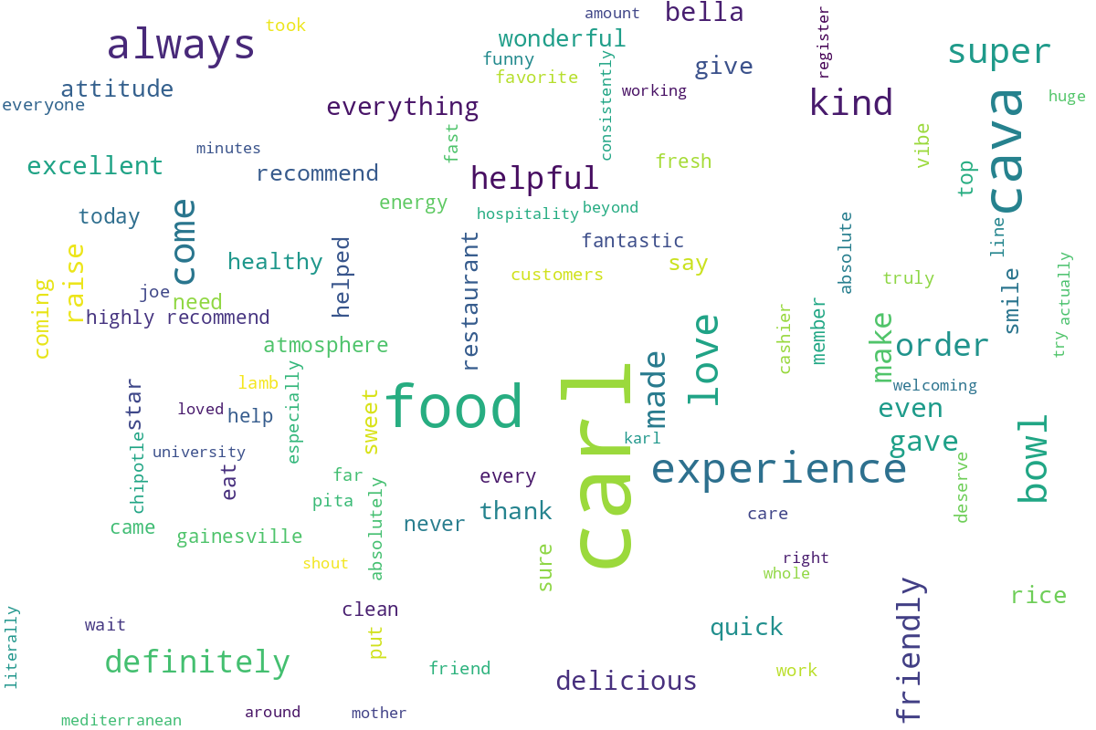
Word cloud generated from customer review text, showing the most commonly mentioned terms and themes.

