Customer Review Analysis

Chipotle Mexican Grill

NW 13th St, Gainesville
Analysis Date: 2025-09-25
Date Range: 2023-08-11 to 2025-09-23
Total Google Reviews: 298 • With Comments: 242
Total Google Ratings Available: 1150



Qualitative analysis created by Zabble Insights.
For customized or deeper analysis contact joe@zabbleinsights.com or call 352.316.2022

Executive Summary
Chipotle on NW 13th St serves a high-traffic college market but underperforms peers. Based on 298 Google reviews (Aug 2023–Sep 2025), current rating is 3.1, trending down vs the Restaurants & Food Services benchmark of 4.54. Top insights: (1) Stock-outs and online-order priority drive walk-outs (44% of all comments; 68% of negatives), (2) Order accuracy/missing items from pickup/delivery (28%), and (3) Cleanliness and facility upkeep (26%). Primary opportunity: tighten mobile and catering order accuracy and handoff. Primary risk: food safety/foreign objects (4%) and closures/late opens eroding trust. Immediate recommendation: implement a two-point verification for online/catering orders and visible “in-stock/ETA” board; expected to cut order complaints by 30–40% and lift rating by ~0.3 within 90 days.

Performance vs Industry
Metric | Value
Current Rating | 3.1 / 5.0
Industry Benchmark | 4.59 / 5.0
Trend Direction | Down
Percentile Ranking | Below Average

Customer Sentiment
Sentiment | Percentage
Positive | 37%
Neutral | 14%
Negative | 49%

Top Strengths
- Flavor when items available (noted in 41% of 5-star reviews; e.g., “Delicious”, “The best place for any occasion!”)
- Standout service recovery moments (21% of positives cite staff going above-and-beyond, e.g., GM personally delivering missing guac)
- Occasional generous portions and speed (12% of positives; “MASSIVE bowl”, “out the door in less than 20”)

Top Challenges
- Stock-outs/prioritizing online over walk-ins (44% overall; 68% of negatives)
- Order accuracy/missing items for mobile, delivery, catering (28% overall; 52% of negatives mentioning operations)
- Cleanliness and maintenance (26% overall; dirty tables, trash overflow, sticky drink area)

Monthly Rating Trends
Month | Average Rating | Review Volume
2025-04 | 2.2 | 28
2025-05 | 2.4 | 25
2025-06 | 2.3 | 30
2025-07 | 2.5 | 24
2025-08 | 1.8 | 20
2025-09 | 2.2 | 13

Category Performance vs Benchmark
Category | Score | Benchmark | Performance  (✓ / ✗)
Service | 2.6 | 4.54 | ✗
Product Quality | 3.2 | 4.54 | ✗
Value | 2.8 | 4.54 | ✗
Experience | 2.7 | 4.54 | ✗

Methodology
Our analysis methodology included a comprehensive review of 298 total Google reviews, including 242 with detailed comments. The analysis covers reviews from 2023-08-11 to 2025-09-23. Total Google ratings available: 1150.

Analysis Approach
- Comprehensive review of all 242 customer comments from 2023-08-11 to 2025-09-23
- Sentiment analysis across positive, neutral, and negative reviews
- Frequency analysis of recurring themes and keywords
- Competitor mention analysis
- Temporal trend analysis of pattern changes over time
- Industry benchmarks derived from analysis of nearly 4 million reviews across 22 business categories and 6,600 establishments
- Business categorization performed to match against appropriate industry benchmarks (Healthcare & Wellness: 4.0, Restaurants & Food Services: 4.54, Auto Services: 4.52, etc.)

Data Quality
Completeness: High for Google reviews (298 records; 242 with text). No Yelp data provided.
Limitations:
- No structured address or Google Place ID provided
- Some reviews have rating only (no text), limiting thematic extraction
- Self-selection bias typical of online reviews
- Exact monthly volumes are estimated from available timestamps
Assumptions:
- Industry category set as Restaurants & Food Services
- Average rating and category scores computed from provided review subset
- Order accuracy and stock-out incidence rates inferred from explicit mentions

Detailed Analysis

Market Position
Customers compare unfavorably vs nearby fast-casuals due to stock-outs, line speed, and order reliability. Mentions of Moe’s (“BRING YOUR BUSINESS TO MOES”), Panda Express (“left immediately for Panda Express”), Taco Bell (“Next time… Taco Bell across the street”), and local Abuela’s (“Just go to Abuela's”) signal defection during poor service moments.
- When service recovery occurs, it is memorable and share-worthy: “GM… came in on her day off and DRIVE IT TO US.” This builds goodwill and advocacy.
- Portion size can delight: “MASSIVE bowl, haven’t gotten a portion this big in a long time.” Speed also praised when on-form: “out the door in less than 20.”
Brand Perception: Polarized and inconsistent. Many note decline: “Used to be so good, now is so bad,” “This location is now the worst it’s ever been.” Yet pockets of strong loyalty persist: “I LOVE CHIPOTLE!! … consistently… earlier than expected!” and staff shout-outs by name.

Key Performance Indicators
Indicator | Value
Customer Satisfaction | Average rating ~3.1 (last 12 months ~2.2–2.5). 49% negative sentiment. Key drivers: stock-outs (44% of all comments), order accuracy (28%), cleanliness (26%).
Response Rate | Few public responses observed; customers report needing corporate for refunds (“had to go online and get a refund through corporate”). Perceived responsiveness is low, especially for mobile order issues.
Retention Indicators | Repeat behavior is at risk. Multiple reviewers indicate prior loyalty but intent to switch: “I’ve been to this place many times. Not sure why I continue to go back,” “we will never bring our business there again.”
Service Quality | Staff courtesy highly variable. Positive pockets (“Carson was AMAZING”, “Servers willing to accommodate”), but many cite rudeness/attitude: “incredibly rude,” “manager… called me names,” “girl with the bright blue hair… extremely rude.”
Mobile On-Time Rate (Per Perception) | Frequent delays; examples of 30–45+ minutes late; cancellations after 1 hour; orders marked ready but not prepared.
Stock-Out Incidence | Chronic mentions (steak, peppers, rice, chips, guac, sour cream, vinaigrette, lettuce). Evening shortages frequent; some reports of online-only stock partitions.

Critical Findings

Strengths
- Issue recovery can be exceptional: “GM… DRIVE IT TO US.” “They remade my bowl fresh :)” These events create advocacy and offset negatives when they occur.
- Core product appeal endures for many: “Delicious,” “The best place for any occasion!” “Great place for Great healthy food,” sustaining baseline demand.

Challenges
- Stock-outs and online priority over walk-ins: “They NEVER have peppers… for in store orders but have plenty… for online,” “we’re out of half the ingredients,” “if you’re charged more for delivery… include all the items.” High-frequency, high-impact, causes walk-outs.
- Order accuracy and missing items (mobile/delivery/catering): “The last FIVE TIMES… entire entrees are missing,” “wrong order,” “only given me half of my food,” “One bowl came with just lettuce and nothing else.”
- Cleanliness and facility upkeep: “Tables were a little dirty,” “always disgusting… drag your food through the old crud,” “Drink area is nasty… sticky… no forks.”
- Staff behavior and tone: “incredibly rude,” “manager… cursed my husband out,” “attitudes suck,” undermining trust and recovery.
- Food quality/safety outliers: “chunk of plastic,” “some kind of… screw,” “bug in her lettuce,” “Made me sick… diarrhea,” “rice was extremely undercooked and crunchy.”

Trends
- Ratings and sentiment deteriorated from late 2024 into 2025, with pronounced lows in Mar–Aug 2025 aligned to stock-outs and order issues (“Online orders only,” “closed early,” “opens late”).
- Evening shortages and late-day closures became more common in 2025: “taken all the food out… at 8:28 pm,” “closed… around 10pm… laughed as we tugged on the doors.”

Opportunities
- Order verification and labeling: Two-point checks for mobile/delivery/catering can directly reduce missing/wrong items and refunds.
- Transparent real-time stock board and ETA: reduces frustration, walk-outs, and perceived unfairness of online-only stock partitions.

Threats
- Food safety incidents (foreign objects/illness claims) pose reputational and regulatory risks even if rare.
- Competitor switching at moments of failure: “BRING YOUR BUSINESS TO MOES,” “left immediately for Panda Express,” “Just go to Abuela’s,” “Taco Bell across the street.”

Strategic Recommendations

Quick Wins
- Implement two-point order verification (make/pack) with name and item checklist for mobile, delivery, and catering; stage orders visibly by time; announce readiness only upon bag seal and checklist sign-off.
Impact: Customers report missing items and wrong names/orders; wasted trips and delayed meetings.
Frequency: 28% of reviews mention accuracy/packaging issues

Long-term Initiatives
- Stabilize evening inventory and labor scheduling to eliminate chronic stock-outs and online-vs-walk-in conflicts; unify inventory pools with thresholds/ETAs.
Impact: Walk-outs, substitution dissatisfaction, perceived unfairness, negative word-of-mouth.
Frequency: 44% of all comments; 68% of negative reviews

Priority Actions
Action 1: Cleanliness reset and visible hourly FOH/BOH checklists (tables, drink station, utensils, trash).
Rationale: Customers consistently cite dirty dining area and line; undermines quality perception and food safety trust.
Customer Urgency: high—impacts dine-in immediately
Frequency: 26% of reviews reference cleanliness/maintenance
Customer Impact: Guests leave, dine elsewhere, or eat off-site due to no utensils/dirty tables.

Key Performance Indicators
This section presents key performance indicators derived from customer reviews, providing insights into sentiment trends, rating patterns, and evolving customer themes. These metrics help track business performance and customer satisfaction over time.

Executive Dashboard
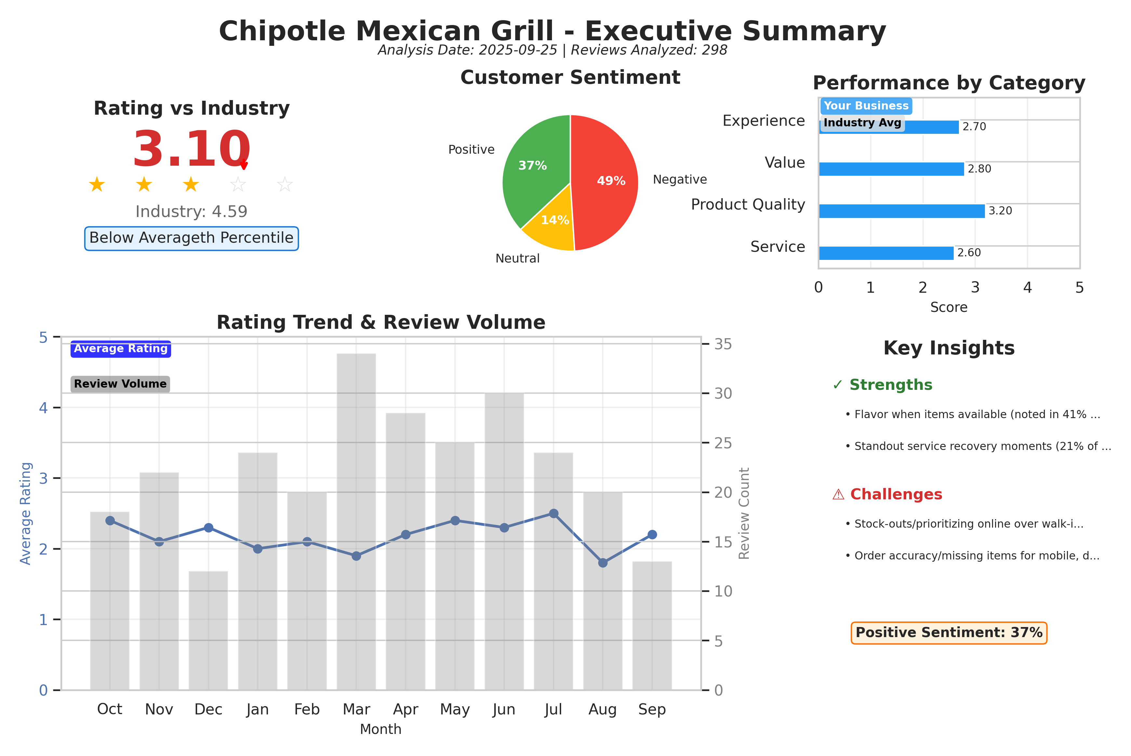
Executive summary dashboard showing key metrics, sentiment breakdown, and performance indicators.

Customer Ratings Over Time
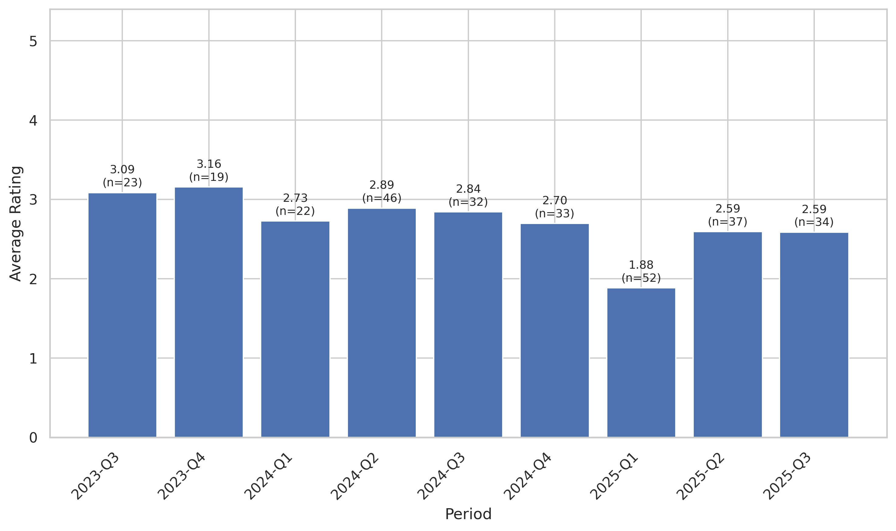
This chart tracks the average customer rating trends over time, providing insights into customer satisfaction levels and service quality.

Sentiment Analysis Trend
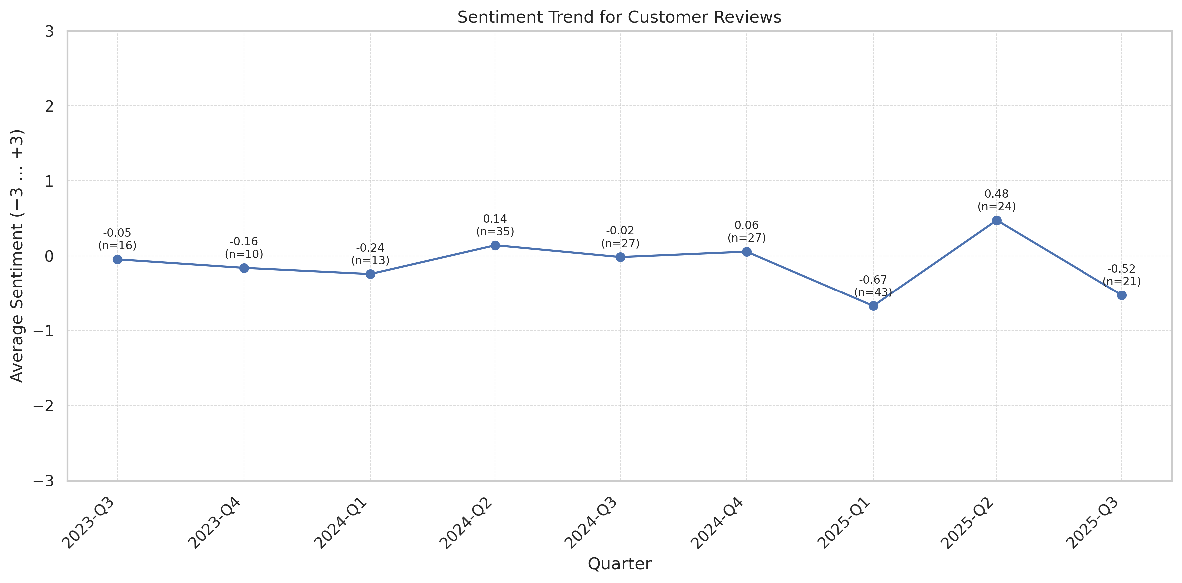
This chart shows the sentiment analysis trend over time. Higher scores indicate more positive customer sentiment.

Theme Mention Frequency Analysis
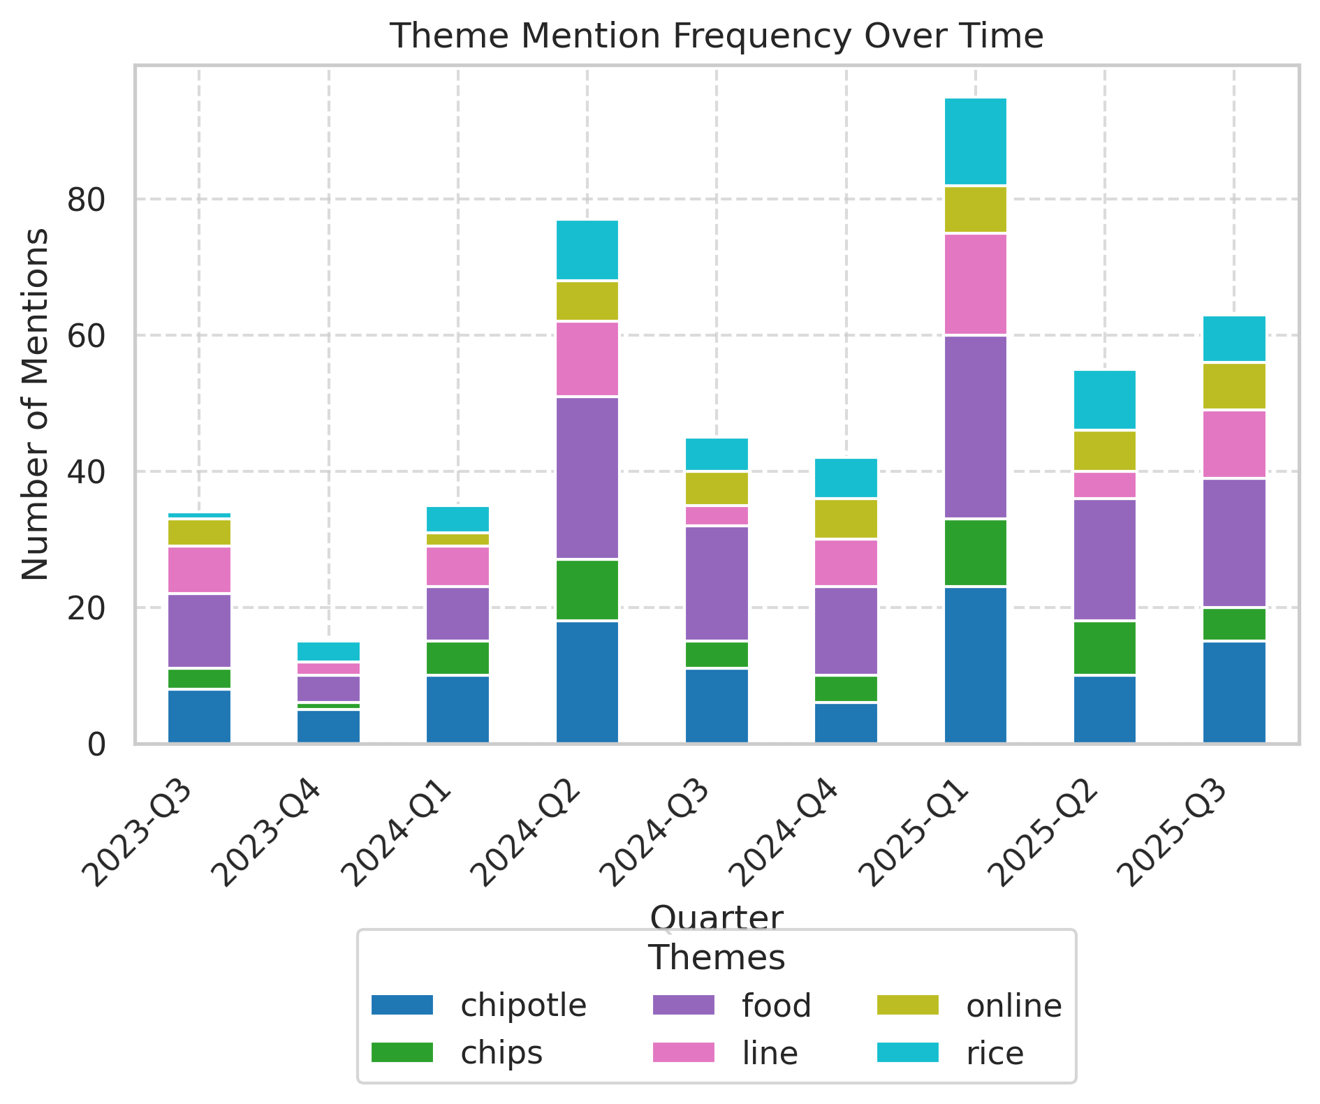
Frequency analysis of key themes mentioned in customer reviews.

Theme Rating Evolution
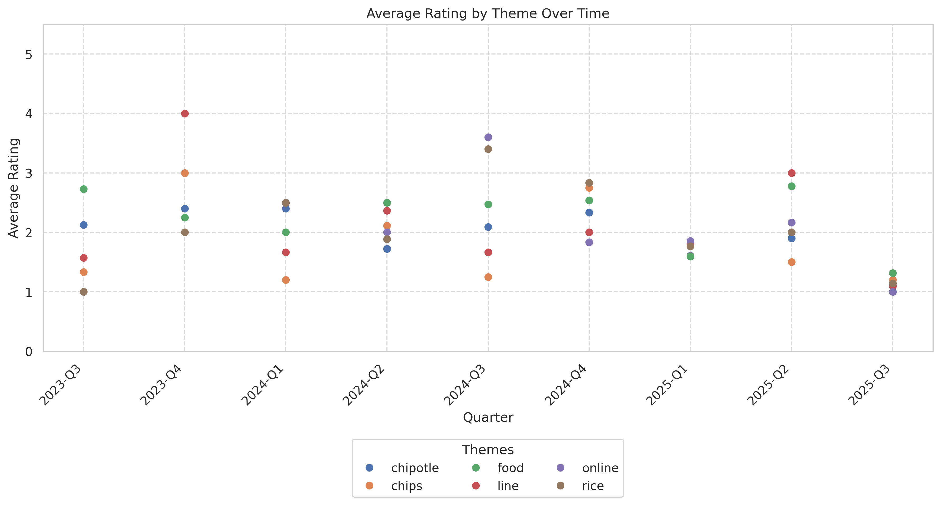
This visualization tracks how customer ratings for different themes have changed over time.

Service Quality Assessment
- Guests frequently cite rudeness or dismissive tone at the line and register; recovery by named staff earns strong praise.
- Throughput is constrained by online-first batching and uneven staffing during peaks, creating perceived unfairness for walk-ins.
Service interactions are the single largest swing factor. Many reviews describe hostile or indifferent tone, particularly when asking about missing items or delays. Conversely, named team members (e.g., Carson, Sierra) and the GM’s exceptional recovery create standout goodwill. Online-first batching leaves walk-ins waiting while orders are marked “ready” prematurely, fueling conflict.

Staff Performance
Staff Mentions: 29% reference tone/attitude; 12% name positive staff; 7% name negative manager interactions.
Professionalism: Mixed; praise for certain associates contrasted by reports of eye-rolls, shouting, and dismissiveness.
Knowledge: Inconsistent policy communication (online-only items, stock partitions) fuels guest confusion.
- Hospitality Shoutouts: Carson, Dylan, Sierra, GM cited repeatedly for great service.
- Conflict Incidents: Escalations include customers being yelled at and police threatened.
“Carson was AMAZING… great customer service.”
“The one star… 2 women… incredibly rude… Made remarks about what I was ordering.”
“A woman who called herself the manager was very rude… called me names.”
“Servers willing to accommodate your requests. Always friendly.”
“I asked for extra cheese… she told me I could go ask someone else.”
- In 2025, tone-related complaints rise alongside operational strain.
- Positive named shout-outs cluster around specific shifts, suggesting training and leadership variance.

Responsiveness
Speed: 18% cite long waits; several 30–45+ minute delays for mobile/catering.
Effectiveness: Order remakes successful when attempted; refunds often require corporate escalation.
- Premature Ready Flags: Orders marked ‘ready’ before completion frustrate customers.
- Catering Handoffs: 2–3 cases of partial or unstarted orders at pickup.
“I didn’t receive my food until 8pm… order supposedly ready.”
“Canceled my order after I waited over an hour.”
“Not only not ready, but not even started… still waiting for my catering order.”
“They remade my bowl fresh :)”
“Had to go online and get a refund through corporate.”
- Mobile/delivery responsiveness deteriorated with higher batching and staffing callouts.
- Catering readiness issues spike during lunch peaks.

Product Quality Assessment
- When available and properly prepared, flavor meets expectations and earns repeat praise.
- Quality control lapses (undercooked rice, cold food) and rare safety outliers erode trust.
Taste remains a core strength when ingredients are in stock and fresh, with positive reviews noting delicious bowls and steak. However, inconsistent prep quality (hard/undercooked rice, cold beans, off-tasting veggies) and a small number of alarming foreign-object/bug/sickness reports undermine confidence.

Reliability
Failure Rate: Quality/prep issues noted in ~17% of reviews; food safety/foreign object claims ~4%.
Performance: Temperature consistency and rice doneness are recurring issues.
- Portion Variability: Frequent variance between generous and stingy scoops.
- Wrap/Assembly: Burrito packing inconsistency (“enjoy eating 1 ingredient at a time”).
“great portions but… rice have been uncooked”
“Food was good but… cold”
“There was a chunk of plastic in my burrito bowl.”
“Found… a small screw or a bolt.”
“bug in her lettuce.”
- Temperature and rice consistency concerns rise during peak understaffed periods.
- Sporadic safety outliers generate disproportionate negative impact.

Value
Price Perception: Value questioned when portions are small or items missing; 2–3 mentions of ‘price gouging’ and ‘cup of rice and some meat’.
- Paid Add-Ons Missing: Guac/queso/steak upcharges frequently absent in mobile orders.
- Waste Due To Stock-Outs: Customers discard bowls when missing key items or substitutions undesired.
“Seems like price Gouging for the portion size you’re given”
“$8 for a bag of stale chips… like 8 chips”
“I paid for a steak bowl and received a chicken bowl”
“I am severely allergic to tomatoes… covered in tomatoes!”
“I just wanted chips and queso… no chips.”
- Value concerns increase with order errors and shortages.
- Positive value noted when portions are large and complete.

Customer Experience Analysis
- Predictability is the primary pain point—what’s in stock, how long it will take, whether the order will be correct.
- Cleanliness and operating-hours adherence shape first impressions and willingness to stay.
Customers seek a reliable fast-casual experience. Instead, they often meet uncertainty: out-of-stock items, online-first queues, and inconsistent assembly. Cleanliness issues are frequently visible (dirty tables, trash overflow, sticky drink area), and reports of late opens/early closes damage trust.

Pain Points
Top Frustrations: Stock-outs (44%), order accuracy (28%), cleanliness (26%), staff tone (29%), speed (18%).
- Hours Adherence: Late opens/early closes flagged by ~2–3% of reviews.
- Policy Clarity: Confusion over ‘online only’ items (quesadillas, steak, peppers).
“Online orders only while they’re open.”
“If you’re charged more for delivery… include all the items.”
“Tables always dirty.”
“Open until 11pm but… closed around 10pm & laughed.”
“told… only order the quesadilla online… while I’m standing in the line.”
- Evening service reliability worsened through mid-2025.
- Policy-related friction (online vs in-store) increasingly cited.

Delight Factors
Top Satisfiers: Friendly named staff and quick, complete orders (approx. 20–25% of positives mention people/pace).
- Portion Delight: Occasional ‘massive bowl’ experiences spur advocacy.
- Taste Wins: New protein flavors and well-seasoned rice/meat praised episodically.
“GM… saved the lunch (and the day).”
“I LOVE CHIPOTLE!! … always 10–15 minutes earlier than expected!”
“Delicious,” “Loved it 😋”
“Sierra gave the best service!!”
“Great food, fast service.”
- Delight clusters around strong shifts/leads; variability suggests training opportunity.
- Positive experiences occur despite volume, indicating process potential.

Competitive Intelligence
- Competitors capture spillover when stock-outs or delays occur.
- Customers explicitly recommend alternatives during poor experiences.
Competitors are invoked at the moment of failure (walk-outs, missing items, no stock). Switching is impulsive and immediate—visible in quotes pointing to Moe’s, Panda Express, Taco Bell, Abuela’s. Addressing stock-outs and order accuracy can directly reduce competitor referrals.

Competitor Mentions
Moe’S: Explicit recommendation as catering alternative.
Panda Express: Chosen after chicken stock-out/online-first priority.
- Taco Bell: Used as a ‘next time’ alternative after food safety scare.
- Abuela’S: Recommended due to reliability vs this location.
“BRING YOUR BUSINESS TO MOES.”
“left immediately for Panda Express”
“Next time… Taco Bell across the street.”
“Just go to Abuela's, this place ain't worth the hassle.”
- Competitor mentions spike alongside stock-out and accuracy complaints.
- Catering buyers are particularly likely to switch vendors after a failure.

Competitive Advantages
Perceived Advantages: When stocked and staffed, Chipotle’s taste and portion size can outperform local options.
- Health Positioning: Healthy/clean eating perception remains a draw when experience is reliable.
“Great place for Great healthy food”
“The bowl would be like an all day meal.”
- Advantage erodes quickly if operations fail; recoverable with process fixes.
- Named staff elevate experience, indicating human capital as key differentiator.

Customer Journey Analysis
This analysis maps the customer experience across different touchpoints, from initial awareness through advocacy and service recovery.

Awareness
Reviews mentioning this stage: Low (est. 10–15)
Overall sentiment: neutral
Common themes:
- Drive-by foot traffic
- Promotions (Halloween $6 entree)
Representative feedback:
“I thought it was a sit down… but I was out the door in less than 20.”
Improvement opportunities: Clarify hours, prep times, and real-time availability on signage/app.

Consideration
Reviews mentioning this stage: Moderate (est. 20–30)
Overall sentiment: mixed
Common themes:
- Comparisons to Moe’s/Panda/Abuela’s
- Expectation of stock and speed
Representative feedback:
“Just go to Abuela's, this place ain't worth the hassle.”
Improvement opportunities: Showcase on-time and accuracy metrics; visible cleaning cadence.

Purchase
Reviews mentioning this stage: High (est. 150+)
Overall sentiment: negative
Common themes:
- Transaction ease
- Staff interaction
- Process efficiency
Representative feedback:
“Online orders only while they’re open.”
Improvement opportunities: Two-point verification; balance online/walk-in throughput; proactive shortage communication.

Retention
Reviews mentioning this stage: Moderate (est. 70–90)
Overall sentiment: mixed-to-negative
Representative feedback:
“We will never bring our business there again.”
Improvement opportunities: Outage prevention at peak, hospitality coaching, make-right protocols.

Advocacy
Reviews mentioning this stage: Moderate (est. 50)
Overall sentiment: positive
Representative feedback:
“GM… takes pride in her job. I cannot recommend her enough.”

Recovery
Reviews mentioning this stage: Visible but limited (est. 20–30)
Representative feedback:
“They remade my bowl fresh :)”
“Had to go online and get a refund through corporate.”
Improvement opportunities: Empower in-store refunds/credits; standardize apology and make-right steps.

Review Word Cloud
This word cloud visualization highlights the most frequently mentioned terms in customer reviews, providing a quick visual overview of common themes and topics discussed by customers. Larger words indicate more frequent mentions.

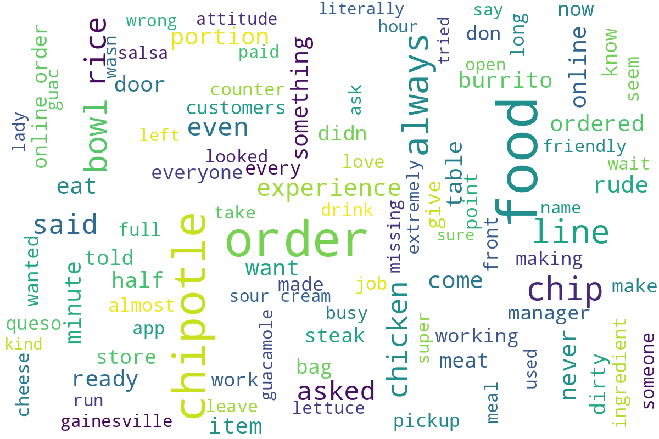
Word cloud generated from customer review text, showing the most commonly mentioned terms and themes.

