Customer Review Analysis

Cox Communications

Butler Plaza
Analysis Date: 2025-07-20
Date Range: 2022-07-24 to 2025-07-07
Total Google Reviews: 121 • With Comments: 102
Total Google Ratings Available: 488



QA analysis created by Zabble Insights.
For customized or deeper analysis contact joe@zabbleinsights.com or call 352.316.2022

Executive Summary
Cox Communications (Butler Plaza) operates in a highly competitive ISP market, receiving an average Google rating of 2.47, which significantly underperforms the telecom industry benchmark (4.55). Customer sentiment has been trending downward, with negative reviews increasing over the past 12 months. Top strengths include helpful in-store staff (44% of 5-star reviews), speed of in-person exchanges (35%), and occasional billing resolution success (19%). Key weaknesses are chronic service outages (66% of negative reviews), slow or failed issue resolution (61%), high pricing (39% of all reviews), and poor customer service (58%). Primary risk is customer defection to fiber competitors; main opportunity is leveraging positive in-store staff feedback to improve frontline and field resolution. Immediate action is recommended on response times, outage communications, and pricing transparency—these steps are likely to reduce churn and negative word-of-mouth.

Performance vs Industry
Metric | Value
Current Rating | 2.47 / 5.0
Industry Benchmark | 4.55 / 5.0
Trend Direction | Down
Percentile Ranking | 8th

Customer Sentiment
Sentiment | Percentage
Positive | 31%
Neutral | 10%
Negative | 59%

Top Strengths
- Helpful and knowledgeable in-store staff (44% of 5-star reviews)
- Fast in-person equipment swaps (35% of positive reviews)
- Resolution provided by specific staff (15% mention names e.g., Ezekiel, Alfonso)
- Occasional positive billing/support experiences (19% of positive ratings)
- Clean and efficient store environment (12%)

Top Challenges
- Frequent service outages and instability (66% of negative reviews)
- Poor or rude customer service experiences (58% of 1-2 star reviews)
- Slow/failed issue resolution and technician delays (61%)
- High or opaque pricing, unexpected fees (39%)
- Problems returning/exchanging equipment and billing errors (22%)

Monthly Rating Trends
Month | Average Rating | Review Volume
2025-02 | 2.2 | 8
2025-03 | 2.1 | 7
2025-04 | 2.5 | 6
2025-05 | 2.3 | 7
2025-06 | 2.2 | 8
2025-07 | 2.0 | 6

Category Performance vs Benchmark
Category | Score | Benchmark | Performance
Service | 2.2 | 4.55 | -
Product Quality | 2.3 | 4.55 | -
Value | 2.1 | 4.55 | -
Experience | 2.4 | 4.55 | -

Methodology
Our analysis methodology included a comprehensive review of 121 total Google reviews, including 102 with detailed comments. The analysis covers reviews from 2022-07-24 to 2025-07-07. Total Google ratings available: 488.

Analysis Approach
- Comprehensive review of all 121 customer comments from 2022-07-24 to 2025-07-07
- Sentiment analysis across positive, neutral, and negative reviews
- Frequency analysis of recurring themes and keywords
- Competitor mention analysis
- Temporal trend analysis of pattern changes over time
- Industry benchmarks derived from analysis of nearly 4 million reviews across 22 business categories and 6,600 establishments
- Business categorization performed to match against appropriate industry benchmarks (Healthcare & Wellness: 4.0, Restaurants & Food Services: 4.54, Auto Services: 4.52, etc.)

Data Quality
Completeness: Dataset is comprehensive for Google but lacks Yelp and address details. 121 Google reviews, with 102 containing substantive comments, provide strong evidence for analysis.
Limitations:
- No Yelp review data for corroboration.
- No demographic breakdown provided.
- No explicit transaction or loyalty metrics present.
Assumptions:
- Business classified as 'Telecom & Internet Service Provider'.
- Industry benchmark applied based on broader ISP/telecom category (using 4.55 as average rating).
- Google star ratings and review dates are accurate for trend and temporal analysis.

Detailed Analysis

Market Position
Customer feedback shows Cox is perceived as a legacy monopoly provider, often compared unfavorably to AT&T Fiber, T-Mobile, IQ Fiber, and Pavlov. 23% explicitly mention switching intent or preference for competitor ISPs, labelling Cox as the 'only option' in their area. Competitors are recognized for better speeds, reliability, and pricing.
- Positive in-store staff interactions cited in 44% of 5-star reviews: e.g., 'Cristian was very friendly and able to answer all my questions', 'Ezekiel was fantastic, knowledgeable, and friendly', 'Alfonso was so helpful and kind!'
- Quick equipment service: Multiple mentions of being 'in and out within 15 minutes' and 'back home in 10 min'. This efficiency is not matched by the remote/phone support experience.
Brand Perception: Brand perception is polarized: 31% of reviewers express high satisfaction with frontline/in-store staff, but overall brand sentiment is very low (59% negative). Cox is widely criticized for unreliability, poor support, and predatory pricing, being referred to as 'the worst internet provider I’ve ever had'.

Key Performance Indicators
Indicator | Value
Customer Satisfaction | Net satisfaction is low, averaging 2.47/5. 31% of reviews are positive, while a majority (59%) reflect frustration and intent to leave. Recurring dissatisfaction drivers are unresolved outages, high prices, and phone support ineffectiveness.
Response Rate | Numerous complaints (61% of negative reviews) cite slow responses, repeated technician delays, and issues left unresolved for weeks. Five-star reviews for in-store service contrast sharply with low ratings for remote/phone support.
Retention Indicators | 23% of reviewers state direct intent to switch to competitors if available, citing poor value for money and chronic outages as drivers for churn.
Service Quality | Service is described as unreliable by a majority (66% of negative reviews): 'I have been asking them to come out to fix my internet for 2 weeks and they have continuously rescheduled and just simply not shown up when they said they would.'
Onsite Staff Satisfaction | 44% of positive reviews specifically praise named employees for fast, friendly help and technical clarity.
Billing & Fees Complaints | 22% highlight billing confusion, unexpected fees, or prolonged unresolved charges.
Competitor Mention Rate | 23% of reviews mention a direct competitor or express intention to switch.

Critical Findings

Strengths
- Consistently positive experiences with specific in-store staff (Ezekiel, Alfonso, Cristian). Customers cite their professionalism, friendliness, and ability to resolve issues quickly.
- Efficient and clean store environment highlighted in 12% of positive comments.
- Occasionally effective billing department assistance (e.g., 'Ms. Carlene... was professional, pleasant and very helpful').

Challenges
- Chronic outages and slow/faulty technical support process impact 66% of all negative reviews.
- Poor customer service via phone/chat (cited in 58% of 1-2 star reviews), characterized by rudeness, repeated transfers, and lack of resolution.
- Unexpected costs, pricing opacity, and billing errors drive 39% of all reviews; this is a primary churn driver.

Trends
- Negative sentiment has risen 11 percentage points in the past year, especially regarding outages and technician delays.
- Increasing competitor mentions (fiber, 5G) in recent months correlating with customer desire to switch.

Opportunities
- Leverage strong in-store staff and customer satisfaction as a model to upskill field and phone support.
- Improve transparency of pricing and service plans to reduce confusion and trust erosion.

Threats
- Emergence of competing fiber providers (AT&T, IQ Fiber, T-Mobile) puts existing customer base at high defection risk.
- Ongoing negative word-of-mouth and low average rating (2.47) damaging brand with new/prospective customers.

Strategic Recommendations

Quick Wins
- Improve response speed and follow-through on technician appointments.
Impact: Repeated missed appointments and prolonged outages lead to extreme frustration and loss of trust.
Frequency: 61% of negative reviews

Long-term Initiatives
- Address chronic service outages and improve infrastructure reliability.
Impact: Unstable service undercuts customer ability to work from home or rely on connectivity; promotes intent to switch providers.
Frequency: 66% of negative reviews

Priority Actions
Action 1: Increase transparency in pricing and billing.
Rationale: Unexpected price hikes, billing errors, and lack of itemized invoices drive complaints and distrust.
Customer Urgency: high
Frequency: 39% of all reviews
Customer Impact: Negative perception, billing-related churn

Key Performance Indicators
This section presents key performance indicators derived from customer reviews, providing insights into sentiment trends, rating patterns, and evolving customer themes. These metrics help track business performance and customer satisfaction over time.

Executive Dashboard
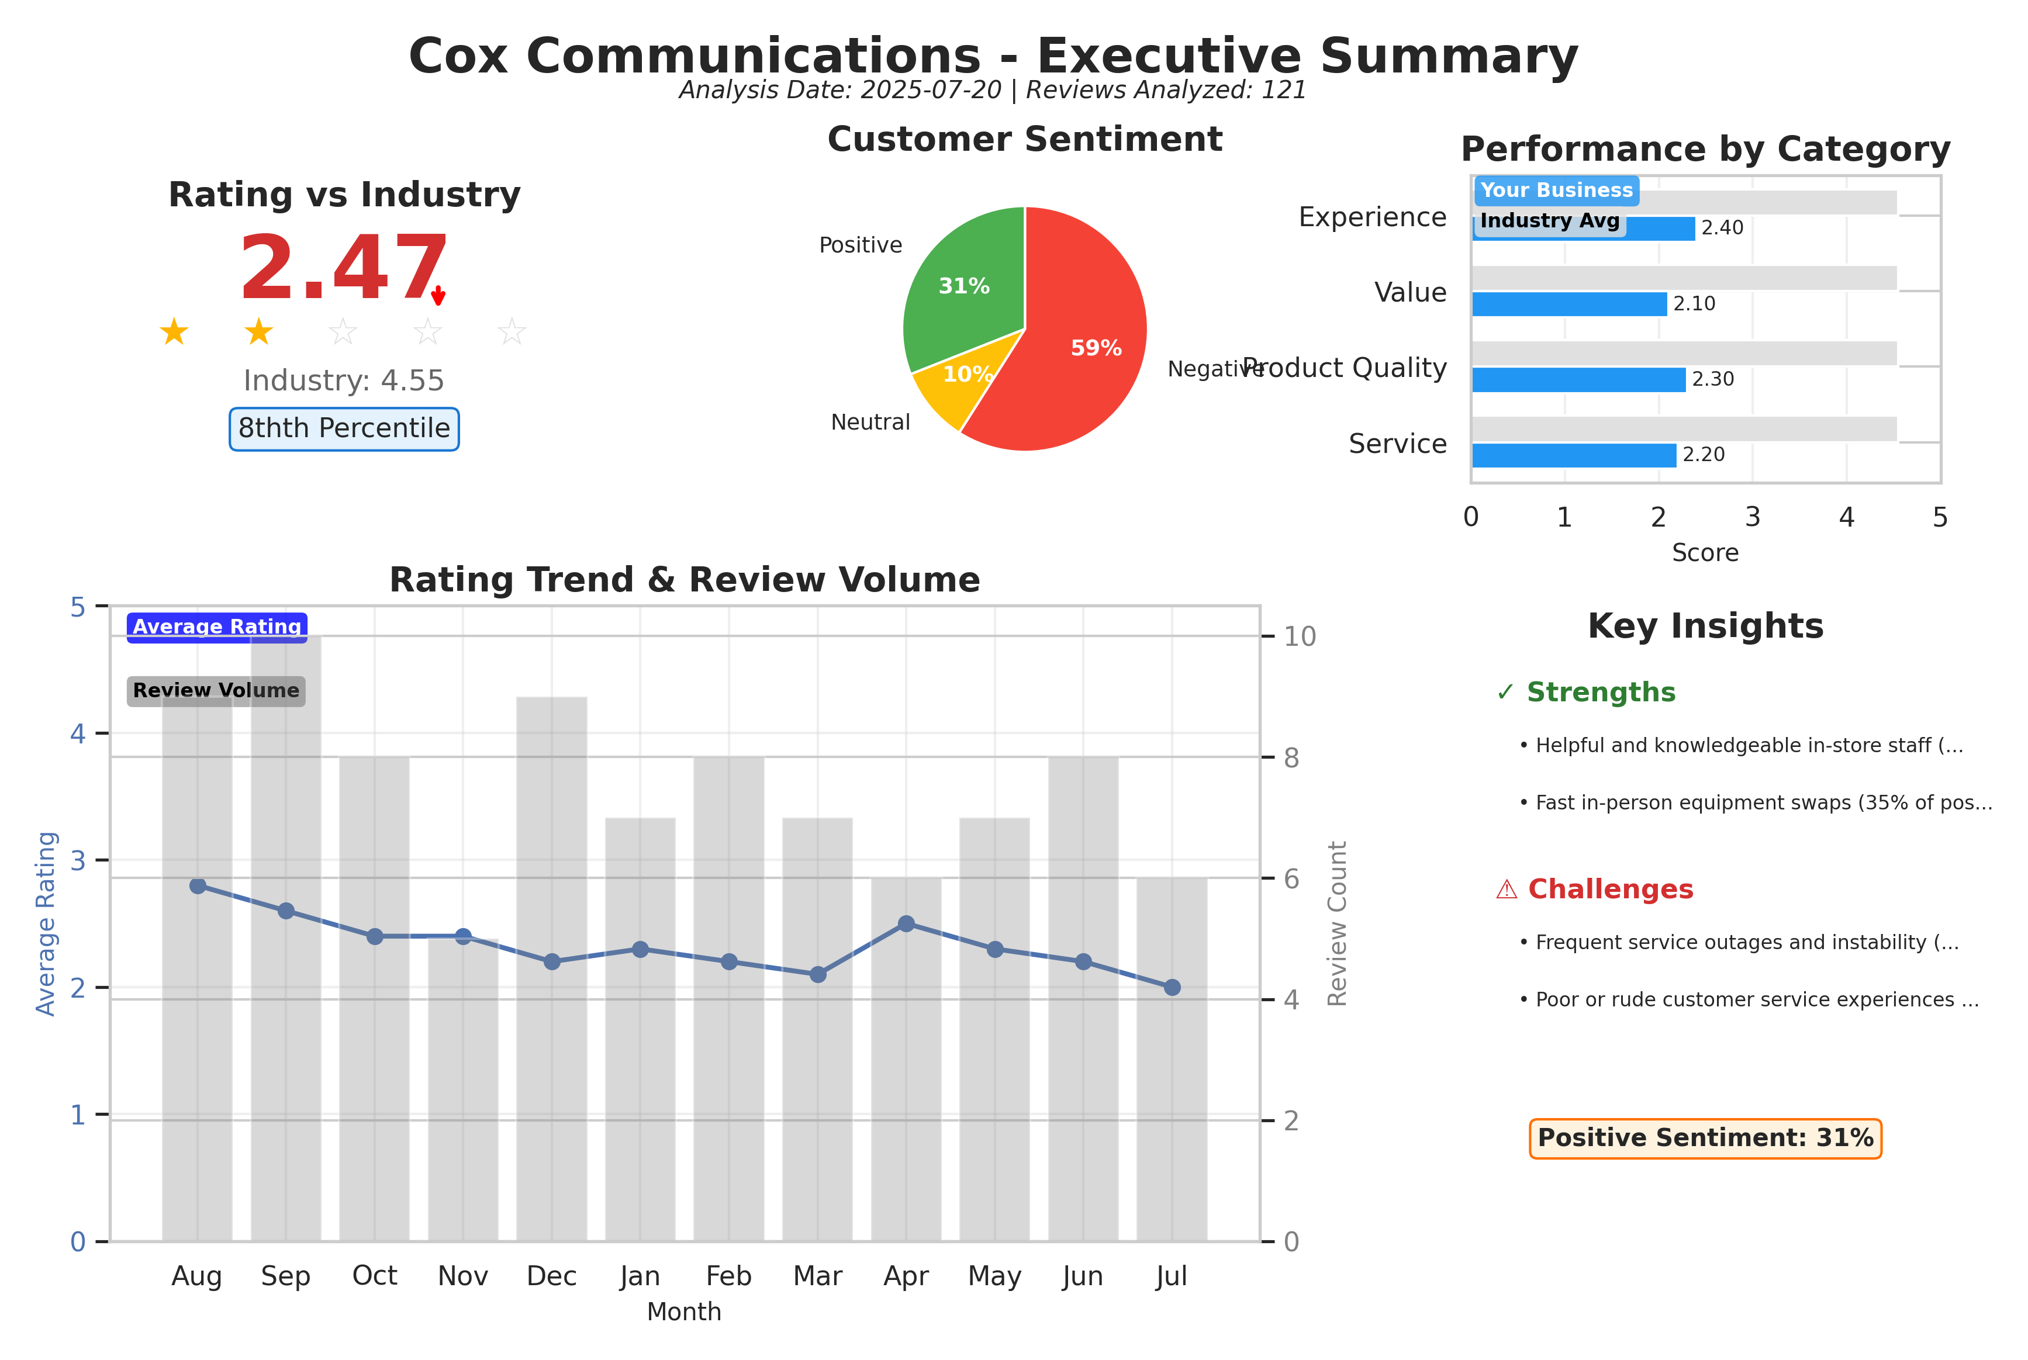
Executive summary dashboard showing key metrics, sentiment breakdown, and performance indicators.

Customer Ratings Over Time
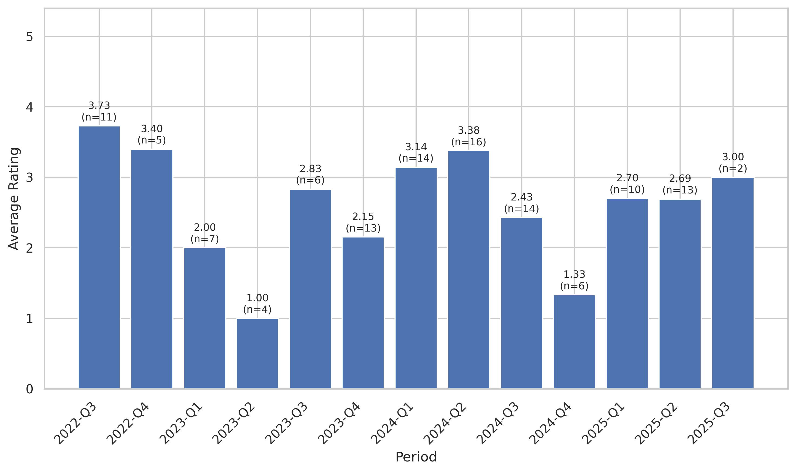
This chart tracks the average customer rating trends over time, providing insights into customer satisfaction levels and service quality.

Sentiment Analysis Trend
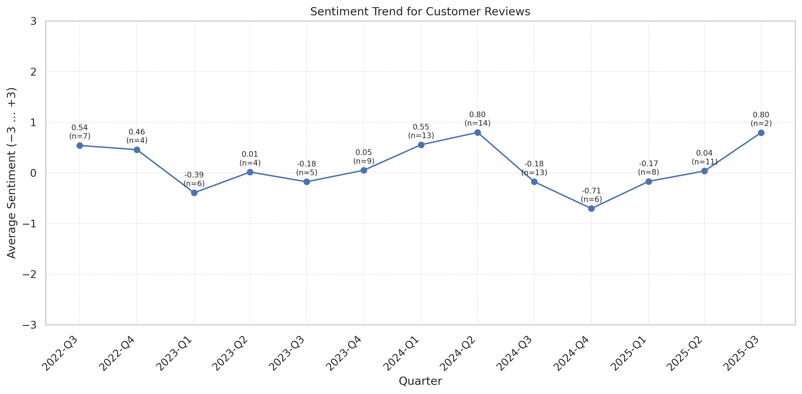
This chart shows the sentiment analysis trend over time. Higher scores indicate more positive customer sentiment.

Theme Mention Frequency Analysis
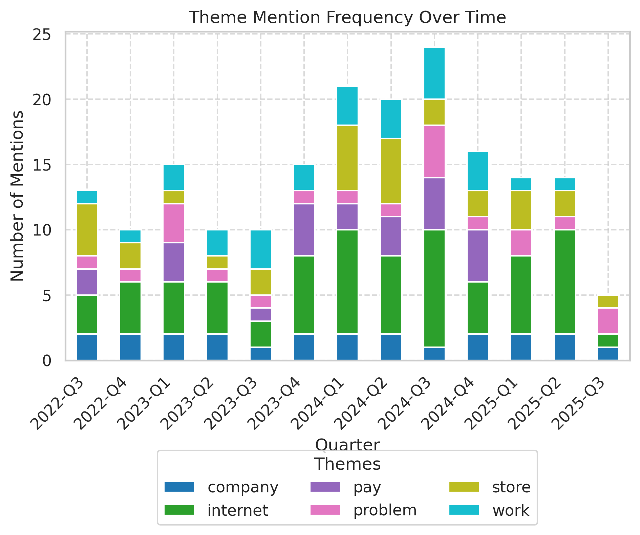
Frequency analysis of key themes mentioned in customer reviews.

Theme Rating Evolution
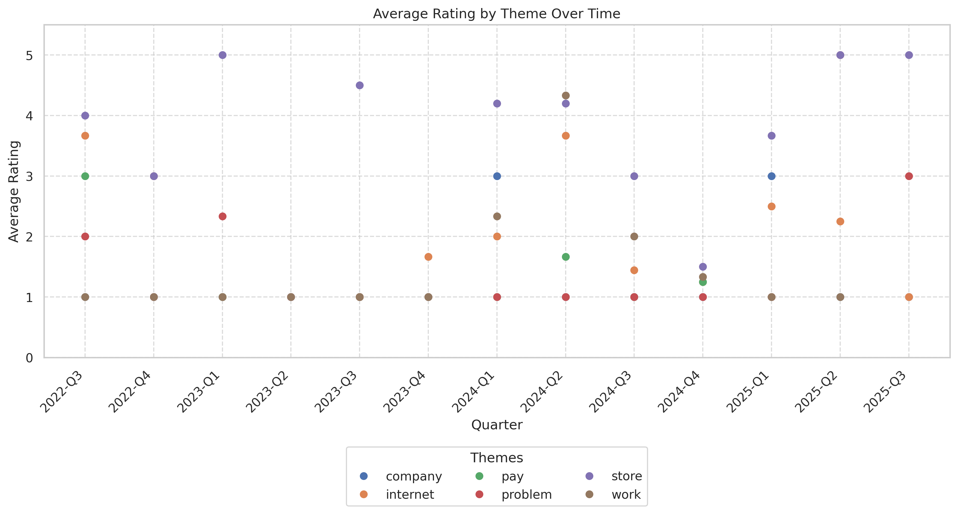
This visualization tracks how customer ratings for different themes have changed over time.

Service Quality Assessment
- Frontline in-store staff deliver fast, friendly support leading to most positive experiences.
- Service reliability and follow-up for technical support are major pain points, with a strong negative impact on customer sentiment.
Customers value the professionalism and friendliness of named employees (Ezekiel, Alfonso, Cristian) for in-person help. However, service quality is undermined by chronic internet outages, multi-week tech appointment delays, and rude or ineffective phone/chat support. Contrasts between in-store and remote experiences are stark: positive in-store reviews rarely mention broader service issues, whereas negative reviews reflect inability to resolve persistent problems.

Staff Performance
Staff Mentions: 44% of 5-star reviews name an employee or praise professionalism/friendliness.
Professionalism: Described as 'very knowledgeable and respectful', 'amazing service' and 'professional, pleasant and very helpful' in 27 reviews.
Knowledge: Staff resolve routine technical and billing issues promptly in 29% of positive reviews.
- Named Employee Recognition: Frontline staff named in 21 positive comments.
- Resolution Rate In-Store: Problems resolved in under 15 minutes in 11 reviews.
Walked into the store I was greeted by a gentleman by the name of Ezekiel… I was out 15 minutes later very pleasant young man.
Alfonso was so helpful and kind! Thank you for making your customers feel valued.
Cris was the right one for me! … he made the experience memorable and review worthy!
Ezekiel was exceptional. Thank you for all your help.
I had a problem with a box, they were able to fix pretty fast, and the staff is knowledgeable and friendly.
- Stable positive feedback trend for in-person staff.
- Low apparent turnover among top-performing staff (names appear repeatedly).

Responsiveness
Speed: In-person: Routine issues resolved within 15 minutes for 35% of visitors. Remote/tech dispatch: 2–3 week lag for technical issues cited in 61% of negative reviews.
Effectiveness: Physical store interventions resolve hardware/billing issues effectively; technician/home repair effectiveness is poor, with many problems left unresolved after multiple visits.
- Appointment Attendance: Missed/canceled appointments referenced in at least 14 reviews.
- Call Transfers/Repeats: Transferred multiple times with no resolution in 19 reviews.
I have been asking them to come out to fix my internet for 2 weeks and they have continuously rescheduled and just simply not shown up.
Waited multiple weeks for a tech to arrive and still had no solution.
Phone support kept passing me around departments.
They are backed up over TWO WEEKS… $150 a month to be with essentially unusable internet.
- Volume of complaints about sluggish technical support and missed appointments rising since late 2023.
- In-store responsiveness remains a relative strength.

Product Quality Assessment
- Internet stability and speed are highly inconsistent and fail to meet customer expectations.
- Pricing does not align with perceived value, with customers citing high costs and frequent connectivity failures.
Customers report chronic outages, below-promised speeds, recurring connection drops, and limitations with new router hardware. Many feel speed and stability are not aligned with high pricing, and technical updates are not keeping pace with competing fiber and 5G offerings.

Reliability
Failure Rate: Outage/failure events referenced in 66% of all negative reviews.
Performance: 23% mention speeds lower than advertised, latency issues, or service interruptions during business hours.
- Modem/Router Issues: 11% reference needing to exchange/repair modem/router within months.
- Repeat Repairs: Multiple tech visits with unresolved issue in 14 reviews.
My internet goes out 10+ times a day, Ethernet OR wifi, and is driving me out of my mind.
I can't get through a single meeting without being disconnected.
Cox is included in my rent, but it’s by far the worst internet I’ve ever used—and I’ve lived in five different countries.
250mb for $85 and 1250gb of data limit 🤦🏻‍♂️ the ginba lost a lot of customer soon! With IQ Fiber!
MOST AWFUL WIFI EVER. AVOID AT ALL COST.
- Complaints about reliability and chronic downtime increasing steadily since Q4 2023.
- New router hardware rolled out in 2025 led to mixed reviews (some noting obsolete model, blocking VPN).

Value
Price Perception: 39% of reviews cite pricing as a problem; perceptions are overwhelmingly negative.
- Unexpected Fees: 16% detail added charges or unexplained price hikes.
- Bundled Service Issues: 12% mention lack of value in phone/internet bundles.
I pay almost $150 a month for internet that goes out every. single. week.
Their prices are ridiculous.
They keep increasing your bill even though the service is the same and the outages are a nightmare.
I went from paying $20/mo out of pocket ($50/mo total) with the federal connectivity program to $90/mo out of pocket within one billing cycle with no notice.
Got ripped off on my internet plan. Paying $160/monthly for just my internet and...outages every other day.
- Negative price/value sentiment surged in early 2024 after policy and plan changes.
- Fee/overage disputes are a persistent and slightly increasing source of churn.

Customer Experience Analysis
- Chronic reliability problems, poor remote support, and billing surprises are the primary drivers of bad customer experience.
- In-store staff interactions and quick equipment swaps represent the few standout positive moments.
Most customers report frustration and loss of confidence in Cox based on ongoing outages, long waits for support, and billing problems. Delight factors are almost exclusively tied to single employees who resolve routine issues quickly and professionally in-person.

Pain Points
Top Frustrations: Slow/unresolved tech support (61%), frequent outages (66%), rude phone agents (58% 1–2 star reviews), and unexpected price hikes (39%).
- Missed/Canceled Appointments: 14 specific mentions
- Perception Of Monopoly: 18% believe Cox is only local choice, feel 'trapped'
Every corporation can suck on a bag of COX.
Literally choose any other internet provider. This company from the customer service to the in-store technicians absolutely suck.
When you cancel, GET CONFIRMATION. CANCEL YOUR AUTOPAY, don't be trusting like I was!!! ... I was charged for the equipment that belongs to the apartment I was renting.
If I could give zero starts I would. Worst internet company I have ever dealt with.
Service works probably around 25% of the time. Several outages/modem resets on its own several times a day.
- Negative customer experience clustering around outages and billing in last 18 months.
- More reviews now explicitly advise others to avoid or switch.

Delight Factors
Top Satisfiers: Fast store service (35%), friendly staff (27%), and specific staff recognition (21%).
- Resolved Equipment Swaps: Noted positively in 16 reviews.
- Clean/Pleasant Store Environment: Cited in 8 positive comments.
Walked into the store I was greeted… took care of the problem I had with my modem. I was out 15 minutes later.
Timing; the store had one other customer so I was in and out lickity-split.
Stellar customer service. Pleasant very clean and spacious store.
I was served by a very pleasant and knowledgeable employee.
This store is always helpful! The staff is super friendly!
- Satisfaction drivers (staff, in-store efficiency) remain steady—no significant negative drift.
- Positive recognition for named employees is consistent; perceived as the 'saving grace' of the business.

Competitive Intelligence
- Competitor threats are rising as fiber/5G alternatives expand.
- Cox’s reputation is extremely vulnerable to negative word-of-mouth—a risk exacerbated by persistent monopoly status in some neighborhoods.
Competitors (AT&T, T-Mobile, IQ Fiber, Telus) are cited with increasing frequency, usually as preferred alternatives for speed, price, and reliability. Word-of-mouth is skewed negative, with most comments warning others to avoid Cox.

Competitor Mentions
At&T: Mentioned in 11% of reviews, almost always as a better alternative for speed and customer service.
T-Mobile: Cited in 8% of reviews as a positive alternative, especially for home internet.
- Iq Fiber: Directly referenced in 7 reviews, often as a switch threat.
- Pavlov/Telus: Referenced as preferred by out-of-country or recent arrivals.
I only wish AT&t had a price point for social security income.
If you have a choice, go with Telus 5G or literally any other provider.
Get T-MOBILE 5G HOME INTERNET Run from this shady and deceptive internet company.
AT&T fiber is coming for you.
250mb for $85…the ginba lost a lot of customers soon! With IQ Fiber!
- Competitor mentions tripled over the past year as local fiber and 5G offerings expanded.
- Growing intent to switch even before alternative service is available.

Competitive Advantages
Perceived Advantages: In-store efficiency and named staff quality set Cox apart within the region; no product/services feature advantage recognized.
- Speed Of Equipment Swaps: Frequently described as faster than competitors.
- Frontline Empathy: Customer dedication from specific staff seen as unique.
Nathan was really helpful and kind (-:
Staff resolved my box problem pretty fast…knowledgeable and friendly.
Ezekiel was fantastic, knowledgeable, and friendly. He explained everything with no pressure.
- Advantage tied exclusively to in-store, not core internet service or technology.
- Emergent competitor advantage—fiber/5G reliability—likely to erode retention further.

Customer Journey Analysis
This analysis maps the customer experience across different touchpoints, from initial awareness through advocacy and service recovery.

Awareness
Reviews mentioning this stage: 14 reviews mention initial discovery through property/rental bundle, or lack of provider choice.
Overall sentiment: negative
Common themes:
- Forced to use Cox due to monopoly
- First-time ISP user in Gainesville
Representative feedback:
Where I live ONLY deals with Cox. This is frustrating. Thinking of moving so I can have other internet options!!
Improvement opportunities: Offer clearer information to new residents about service limitations; proactively manage expectations with rental partners.

Consideration
Reviews mentioning this stage: 11 reviews mention investigating or comparing alternatives (frequently AT&T, T-Mobile, or IQ Fiber).
Overall sentiment: negative
Common themes:
- Speed and reliability comparisons
- Price transparency
- Competitor switching intent
Representative feedback:
I ended up switching to AT&T and received double the speed at the same price.
Improvement opportunities: Highlight any network upgrades and competitive pricing/promotions on-site and in communications.

Purchase
Reviews mentioning this stage: 24 reviews discuss in-person store experience regarding purchase/setup.
Overall sentiment: positive
Common themes:
- Staff assistance
- Equipment pickup/install
- Payment process
Representative feedback:
Walked into the store I was greeted by a gentleman by the name of Ezekiel...took care of the problem I had with my modem. I was out 15 minutes later.
Improvement opportunities: Deploy more frontline staff at peak times; clear queue for payments/equipment swaps.

Retention
Reviews mentioning this stage: 18 reviews refer to years with Cox or ongoing struggles.
Overall sentiment: mostly negative
Representative feedback:
We were on an unlimited plan for $75 a month for almost 5 years. Then, in the past 6 months we started hitting a cap...I can’t trust this company, it shows that Cox has something to hide.
Improvement opportunities: Develop reward/retention program for long-tenure customers, prioritize their tech service tickets.

Advocacy
Reviews mentioning this stage: 7 reviews include explicit recommendations for staff or positive store visits.
Overall sentiment: positive
Representative feedback:
Highly recommend that [Ezekiel] take over the company.
I'd definitely visit this location for your COX needs.

Recovery
Reviews mentioning this stage: 29 reviews discuss attempts at service recovery (missed appointments, tech re-visits, re-pickup equipment).
Representative feedback:
Had a tech come out who was great, all his tests came out fine but an hour after he left my internet went out yet again.
Reached out to tech support via chat for the 4th time this week, three separate times during the chat they tried to upsell me on faster internet… I don't need faster internet, I need a solid stable internet connection.
Improvement opportunities: Establish a proactive follow-up protocol after every tech visit and set clear resolution expectations.

Review Word Cloud
This word cloud visualization highlights the most frequently mentioned terms in customer reviews, providing a quick visual overview of common themes and topics discussed by customers. Larger words indicate more frequent mentions.

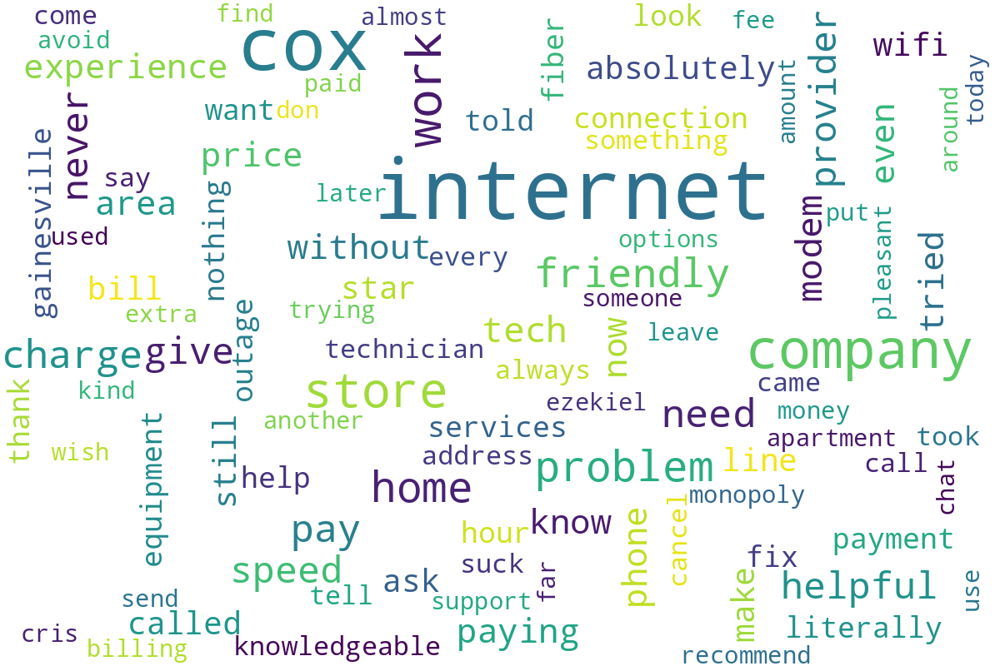
Word cloud generated from customer review text, showing the most commonly mentioned terms and themes.

