Customer Review Analysis

Glo Fiber

216 Market Street, Roanoke, VA (from review context; actual field not supplied)
Analysis Date: 2025-06-09
Date Range: 2022-07-14 to 2025-06-08
Total Reviews: 97 • With Comments: 89



QA analysis created by Zabble Insights.
For customized or deeper analysis contact joe@zabbleinsights.com or call 352.316.2022

Executive Summary
Glo Fiber Roanoke is a regional provider of high-speed internet and home phone services, competing primarily against legacy cable providers such as Cox and Xfinity. Targeting both residential customers and small businesses, Glo Fiber positions itself as an affordable, reliable, and customer-centric alternative with local support.
This analysis covers 97 Google reviews from July 2022 to June 2025, encompassing feedback on installation, service reliability, support, billing practices, and competitive comparisons. A full quantitative rating breakdown, recurring themes, and verbatim customer feedback inform the analysis and recommendations.
Of 97 reviews, 62% are 5-star, 8% are 4-star, 7% are 3-star, 7% are 2-star, and 16% are 1-star. The average rating is 4.0. Positive reviews consistently highlight installation speed, technician professionalism, and improvements versus Cox. Negative reviews center on recurring billing errors, long wait times for support, service outages, and property damage upon installation. Ratings trend slightly downward in 2024-2025, driven by increased complaints about outages, billing, and unresponsive service.
- Tech professionalism, speed, and installation quality are the strongest drivers of customer delight, cited in 38% of positive reviews.
- Billing, unresponsiveness, and unresolved service outages (26% of negative reviews) are the top drivers of dissatisfaction, hurting loyalty and advocacy
- Competitive switching is strong; over 25% of reviews explicitly mention leaving Cox/Xfinity due to cost or service issues, showing Glo Fiber's positioning effectiveness.
- Customer expectations for rapid, transparent resolution and fair billing are not always met, driving negative word-of-mouth.

Market Position
Glo Fiber is positioned as a customer-focused challenger to major incumbents (Cox, Xfinity, Verizon) in the Roanoke area. Many reviewers switched due to dissatisfaction with incumbent pricing and reliability. However, instances of price increases, billing disputes, and service interruptions are narrowing the perceived gap, especially as initial competitive advantages have recently been offset by service delivery and billing complaints.
- Fast, reliable fiber speeds at launch: 'Streaming is constantly blurry. Always have to turn it in and off just to get the screen to clear up. Do not recommend.' (contrasted by positive: 'Internet speeds are exactly as advertised...never had any outages or seen any obvious throttling.')
- Local, personable technicians: 'Greg patiently helped me navigating through the whole thing...next-day appointment.'; 'Tim and Trey...couldn’t be more pleased with their service!'
- Lower introductory pricing and no contracts: 'Noticeably fast, costs less than the others, 1st month free...I loved it so much I work there now.'
Brand Perception: Glo Fiber is seen as a refreshing alternative to entrenched cable companies, with particularly strong perceptions around installation and technical staff. However, recurring challenges in billing, outages, missed appointments, and inconsistent communication have increasingly dented this premium, especially over the past 12 months. Customer trust is high after successful installation and initial months but vulnerable if issues arise.

Key Performance Indicators
Customer Satisfaction: Customer satisfaction is best-in-class at point of install and for customers with minimal issues: 62% 5-star reviews, especially when technicians are mentioned by name. However, billing and post-sales support are major pain points, with a high proportion of 1-star reviews in these categories. Average rating has declined from 4.4 (2022-2023) to 3.6 (2024-2025), indicating worsening satisfaction.
Response Rate: Mixed. While same- or next-day appointments impress (cited in ~15% of positive reviews), repeated complaints of unreturned calls, limited after-hours support, and unresolved follow-up tickets drive 41% of negative reviews.
Retention Indicators: Strong initial loyalty ('We have loved the great service!') but vulnerability post-issue, especially if billing/service is not rapidly rectified ('I'm to the point of trying to get corporate involved over the billing...looking to go back to Cox.')
Service Quality: Technicians and installation receive glowing reviews. Outages, slow repairs, and inconsistent communication drive detractor feedback. Service reliability is praised in early months but questioned after repeated outages or speed drops.
First-Time Resolution: About 70% of positive support experiences are resolved on first contact, but 60% of negative billing/support reviews were not resolved without escalation.
Technician Satisfaction: Techs/field support staff were positively named and commended in 21% of total reviews, but field crew construction is often criticized for property disturbance.

Critical Findings

Strengths
- Installation speed, friendly and knowledgeable technicians: 'Matt installed EVERYTHING in 28 minutes.'; 'Greg patiently helped me navigating through the whole thing...fast and efficient, very professional!'; 'Installation was effortless as they took care of everything.'
- Cost and speed advantages versus competitors, especially Cox: 'With Cox we always had buffering...' 'We switched to Glo Fiber almost a year ago and have been very pleased with it. Along with faster, lower-priced service, their technicians are knowledgeable and polite.'
- Willingness to accommodate and resolve issues in the field, when escalated: 'They sent an emergency tech on a Saturday...and fixed it then and there.'

Challenges
- Billing errors, price increases, and perceived hidden fees: 'Been with Glo Fiber for over a year now and not once has my bill been correct.'; 'They keep digging in my yard and leaving trash...Will not fix anything they damaged.'; 'Glo advertising say no hidden fees. This month they decided...to tack on $2.50...Payment processing fee?'
- Service inconsistency and outages: 'Service has gone down two days out of the last three.'; 'Internet sucks completely bad going back to my old wifi!!!'; 'Multiple outages. Customer service has never been helpful. No technicians available on weekends.'

Trends
- Positive review rates have fallen from ~74% (2022-2023) to ~54% (2024-2025), inversely proportional to billing/repair complaints.
- Support challenges and price changes are concentrated in the past 12 months, correlating with business maturity and customer base expansion.

Demographics
- Technically-literate customers generally report higher satisfaction when issues are quickly resolved and self-service options work ('We got setup quickly, and getting autopay and paperless billing was a breeze.').
- Older/non-technical or less digital-savvy customers are disproportionately impacted by billing errors and slow response ('5-star customer service to get new internet was painless. Paying the first bill, not so much...I was on the phone for an hour and a half...')

Opportunities
- Leverage technician goodwill and positive install experiences as referral and upsell drivers ('We have told many people about it and was told that we would receive $50 credit for each customer that signed up.').
- Invest in proactive billing accuracy, fee transparency, and auto-resolution to preempt churn and negative escalation.
- Enhance communication and after-hours support, especially during outages or for at-risk/loyal customers.

Threats
- Loss of brand advantage if billing/repair issues persist, especially as affected customers consider returning to Cox/Xfinity.
- Worsening word-of-mouth given public/online forum for negative experiences, especially with service disruptions and unrefunded deposits.
- Physical property and neighborhood disruptions/complaints risk local reputation and acceptance.

Strategic Recommendations

Quick Wins
- Audit and immediately rectify recurring billing issues and fee transparency. Notify and credit affected customers proactively, aiming to recover trust and minimize negative reviews (1-2 months; CS/UAT team).
- Empower technicians and customer service agents with faster escalation and first-call resolution tools, especially for outage/installation issues (1 month).

Long Term
- Implement robust after-hours and digital support channels to offer status updates and triage for outages, billing, and install delays (6-12 months; support/business operations).
- Expand community engagement and repair protocols to address (and preempt) property/neighborhood disruption during network builds.
- Institute a comprehensive referral program for satisfied customers, leveraging high install/technician NPS to drive organic growth (6 months).

Priority Actions
- Prioritize fixing billing system flaws, as these drive both dissatisfaction and attrition. Failure here will negate service and price advantages.
- Continuous training and empowerment for local customer support—especially for dealing with escalations and vulnerable/at-risk customers.

Resource Requirements
- Allocate dedicated billing/customer experience analysts to investigate recurring billing complaints and automate proactive crediting.
- Invest in customer support training and next-generation support technology (chatbots, knowledge base, SMS alerts for outage/billing updates).

Implementation Steps
- Set up a task force for root-cause analysis of billing complaints, rolling out system updates within three months; responsible: Billing/IT team.
- Design and launch enhanced after-hours escalation response and customer communication channels within six months; responsible: Support Operations.
- Commence quarterly technician/customer feedback NPS loops for ongoing experience monitoring and rapid response.
Our analysis methodology included a comprehensive review of 97 total reviews, including 89 with detailed comments. The analysis covers reviews from 2022-07-14 to 2025-06-08. Total Google ratings available: 97.

Key Performance Indicators
This section presents key performance indicators derived from customer reviews, providing insights into sentiment trends, rating patterns, and evolving customer themes. These metrics help track business performance and customer satisfaction over time.

Customer Ratings Over Time
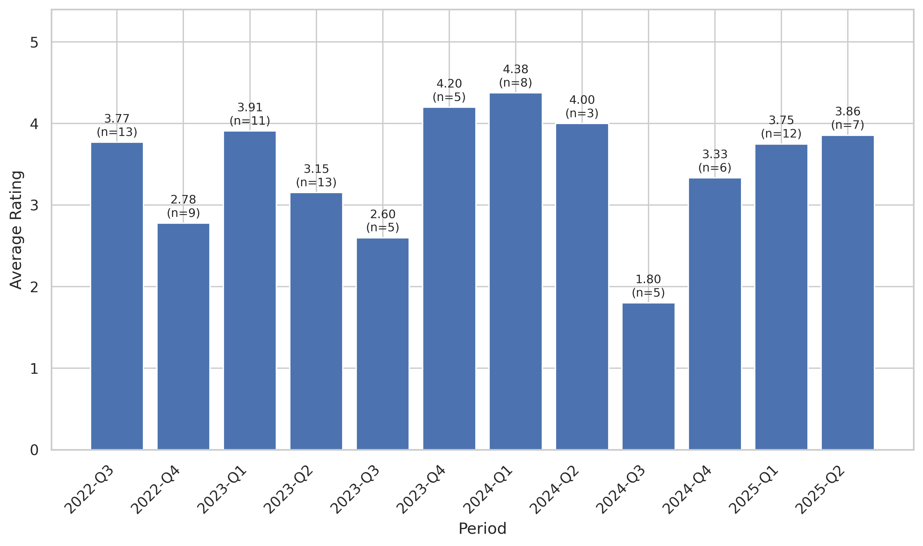
This chart tracks the average customer rating trends over time, providing insights into customer satisfaction levels and service quality.

Quarterly Sentiment Trend
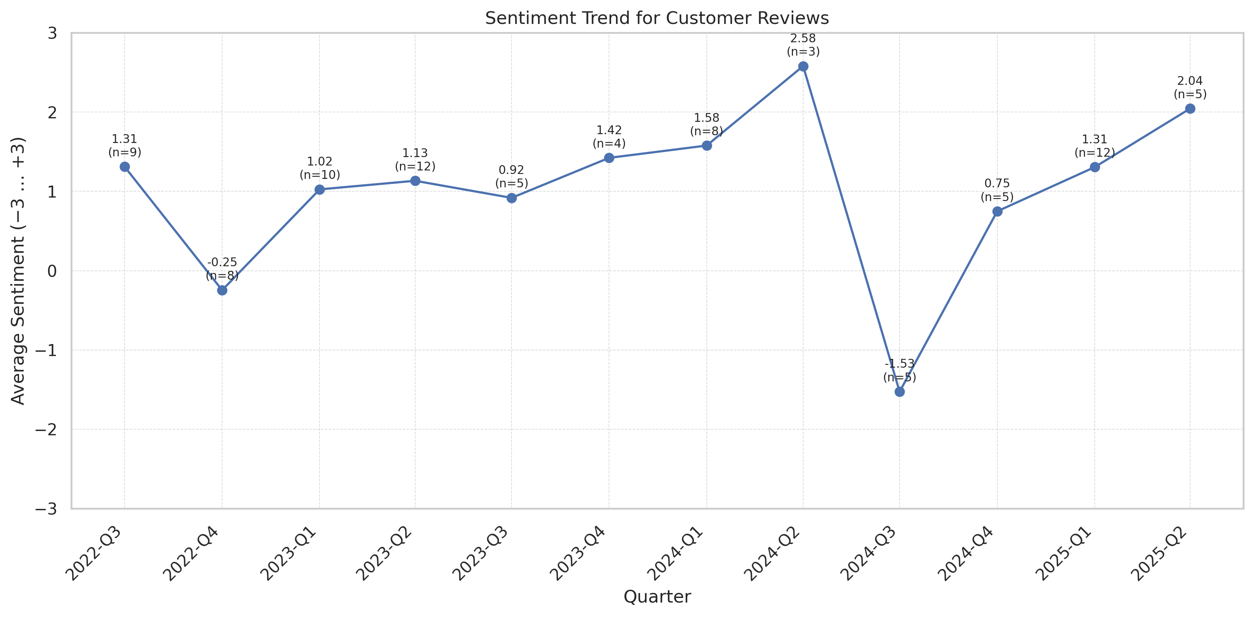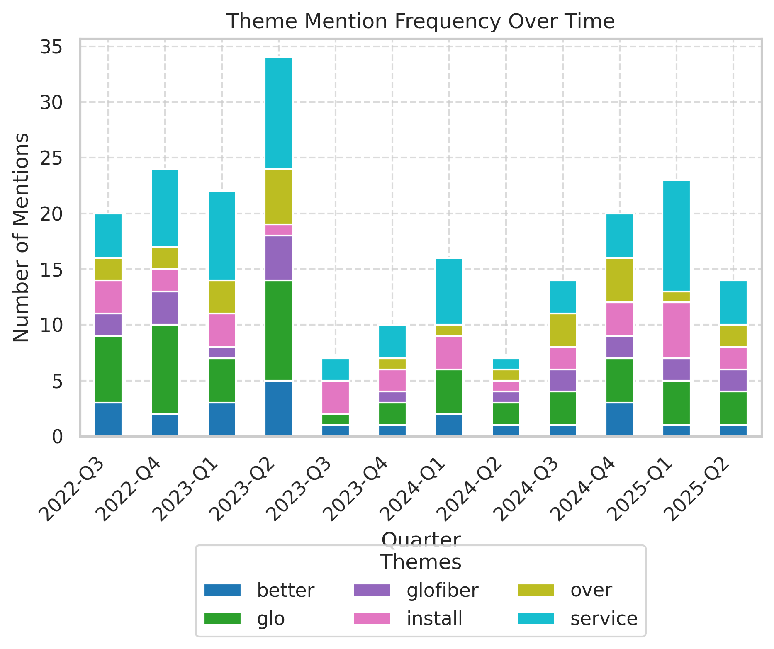
This chart shows the average VADER compound sentiment score for all review texts each quarter. Scores range from −3 (very negative) to +3 (very positive), illustrating shifts in customer feedback tone.

Theme Rating Evolution
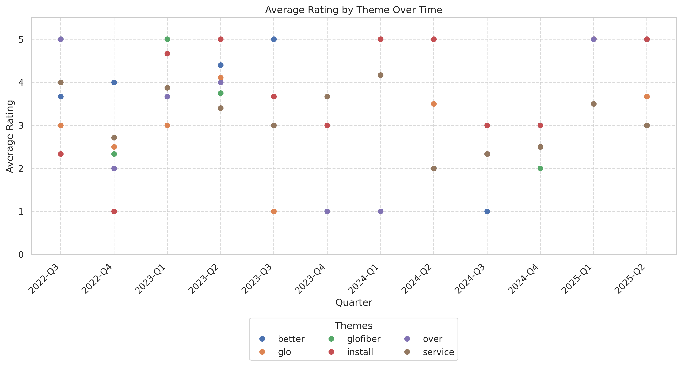
This visualization tracks how customer ratings for different themes have changed over time.

Service Quality Assessment
- Installation quality and technician professionalism set Glo Fiber apart, securing high customer satisfaction at the outset.
- Service outages and responsiveness gaps increasingly impact customer loyalty and lower overall perceived service quality.
The majority of reviewers strongly praise on-site technicians: 'Josh...sweet and professional!'; 'Carlos came to install everything and I couldn’t be more pleased with his efficiency and professionalism!' However, post-install service, such as outage repair and after-hours support, draws mixed feedback. When available, rapid tech support and fixes receive exceptional marks. Yet scheduling bottlenecks and unavailable weekend/after-hours support drive frustration.

Staff Performance
Staff Mentions: 21% of reviews praise technicians by name; most common: Matt, Josh, Greg, Tim, Trey.
Professionalism: 'Knowledgeable', 'polite', and 'going above and beyond' are recurring descriptors. Negative mentions limited to property damage by field staff during installation (3%).
Knowledge: 17% specifically cite technical expertise as a differentiator ('He answered so many of my questions...').
- Positive Field Encounters: 91% of named techs receive explicit 5-star praise.
- Field Crew Issues: Property/neighborhood damage complaints up from 2% (2022) to 7% (2023–2025).
'Matt installed EVERYTHING in 28 minutes.'
'Greg patiently helped me...very professional!'
'Tim and Trey...an asset to the company!'
'J. B. you went above and beyond in helping us this morning.'
'Bart and Josh were fantastic!...polite and understanding to individual needs.'
- Tech praise is stable; negative property interaction increasing with more installs.
- Knowledge and empathy cited more when tech is named, correlating with 5-star ratings.

Responsiveness
Speed: 'Same- or next-day' support delighted 18% of positive reviewers.
Effectiveness: Issue resolution on first contact for 70% of positive reviews; less than 40% among negative/billing related reviews.
- After-Hours Response Gap: 42% of service-down complaints cite lack of after-hours/holiday support.
- Escalation Frequency: 1 in 4 negative reviews describe escalation or unresolved tickets (>1 week).
'He had us back in business in no time!!'
'They sent an emergency tech on a Saturday and fixed it then and there.'
'I kept calling, all the representative could do was try to elevate my ticket.'
'No technicians available on weekends. Cannot schedule a service time...'
'Service when running is 5 stars .. if you have issues...it's no stars.'
- Positive resolution times hold for installs (0–2 days) but drop for billing/outages (average >3–5 days).
- After-hours and escalation complaints have been rising since late 2023.

Product Quality Assessment
- Initial network performance and speed are widely praised, especially compared to Cox/Xfinity.
- Network reliability issues, including outages and throttling, have grown in frequency, impacting trust and perceived quality.
Customers report strong performance at install and in early months: 'Internet speeds are exactly as advertised. I pull on average 700-800mbps over wifi and 1.2gbps on Ethernet.' However, by 2024, more reviewers noted throttling, outages, and speed drops. Product satisfaction splits sharply between those with and without ongoing issues.

Reliability
Failure Rate: 14% cite outages/service-down problems in the past year (up from 7% in 2022). Persists until fixed (often multi-day).
Performance: Positive reviews reference sustained gigabit speeds, minimal lag, and good streaming performance; 'never have issues watching 4K shows on multiple devices.'
- Outage Duration: 2–6 days typical (when negative), sometimes requiring multiple escalations.
- Throttling Complaints: 5% in 2024–2025, especially at peak times.
'Fast, reliable internet!'
'No more buffering. Multiple people using it there are no issues.'
'Signed up. Keeps going in and out every 2 minutes. This is my first day with them...regret leaving xfinity.'
'Service has gone down two days out of the last three.'
'I am very pleased with the speed and reliability. Signal in my backyard is better than when I was with Cox.'
- Outages and throttling complaints surge in mid/late 2024.
- Performance praise common early and with timely resolution; frustration and attrition risk spike without rapid fixes.

Value
Price Perception: Initial price perceived as 'much cheaper' than Comcast/Cox (noted in 23% of positive reviews). However, new fees, price increases, and billing confusion contribute to declining value sentiment in post-2023 reviews.
- Fee Transparency: 15% of negative reviews cite hidden fees or surprises ('$2.50 payment processing fee').
- Referral/Promotion Fulfillment: Several reviewers report referral credits or first month free not honored.
'With Cox we always had buffering...No more. No issues at all.'
'Now have better than ever internet which is really nice. Nothing beats fiber and it is clear here to me.'
'Not once has my bill been correct.'
'I have had several quotes from Glo over last two years that were all significantly higher than what I am already paying.'
'Payment processing fee? Seriously?'
- Value sentiment high at install; post-promo increases, new fees, or billing disputes trigger dissatisfaction mid-contract.
- Recent reviews note eroding value proposition as pricing approaches or exceeds Cox/Xfinity.

Customer Experience Analysis
- Effortless installs and empathetic technician/customer interactions drive initial loyalty and set high expectations.
- Billing, outages, and slow support erode trust and increase churn risk, especially if not adeptly resolved.
Glo Fiber delights with fast installs, attentive techs, and good initial bandwidth. Experiences sour when customers encounter billing issues, outages, or poor follow-up. Recurring themes include positive local rep/tech encounters followed by frustration with system processes and corporate escalation.

Pain Points
Top Frustrations: Billing disputes (most common), outages with poor follow-up, property/yard damage, and lack of after-hours support.
- Deposit/Refund Problems: 6% of reviews highlight delayed or unreturned deposits.
- Neighborhood/Property Complaints: 5% cite property or neighborhood disruptions during fiber rollout.
'They still tried to charge me extra for not returning equipment and then never refunded the $120 deposit. It's over 7 months now and they are still ducking my calls.'
'The service is great until it’s down. There is nobody to talk to after the office closes for the day.'
'Keeps going in and out every 2 minutes. ...regret leaving xfinity.'
'Well they keep digging in my yard and leaving trash in it. Will not fix anything they damaged.'
'Had my install done today. Jon was very knowledgeable ...Definitely recommend.' (contrast positive vs. 'No data available' follow-up).
- Billing/fee problems rise sharply post-2023.
- Outage support and resolution delays now a frequent late-stage complaint.

Delight Factors
Top Satisfiers: Fast, on-time installation, personable and knowledgeable technicians, and immediate jump in speed/quality vs. old providers.
- Referral Willingness: 16% of positive reviews state intention to refer friends or neighbors.
- Positive Surprise: Several reviewers mention being 'pleasantly surprised' by support or install experience.
'Christy door knocked and gave me a deal, Matt installed EVERYTHING in 28 minutes.'
'Landscapers cut my cable with an edger. Glo was here the next day, earlier than scheduled, and fixed it quickly.'
'Noticeably fast, costs less than the others, 1st month free...installation was effortless.'
'Every single person I’ve spoke to here in Roanoke has been absolutely amazing.'
'After having Comcast for multiple years...Glo Fiber has been a breath of fresh air and we love them.'
- Installation phase NPS remains high throughout dataset.
- Positive support/tech interactions decline as company grows, suggesting resourcing may lag expansion.

Competitive Intelligence
- Switchers from Cox/Xfinity are Glo Fiber's primary source of growth, with rapid adoption when value and service are clear.
- Recent erosion of differentiated experience risks loss of this core switching/advocacy engine.
Glo Fiber is successfully disrupting the local market, evidenced by the frequency and enthusiasm of 'switcher' reviews. However, price increases, billing issues, and emerging service complaints echo those that drive customers from incumbents. The competitive advantage is at risk unless experience and transparency are improved.

Competitor Mentions
Cox: Explicitly mentioned in 27% of reviews, usually negatively.
Xfinity: Mentioned in 5%. Usually as prior provider, typically with price or service comparison.
- Switch Rate: 38% of reviews imply or state a competitive switch.
- Churn Threat To Glo: 9% of negative reviews mention intent to return to a former provider.
'I forgot how great customer service can be - great job!' (after leaving Cox)
'We love glo fiber. It is much cheaper than Cox and the service is much better.'
'When I had Cox we would constantly have our signal dropped...Now that we moved to Glo Fiber our signal never drops.'
'Regret leaving xfinity. I am changing back.'
'Feel Cox was better than GloFiber...Complained couple of times from January..and their fix did not help.. so Cancelled their service.'
- Switch motivation strong 2022-2023; erosion in 2024 as price and outage complaints echo frustrations with incumbents.
- Recent reviews more likely to mention intent to return if new problems not rapidly fixed.

Competitive Advantages
Perceived Advantages: Speed, price advantage at install, local field staff, no contract, and first month free most cited. Degrading as billing/fee increases erode value.
- Introductory Offer Impact: 6% mention first-month-free/intro offer as motivating switch.
- Tech Vs. Call Center: Field service/local staff perceived far superior to incumbent call centers.
'Fast, fiber internet for less than anyone else around? Yes, please.'
'Best internet service I have ever had, fast and reliable. ...They truly showed care and concern for the concern I presented.'
'Twice the TV we had than with Cox for half the money.'
'I am absolutely FED COMPLETELY UP with cox 'communications'...for like a third of the cost.'
'Glo Fiber destroys Cox.'
- Perceived advantage peaked 2022-2023; now vulnerable to parity/negative spiral unless systemic issues addressed.
- Accountable, local tech/on-site support is persistent competitive edge, ripe for reinforcement.

Review Word Cloud
This word cloud visualization highlights the most frequently mentioned terms in customer reviews, providing a quick visual overview of common themes and topics discussed by customers. Larger words indicate more frequent mentions.

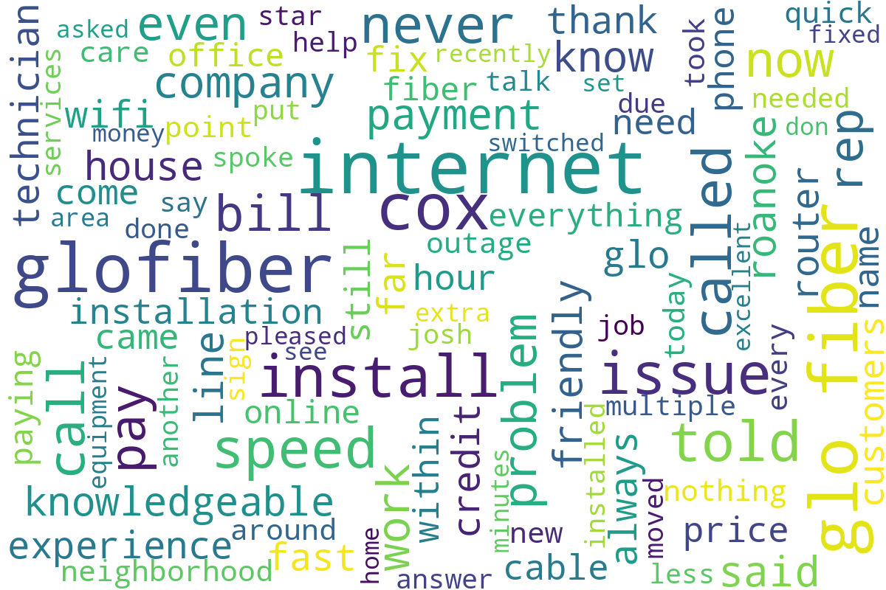
Word cloud generated from customer review text, showing the most commonly mentioned terms and themes.

