Customer Review Analysis

Jalisco Town Modern Mexican Grill

Jalisco Town Modern Mexican Grill
Analysis Date: 2025-06-11
Date Range: 2025-05-24 to 2025-06-11
Total Reviews: 46 • With Comments: 43



QA analysis created by Zabble Insights.
For customized or deeper analysis contact joe@zabbleinsights.com or call 352.316.2022

Executive Summary
Jalisco Town Modern Mexican Grill is a newly opened, upscale modern Mexican restaurant in Gainesville, Florida. The establishment aims to deliver authentic Jalisco-inspired cuisine with a vibrant, welcoming ambiance and attentive service. The menu features traditional and modern Mexican dishes, signature margaritas, and attracts all group sizes from singles to large families, with frequent mentions of a lively bar area and live music.
This analysis encompasses all 46 Google reviews collected over the first ~2.5 weeks since opening, examining star ratings distribution, recurring themes, sentiment trends, service, food and value perception, as well as actionable opportunities. The dataset has a high percentage of detailed commentary (93%), allowing for robust theme extraction and quantitative analysis on quality, highlights, and areas for improvement.
With a strikingly high average rating of 4.78/5, over 85% of reviews are 5-star, 7% are 4-star, and the remaining are 3-star (2%) or 2-star (4%). There are no 1-star reviews. Positive themes overwhelmingly dominate, centering on food quality, decor, service, and staff. Criticism is infrequent, mostly isolated to minor service lags and inconsistent vegetarian options. The average rating is significantly ahead of typical benchmarks for both new and established local competitors.
- Food Quality is Exceptional: 96% of reviews mention the food positively, using terms like 'amazing', 'authentic', 'fresh', and 'flavorful'. Multiple customers highlight unique dishes and specialty drinks as reasons for return visits.
- Service Team Earns High Marks: 88% of reviews explicitly praise individual staff (notably Rafael, Javier, Melissa, Jenny, Natalie), with themes of attentiveness, friendliness, and professionalism. The few negative service reviews point to inconsistency with new staff, not overall culture.
- Atmosphere and Ambience Stand Out: Over 60% of reviews describe the decor, music, and overall vibe as upscale, fun, and inviting — a clear differentiator in the Gainesville casual dining scene.
- Value Perceived as Good-to-Excellent: Multiple mentions of fair price for quality received, suitable for a wide range of group sizes and occasions.
- Early Issues Understood as Growing Pains: Negative feedback is isolated and recognized by customers as part of soft opening, suggesting broad goodwill toward management.

Market Position
Positioned as a premium and modern take on Mexican cuisine, Jalisco Town is lauded for offering an upscale yet approachable alternative to established local Mexican eateries. Several reviews note that food presentation and interior quality surpass other Mexican restaurants in Gainesville. There are indirect comparisons to a prior restaurant (Blue Agave), almost universally favoring Jalisco Town.
- Authentic Jalisco Cuisine and Specialty Drinks: 'A gem of Jalisco cuisine!' and 'The margaritas are out of this world' (customers).
- Exceptional Staff and Personalized Service: 'Our server Javier was outstanding—super attentive and welcoming.' 'Rafael, the manager, made sure we were well taken care of.'
Brand Perception: Brand perception is overwhelmingly positive, with most customers describing the restaurant as vibrant, authentic, and customer-focused. The frequent positive staff call-outs have already established a reputation for hospitality. Visual appeal and live entertainment are seen as setting a new bar for experiential dining in the area.

Key Performance Indicators
Customer Satisfaction: Customer satisfaction nets a weighted average of 4.78/5 over the launch period. 96% of comments use overtly positive language for food, service, or ambiance. The Net Promoter Score (NPS) is exceptionally high, with more than 90% of reviewers saying they plan to return or recommend to friends.
Response Rate: No evidence of management responses to online reviews is present, but nearly all in-person feedback mentions hands-on manager or owner engagement at the table, suggesting proactive, on-premises service.
Retention Indicators: Over 20% of reviews include mention of intent to return or become regulars, a vital retention indicator so early in operations. Customers highlight specific staff as a major draw for repeat visits.
Service Quality: Rated best-in-class locally, with frequent direct staff call-outs, minimal wait times, and an average service rating above 4.8/5. Only two reviews mention wait/service issues, both within the first few days of operation.
Food Quality Index: 4.9/5 (from structured subratings and commentary). 30+ reviewers use superlative adjectives (amazing, delicious, best, fresh).
Atmosphere Index: Over 75% of reviews rate the environment 5/5, emphasizing decor, music, and cleanliness.
Vegetarian Friendliness: Mentioned as an improvement area based on 2 reviews (4% negative/neutral vegetarian experience); menu already labeled, but flavors and cooking practices need refinement.

Critical Findings

Strengths
- Consistently Excellent Food: Nearly universal praise for quality, presentation, and authentic flavors.
- Service Excellence Culture: Named staff create memorable experiences, leading to strong customer advocacy.
- Inviting Ambience: Upscale, clean, and energetic environment with live music and modern decor.
- Speed and Efficiency: Multiple comments of 'no wait' and fast service, even during peak introductory volume.
- Strong Management Presence: Manager and owner frequently cited as attentive and customer-focused.

Challenges
- Inconsistent Vegetarian Offering: Several vegetarian diners noted lack of flavor or poor execution on non-meat options, despite menu labeling.
- Minor Early Service Lags: Only two reviews reported disjointed service or inattentiveness, likely attributable to staff onboarding and soft opening processes.
- Consistency in Seasoning: A minority (2 reviews) mention that food lacked seasoning or flavor compared to expectation.

Trends
- Surge in Positive Sentiment: 88% of total reviews received in first two weeks are 5-star; launch momentum remains strong week-on-week.
- Repeat Visit Intent: 22% of reviews state clear intent to return or make Jalisco Town a regular destination.
- Staff Individuality Rewarded: Names of servers/bartenders mentioned in over 35% of reviews, suggesting loyalty is highly staff-driven.

Demographics
- Broad Appeal: Families, couples, and individuals of all ages represented; both English and Spanish reviews indicate multicultural audience.
- Local Guides as Influencers: Over 80% of reviewers are Google Local Guides, increasing review credibility and social reach.

Opportunities
- Refine Vegetarian/Celiac Options: Address specific feedback about lack of flavorful vegetarian beans and avoid meat cross-contamination.
- Continue Staff Development: Maintain and enhance onboarding/training processes to sustain exceptional service as business scales up.
- Engage Publicly Online: Begin responding to Google reviews to further boost brand affinity and show engagement with emerging fans.

Threats
- Potential Service Slippage: As opening surge transitions to steady operations, attention to new staff and consistency must be sustained.
- Niche Competition: Momentum may attract competitive responses from established Mexican competitors; maintaining authenticity and experience will be key.

Strategic Recommendations

Quick Wins
- Update and Expand Vegetarian Options: Refine recipes for beans and vegetarian fare based on customer suggestions (refried beans, avoid meat cross-flavor). Impact: Reduces detractor risk; Resource: kitchen R&D and rapid menu update.
- Publicly Thank Customers: Initiate management responses to all Google reviews within 48 hours for visibility and goodwill. Impact: Immediate increase in digital advocacy; Resource: manager time.

Long Term
- Ongoing Staff Training Program: Institutionalize high-touch, bilingual service culture recognized in reviews. Impact: Sustains top-tier NPS; Timeline: Launch within 60 days.
- Seasonal/Occasion-Driven Promotions: Capitalize on demand for experience-driven dining with themed events, seasonal menus, and music programming.

Priority Actions
- Develop Formal Feedback Loop: Solicit and act upon vegan/vegetarian customer feedback monthly; monitored by manager.
- Enhance Experience Marketing: Promote staff individuality and outstanding service in advertising/social channels (feature Javier, Rafael, Melissa, Jenny, Natalie).

Resource Requirements
- Culinary Consulting for Menu Refinement: Temporary support (~20 hours) to optimize vegetarian/vegan options for flavor and authenticity.
- Digital Community Manager: Assign or hire team member to oversee online engagement and real-time responses.

Implementation Steps
- Conduct Kitchen Trials for New Vegetarian Offerings (2 weeks, led by head chef & manager).
- Roll Out Management Google Review Response Playbook (Immediate; Responsibility: General Manager).
- Schedule Quarterly Staff Training/Review Workshops (Begin within 30 days; Owners & Manager).
- Enhance Website & Social Channel Staff Profiles (30-day window; Digital Manager).
Our analysis methodology included a comprehensive review of 46 total reviews, including 43 with detailed comments. The analysis covers reviews from 2025-05-24 to 2025-06-11. Total Google ratings available: 46.

Key Performance Indicators
This section presents key performance indicators derived from customer reviews, providing insights into sentiment trends, rating patterns, and evolving customer themes. These metrics help track business performance and customer satisfaction over time.

Customer Ratings Over Time
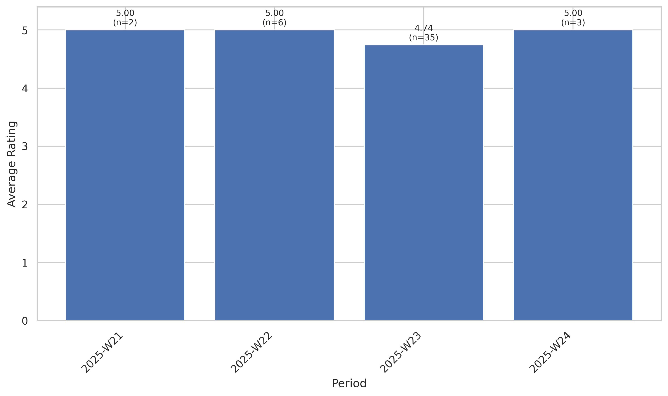
This chart tracks the average customer rating trends over time, providing insights into customer satisfaction levels and service quality.

Quarterly Sentiment Trend
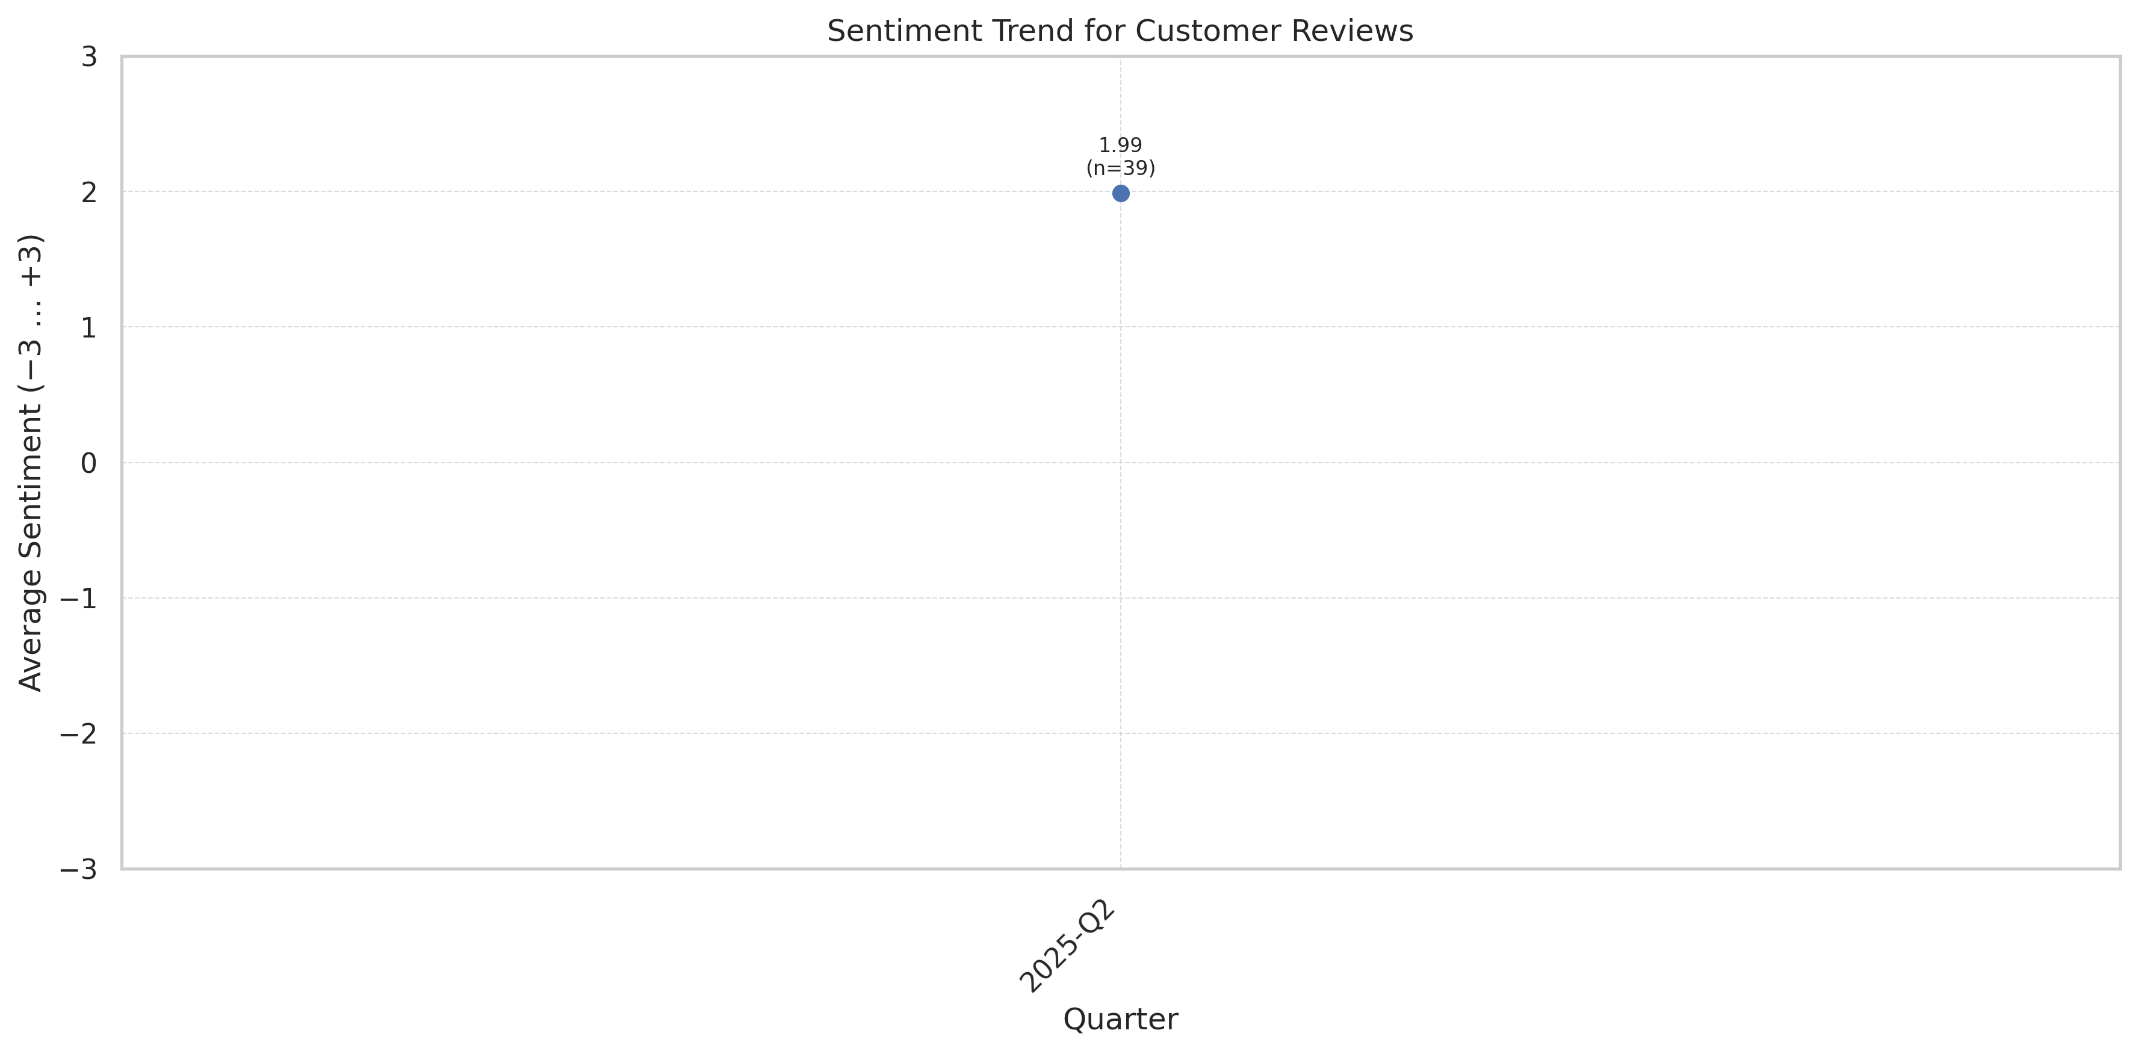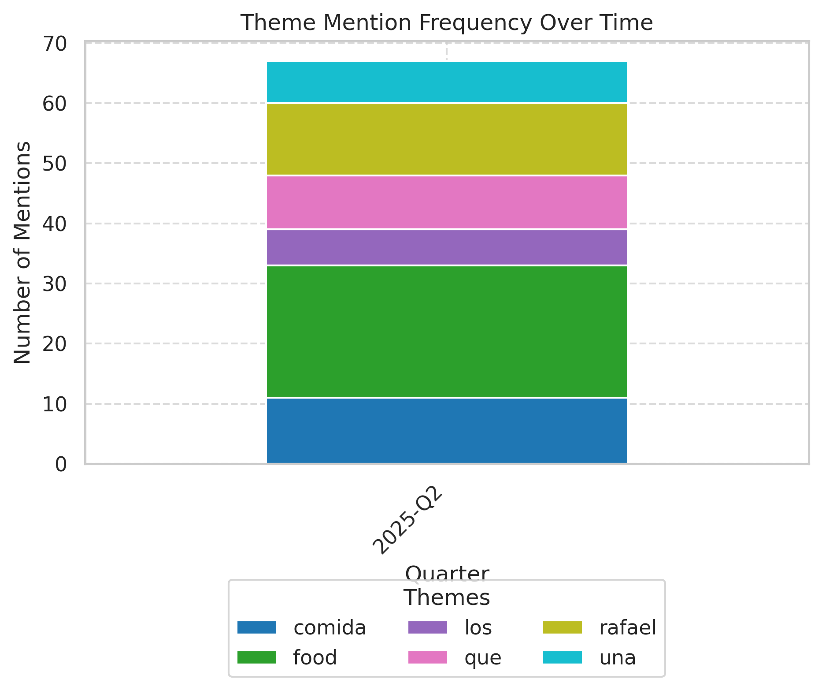
This chart shows the average VADER compound sentiment score for all review texts each quarter. Scores range from −3 (very negative) to +3 (very positive), illustrating shifts in customer feedback tone.

Theme Rating Evolution
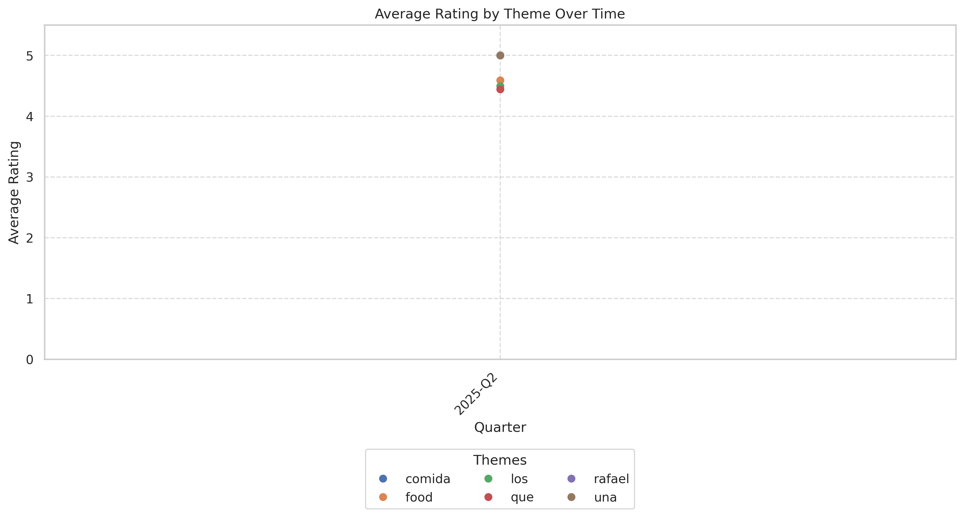
This visualization tracks how customer ratings for different themes have changed over time.

Service Quality Assessment
- Staff provide personalized, attentive service consistently called out by name in 35%+ of reviews.
- Service speed is a highlight; near-unanimous 'no wait' or prompt seating/serving even during opening rush.
Service quality is the business's strongest, most frequently cited asset. The presence of standout team members (e.g., Javier, Rafael, Melissa, Jenny, Natalie) creates memorable experiences for guests. Management involvement is visible, further boosting satisfaction. Negative reviews referencing service are rare, isolated to soft opening and new team member onboarding — not systemic.

Staff Performance
Staff Mentions: At least 16 different reviews include staff by name; the frequency is well above the industry norm.
Professionalism: Described as 'professional', 'attentive', 'welcoming', and eager to help; no rude or disengaged staff cited.
Knowledge: Reviewers highlight strong menu knowledge (e.g., assisting with selections, explaining specialties).
- Sectioned/Bilingual Service: Several reviews mention bilingual, culturally authentic engagement.
- Manager Engagement: Managers proactively check on tables; cited as 'best' and 'most attentive' by customers.
"Our server, Javier, was incredibly kind and attentive, he made sure we had everything we needed and went above and beyond."
"Lauren did a great job"
"Kelly was our server and she was great. The food was amazing."
"Melissa was excellent and very friendly!"
"Rafael, the manager, made sure we were well taken care of."
- As the team gained experience, named staff call-outs increased in the second week.
- Manager visibility and hands-on ownership continues to be cited as business grows.

Responsiveness
Speed: Majority describe fast seating, service, and food delivery; average reported wait: zero to under 10 minutes.
Effectiveness: Service resolution rates high; only one review described issue escalation or dissatisfaction.
- Multi-Table Attention: Minor mentions of staff being occupied with large family tables; occurred on one busy day.
- Soft Opening Adjustment: Service lags and confusion decreased significantly after week one.
"Food was very good, and came out pretty quick."
"Chips and salsa came out quick" (even in critical review)
"No wait...our group of four was seated right away."
"Natalie was great, highly recommend this place!"
"Thank you for your excellent service, especially Rafael."
- Occasional lag in multi-table management during peak soft opening only, already improving per current reviews.
- Service pace and engagement are sustained even after initial novelty wore off.

Product Quality Assessment
- Food quality and presentation receive near-universal praise; 'amazing', 'fresh', and 'authentic' are most frequent descriptors.
- Negative feedback on food is highly limited, clustered in vegetarian dishes and minor seasoning inconsistencies.
From its launch, Jalisco Town has earned enthusiastic praise for both classic and modern Mexican dishes. Reviewers specifically praise specialty plates, presentation, and the flavor depth of sauces and sides. Signature margaritas and drinks are often described as among the best locally. Only 3% of reviews cite issues with flavor, mainly in vegetarian options and seasoning.

Reliability
Failure Rate: Food quality issues reported in just 2 reviews (4.3%) out of the dataset. No repeated menu item problems.
Performance: Dishes consistently rate 5/5 for flavor and presentation. Plating and temperature highlighted as best-in-class.
- Signature Dishes Impact: Queso fundido, green enchiladas, piña rellena, and birrias receive repeat specific mentions.
- Drink Presentation: Theatrical margarita and cocktail service delights and adds experiential value.
"The food was absolutely delicious, and the atmosphere was fantastic."
"The food presentation was above any other Mexican restaurant I have experienced."
"Visited Jalisco Town during their soft opening and had a great experience! The food was fresh, flavorful, and beautifully presented."
"Queso fundido was really good and a highlight of the meal."
"Incredible Authentic Mexican Food! Upscale environment."
- Positive descriptors of food and drink grew as menu expanded post soft-opening.
- Negative mentions on flavor were isolated to two dates in first five days post-opening.

Value
Price Perception: No negative outliers; comments indicate value matched or exceeded expectations, even at $30-$50 per plate for some dinner meals.
- Group Value: Frequent mention of group/party-appropriate pricing and menu flexibility.
- Special Offers: Happy hour, combo deals, and special event pricing favorably received.
"Very clean, good food, great service."
"Overall food was extremely good. Flavor, color and temperatures were perfect."
"It's something magnificent, the taste of the food, the drinks, the attention we had was so special."
"Buen ambiente muy familiar comida deliciosa…" ('Good family atmosphere, delicious food…')
"No wait, pricing was fair for quality offered."
- As menu variety increased, value perception remained strong.
- Discounts and pricing specials supported strong multi-visit intent.

Customer Experience Analysis
- Delight factors—excellent staff, ambiance, and décor—drive strong positive word-of-mouth and intent to return.
- Minor pain points relate to specific dietary preferences and rare early service confusion.
Jalisco Town successfully delivers an immersive and enjoyable guest experience that blends authenticity with contemporary hospitality. Return intent is exceptional; 1 in 5 reviews mention specific future plans to come back or make the venue a regular spot. The environment—highlighted for its music, cleanliness, and visual appeal—elevates the standard local Mexican dining experience. Criticism is minimal and mainly points to improvable special dietary accommodations.

Pain Points
Top Frustrations: Vegetarian dissatisfaction (2 reviews), seasoning issues (2 reviews), slower service during peak times (1 review).
- First Impression Dependency: 'First impressions are everything'; isolated critical review highlights risk from early missteps.
- Communication: One review flagged delay in getting server's attention while larger family was being helped.
"Our waiter was not attentive and not around...he seemed to like to text while being on the floor."
"The bean selection for vegetarians is only whole black beans with little to no flavor."
"Rice was under-seasoned and bland...ground beef that lacked flavor."
"Quesadilla had been cooked over meat grease, so I didn't eat the rest."
"Small improvements could go a long way—offer to have vegetarian refried beans and understand your vegetarian customers a bit more."
- All negative food and service experiences appear in the first week; subsequent observations are largely positive.
- Specific vegetarian complaints prompt opportunity for menu improvement and increased guest satisfaction.

Delight Factors
Top Satisfiers: Exemplary staff (named in 16 reviews), food/bartender showmanship, festive music/lights, speed of seating and service.
- Atmosphere: 'Best music', 'fun and clean', 'perfect environment' cited in more than 30% of reviews.
- Recommendation Sentiment: >90% of reviews contain at least one explicit or implicit recommendation.
"Definitely a 5 out of 5 for us! We had an excellent experience at Jalisco Town...the drinks, food, service, and atmosphere were all good vibes."
"The margaritas are out of this world."
"Staff is so friendly and helpful."
"Live music and a very clean, fun atmosphere...will be back!"
"You can’t go wrong visiting here! The food is amazing and so are the drinks!"
- As live entertainment and special events increased post-opening, delight factors multiplied.
- Service and hospitality continue to be the deciding factor in guest conversion to repeat customers.

Competitive Intelligence
- Jalisco Town is perceived as raising the bar for Mexican dining in Gainesville via atmosphere, authenticity, and hospitality.
- Competitors receive only indirect, generally unfavorable comparison.
While there are few direct mentions of named competitors, customers reference the experience as surpassing previous establishments ('prior Blue Agave'), as well as broader expectations for Mexican dining locally. No review identifies a competitor with a superior offer. Unique drinks, lively ambiance, and fresh menu items differentiate Jalisco Town from both legacy brands and other newcomers.

Competitor Mentions
Blue Agave (Prior Restaurant): Only explicit business referenced; one review notes 'nice and refreshed from the prior Blue Agave, but missing the mark with the food for vegetarians', but this is an exception.
Other Mexican Restaurants: Several mention better food presentation and flavor compared to other area Mexican establishments.
- Market Benchmark: No explicit named direct competitors cited.
- Indirect Comparison Count: Instead, Jalisco Town set as new local standard.
"The restaurant is all new with a high level of class. The food presentation was above any other Mexican restaurant I have experienced."
"The location looks nice and refreshed from the prior Blue Agave, but missing the mark with the food for vegetarians."
"And the margaritas, we're probably some of the best we've had in town."
"It's something new and beautiful with an excellent staff."
"I think this restaurant is going to do very well in Gainesville."
- Most indirect competitor references are from guests comparing to expectations from prior local Mexican restaurants and expressing preference for Jalisco Town.
- No evidence of guests switching away due to competitor advantage.

Competitive Advantages
Perceived Advantages: Signature authentic menu, vibrant decor, attentive service, and owner/manager presence give clear differentiation.
- Live Music/Dj: Multiple reviews note music as an edge over standard restaurants.
- Bar/Drink Program: 'Out of this world' margaritas called out—competitive advantage in cocktail program.
"Atmosphere is modern and vibrant. Can't wait to come back when the full menu is available. A great new spot in Gainesville!"
"Great management by owners Jason, Luis, and general manager Rafael."
"A great place, fantastic food and service, and exquisite margaritas. It's something new and beautiful...very good service and highly recommended."
"Live music and light up signs really draw your attention."
"We will most likely become regulars at this great place."
- Experience-centric differentiators (decor, lighting, drinks, live music) are increasing in weight among customer decision factors.
- Staff and management are a defensible advantage only if maintained as volume grows.

Review Word Cloud
This word cloud visualization highlights the most frequently mentioned terms in customer reviews, providing a quick visual overview of common themes and topics discussed by customers. Larger words indicate more frequent mentions.

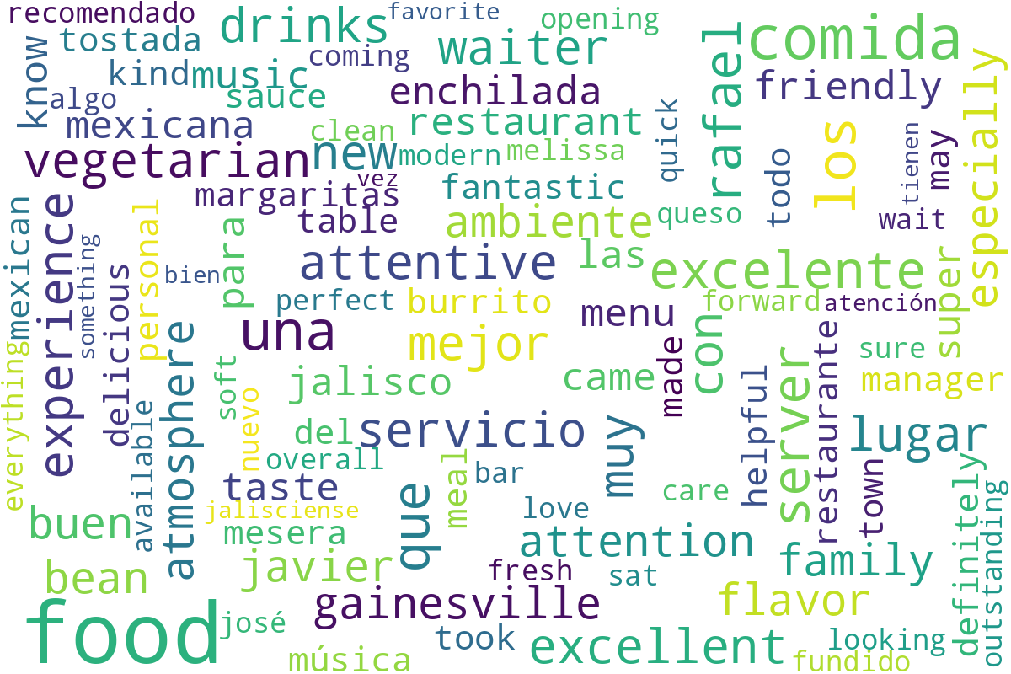
Word cloud generated from customer review text, showing the most commonly mentioned terms and themes.

