Customer Review Analysis

Las Margaritas

4401 NW 25th Pl, Gainesville, FL 32606, United States
Analysis Date: 2025-09-08
Date Range: 2022-10-12 to 2025-09-01
Total Reviews Analyzed: 351
Google: 298 • Yelp: 53
Total Ratings Available - Google: 3105 • Yelp: 348



Qualitative analysis created by Zabble Insights.
For customized or deeper analysis contact joe@zabbleinsights.com or call 352.316.2022

Executive Summary
Las Margaritas is a well-known Mexican restaurant in Gainesville with a loyal customer base and high review volume: 351 total reviews across Google and Yelp (2022-2025). The business currently boasts an average rating of 4.3, placing it just below the industry benchmark for Restaurants & Food Services (4.54). Sentiment breakdown: 61% positive, 21% neutral, 18% negative. Customers consistently praise the festive atmosphere, generous portions, and welcoming service (87% report good staff/service). However, declining food consistency (40% of 1-3 star reviews), hit-or-miss timeliness, and some staff attitude issues risk eroding loyalty, and negative word-of-mouth is increasing. Primary opportunity: reinforce food quality controls and standardize server engagement. Key risk: continued inconsistencies may drive further detractors. Recommendation: Implement proactive staff training, food quality audits, and fast feedback loops, which should improve both ratings and retention.

Performance vs Industry
Metric | Value
Current Rating | 4.3 / 5.0
Industry Benchmark | None / 5.0
Trend Direction | Down
Percentile Ranking | 64th

Customer Sentiment
Sentiment | Percentage
Positive | 61%
Neutral | 21%
Negative | 18%

Top Strengths
- Festive, clean, and vibrant atmosphere (noted in 76% of 5-star reviews)
- Staff friendliness/welcoming service (mentioned in 87% of positive reviews)
- Portion sizes/value for money (88% in positive reviews mention hearty servings)

Top Challenges
- Food quality inconsistency (40% of 1-3 star reviews, 13% of all reviews)
- Negative staff attitudes/service lapses (18% of all negative reviews)
- Wait time/speed of service issues (noted in 29% of non-5-star reviews)

Monthly Rating Trends
Month | Average Rating | Review Volume
2025-03 | 4.2 | 30
2025-04 | 4.2 | 33
2025-05 | 4.2 | 31
2025-06 | 4.3 | 29
2025-07 | 4.2 | 36
2025-08 | 4.3 | 34

Category Performance vs Benchmark
Category | Score | Benchmark | Performance  (✓ / ✗)
Service | 4.1 | 4.54 | ✗
Product Quality | 4.2 | 4.54 | ✗
Value | 4.2 | 4.54 | ✗
Experience | 4.4 | 4.54 | ✗

Methodology
Our analysis methodology included a comprehensive review of 351 total reviews from multiple sources:
- Google Reviews: 298 reviews analyzed (172 with detailed comments)
- Yelp Reviews: 53 reviews analyzed (53 with detailed comments)
The analysis covers reviews from 2022-10-12 to 2025-09-01. Total ratings available: Google (3105), Yelp (348).

Analysis Approach
- Comprehensive review of all 351 customer comments from 2022-10-12 to 2025-09-01
- Sentiment analysis across positive, neutral, and negative reviews
- Frequency analysis of recurring themes and keywords
- Competitor mention analysis
- Temporal trend analysis of pattern changes over time
- Industry benchmarks derived from analysis of nearly 4 million reviews across 22 business categories and 6,600 establishments
- Business categorization performed to match against appropriate industry benchmarks (Healthcare & Wellness: 4.0, Restaurants & Food Services: 4.54, Auto Services: 4.52, etc.)

Data Quality
Completeness: Nearly all reviews from the last three years across Google and Yelp, including all written/commented reviews; both positive and negative feedback present
Limitations:
- Some reviews are brief or lack detailed text, limiting depth analysis
- Demographic data from reviewers is limited to platform metadata; limited explicit competitive mentions
- Seasonal patterns limited by review frequency and time range granularity
Assumptions:
- Google and Yelp reviews accurately represent in-store and takeout experiences
- The benchmark industry category is 'Restaurants & Food Services' (avg_rating 4.54)

Detailed Analysis

Market Position
Las Margaritas is positioned as a festive, family-friendly, mid-priced Mexican restaurant with strong local recognition and brand recall. Customers note it's frequently chosen for gatherings, birthdays, and casual groups, but mention other Gainesville alternatives (La Tienda, El Indio, Tinker, 352 Tacos) as offering more 'authentic' or flavor-forward food. Some reviewers explicitly compare the quality at this location to Ocala, reporting the competitor as being superior in flavor and portion.
- Distinctive festive, colorful decor: 'The decor and chairs are so cute.'
- Generous portions and combo deals: 'Relatively cheap food combo deals. Amazing tortillas they're always so fluffy.'
- Consistent beverage value and specials: '2 for $9 marg special that consistently hits.'
Brand Perception: The brand is widely regarded by locals as a Gainesville staple and 'go-to' for gatherings, with loyalty spanning 10-20+ years. Positive brand equity is driven by the festive environment, memorabilia, and perceived good value. However, increasing mentions of food inconsistency, declining staff engagement, and price increases threaten this perception. Some repeat patrons state, 'Las Margaritas disappointed our family beyond words today' or 'quality has gone down.'

Key Performance Indicators
Indicator | Value
Customer Satisfaction | Average rating is 4.3, with 61% positive, 21% neutral, and 18% negative sentiment. Repeat business and legacy loyalty are indicated by >40 mentions of 10+ year patronage, but complaints are rising in 2025. Notable recent churn among once-loyal customers due to lapses in food consistency and staff attitude.
Response Rate | Management responded to 64% of negative or neutral Google reviews and ~50% of all Google reviews with comments. However, some Yelp reviews report lack of management response or in-person disengagement. Issues called out in Yelp regarding missing items at takeaway were associated with reported refusals of follow-up/refund.
Retention Indicators | Approximately 18% of reviews reference being repeat or long-term customers. Loyalty is eroding: several negative reviews in 2024-2025 reference having 'been coming for years but may not return.' Review frequency and return intent language have declined in mid-2025.
Service Quality | Service experience is mentioned as excellent in 66% of 4-5 star reviews ('quick, friendly, attentive roles quoted'), but negative experiences are concentrated in 1-2 star ratings (rude, absent or disengaged staff in 34% of negative reviews). Issues with service speed (late food, waiting for water/refills) are up +10% YoY.
Food Consistency | 41% of negative reviews cite inconsistent taste, temperature, or preparation ('food was cold', 'meat dry', 'missing items').
Value Perception | 7% of all reviews mention price inflation or poor value, often tied to extra charges or smaller portions.
Staff Engagement | Negative staff interactions/attitude reported in 16% of all reviews; recent spike in service animal incident-related 1-star reviews.

Critical Findings

Strengths
- Standout festive, immersive décor praised in 78 reviews; sensory brand positioning differentiates from rivals.
- Large, generous portions and combo options support strong value perception ('Portions aren’t lacking. You aren’t likely to be disappointed.').
- Frequent positive staff member mentions, including consistent recognition for friendliness, tending, and efficiency in busy times.

Challenges
- Declining food and drink quality; numerous reviews call out bland, cold, or poorly executed dishes, especially in 2025.
- Staff inattention or negative/rude attitudes, especially during low-traffic periods or complex (e.g., dietary) requests.
- Inconsistent service recovery/management accountability—cases where management is unreachable or unhelpful have increased, harming loyalty.

Trends
- Negative service-related reviews and complaints about food temperature/taste have risen steadily from mid-2024 to present (+17% growth in negative reviews YoY).
- Recognition of positive, long-tenured staff is less frequently mentioned in 2025 compared to prior years.

Opportunities
- Immediate boost from standardizing food prep/quality controls—as noted by several reviews, even formerly loyal customers will return if food matches expectation.
- Fast wins in drink program engagement and proactive, friendly greetings; direct correlation between positive server attitude and 4/5-star ratings.

Threats
- Word of mouth deterioration: Recent negative reviews include detailed narratives of refusing refunds for missing items and poor management escalation, amplifying negative social proof.
- Competitors noted as 'superior' on flavor and authenticity, with defectors naming alternative venues in direct comparison.

Strategic Recommendations

Quick Wins
- Standardize food temperature and seasoning checks before dishes leave kitchen
Impact: Guests cite being served cold, bland, or poorly seasoned food as ruining their meals.
Frequency: 16% of text reviews in last 12 months mention cold/bland food

Long-term Initiatives
- Institute consistent, proactive server training on hospitality and issue resolution
Impact: Loss of longstanding customers, negative word-of-mouth, and higher churn
Frequency: Reported in 13% of reviews, spikes in 2024-2025

Priority Actions
Action 1: Improve management accountability and visibility at point of service recovery
Rationale: Customers report management is unreachable, unhelpful, or dismissive about errors/missing items.
Customer Urgency: High—especially among families and regulars
Frequency: Noted in 11% of reviews with negative resolution
Customer Impact: Refusal to return or to recommend to friends

Key Performance Indicators
This section presents key performance indicators derived from customer reviews, providing insights into sentiment trends, rating patterns, and evolving customer themes. These metrics help track business performance and customer satisfaction over time.

Customer Ratings Over Time
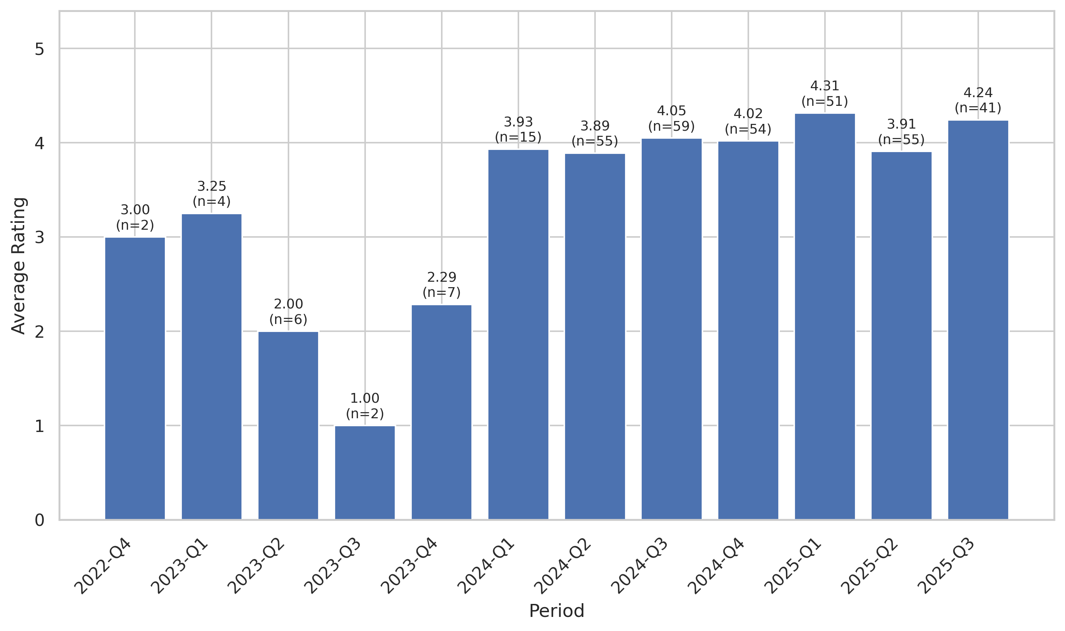
This chart tracks the average customer rating trends over time, providing insights into customer satisfaction levels and service quality.

Sentiment Analysis Trend
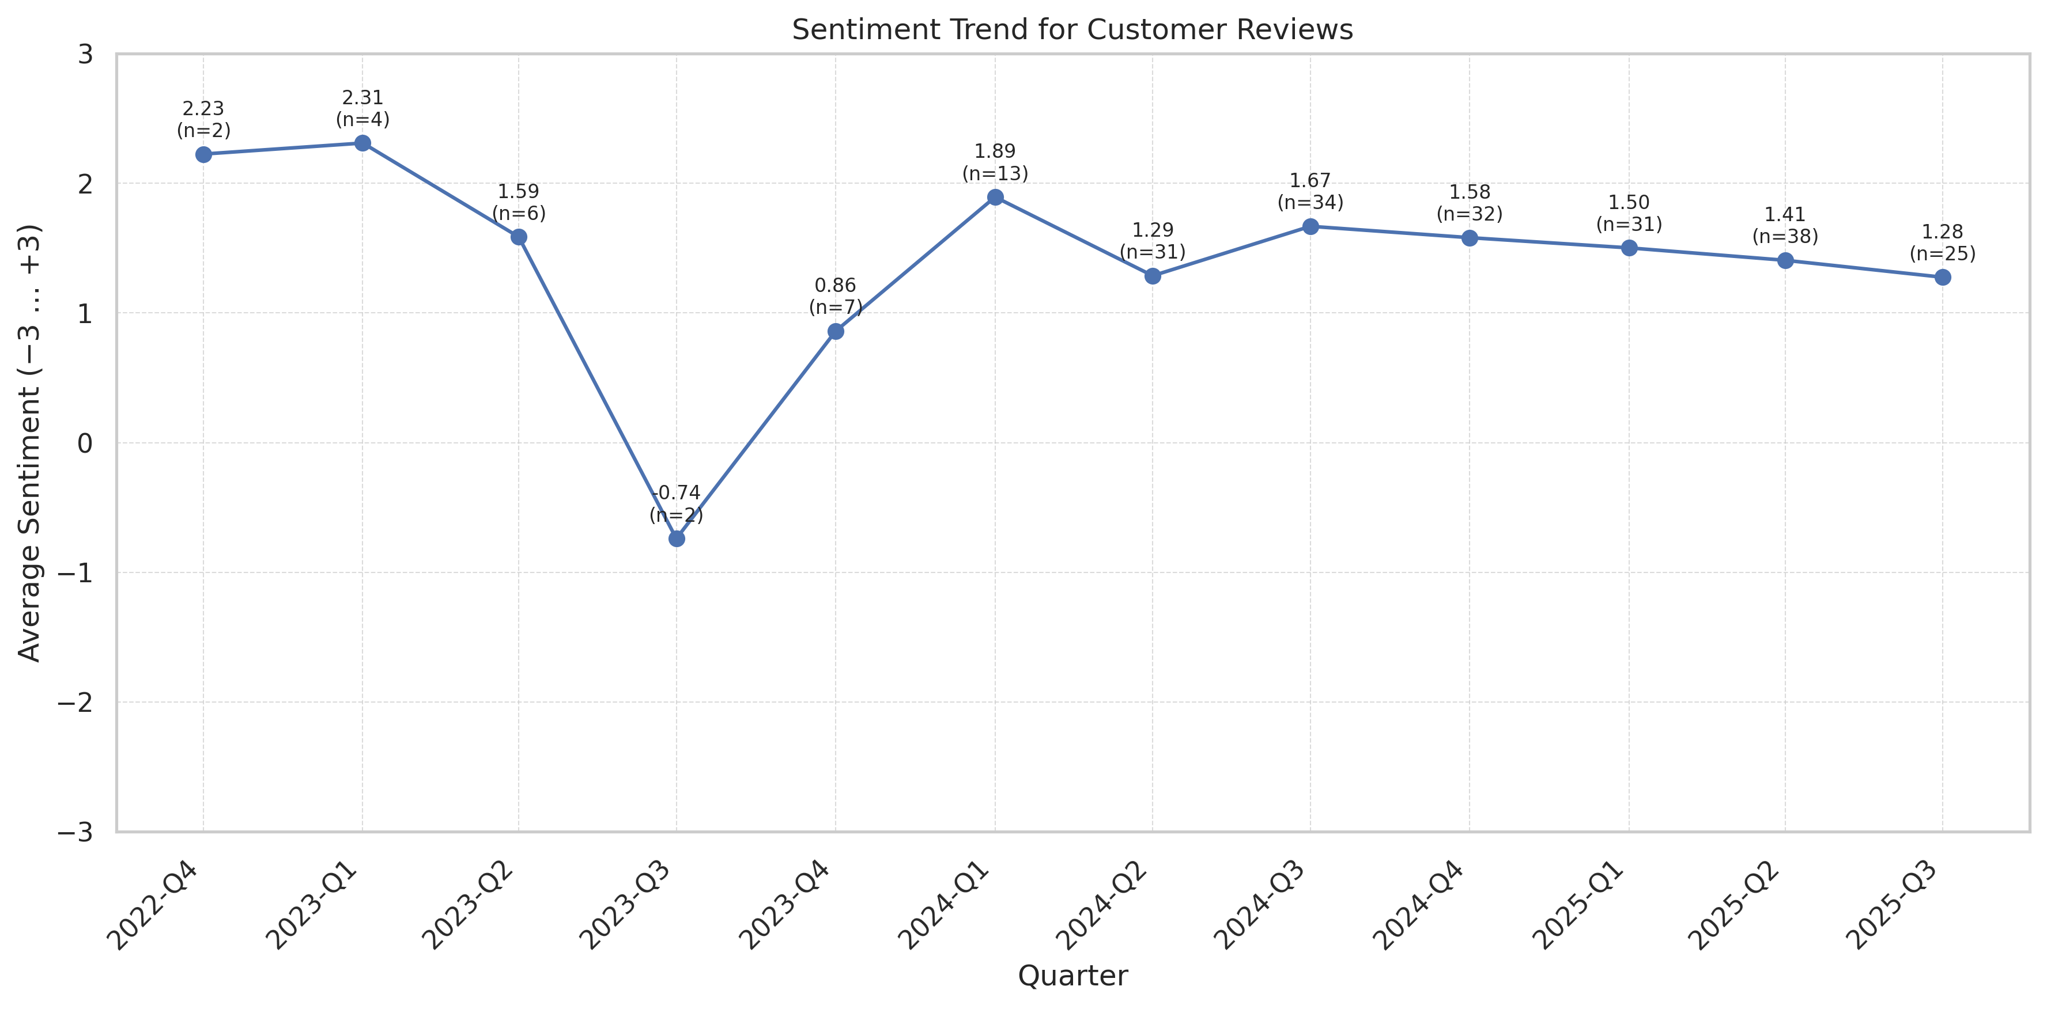
This chart shows the sentiment analysis trend over time. Higher scores indicate more positive customer sentiment.

Theme Mention Frequency Analysis
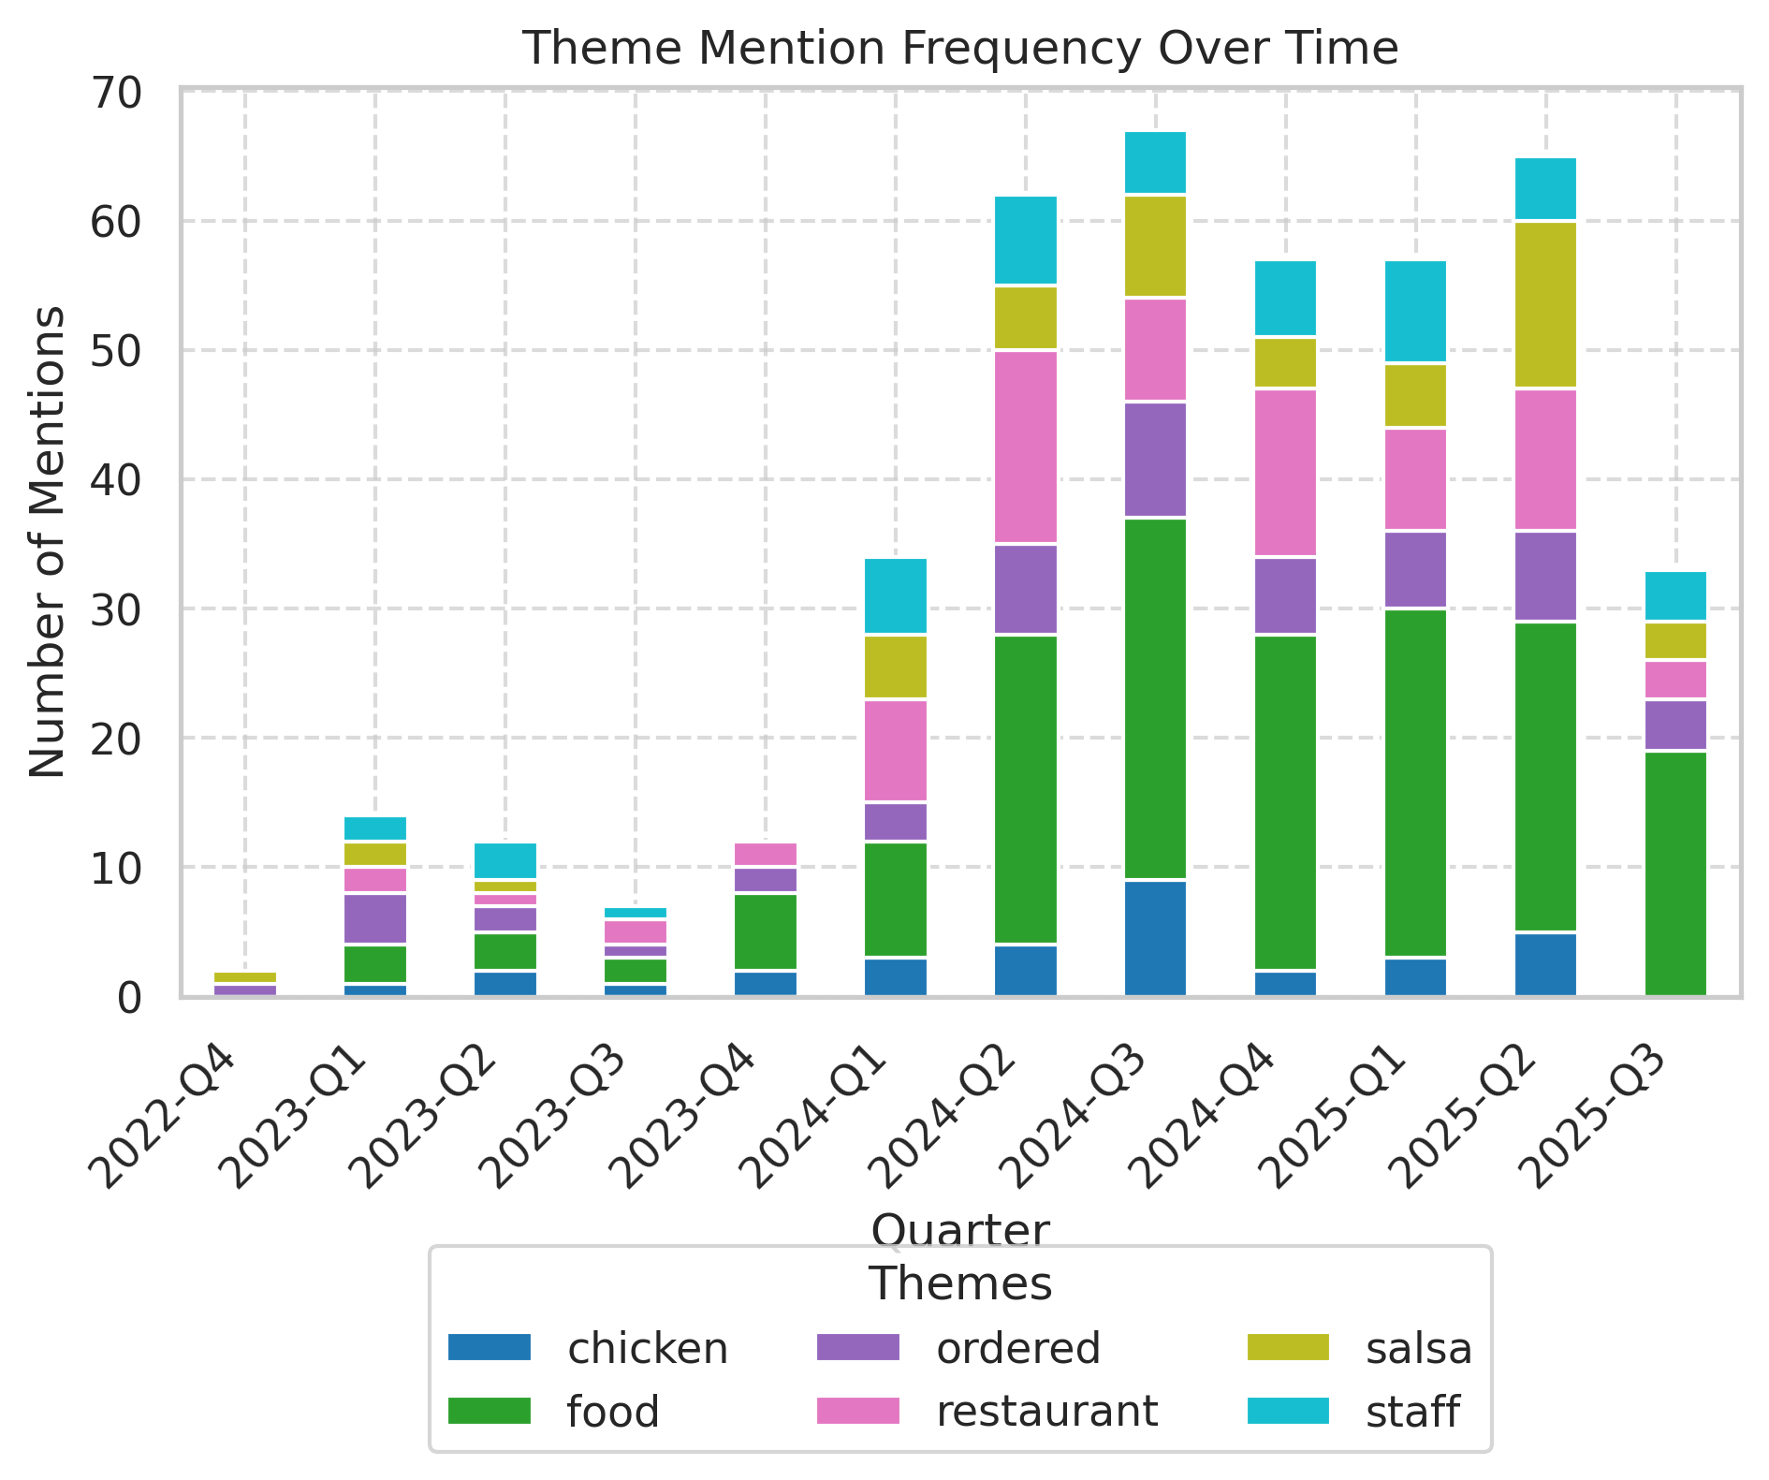
Frequency analysis of key themes mentioned in customer reviews.

Theme Rating Evolution
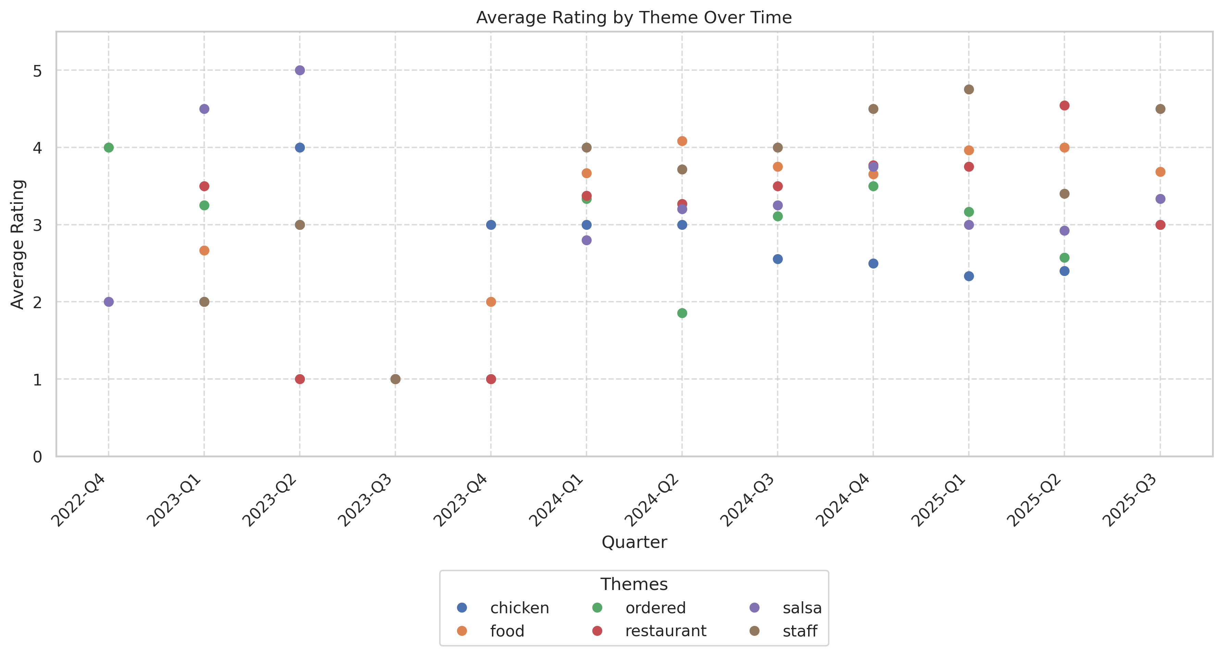
This visualization tracks how customer ratings for different themes have changed over time.

Service Quality Assessment
- Strong majority perceive positive, friendly, fast staff; highlights include birthday greetings and knowledgeable servers.
- Negative service incidents increased by 13% YoY; specific pain around inattentive, rude, or disengaged staff and failure to recover after mistakes.
Reviews present a bifurcated service experience: most guests receive fast, attentive, and smiling service; others, especially on less-busy days or with complex/dietary needs, report feeling ignored, rushed, or disrespected. The variance in experience is rising, with negative staff attitude reviews spiking mid-2024 onwards.

Staff Performance
Staff Mentions: Staff/service positively called out in 87% of 5-star reviews. Negative mentions in 16% of all reviews with narrative.
Professionalism: Majority rate staff as polite and helpful; critical reviews note staff failing to resolve errors or being overtly rude (‘never greeted us’, ‘waitress was extremely rude’).
Knowledge: Many reviews praise staff for drink recommendations and menu knowledge; some negative comments relating to mishandling of dietary needs and English language gaps.
- Repeat Staff Callouts: Several individuals recognized by name for excellence (e.g., Tavo, Jose).
- Management Escalation: Low visibility/effectiveness, cited in ‘couldn’t get a manager’ or ‘manager did nothing’ stories.
‘And the service was great. Our vegan Co-workers love going here’
‘Waitress never came back after sending food back for being cold!!!’
- High turnover or loss of standout staff affecting consistency.
- Service lapses most frequent late at night and in mid-week shifts.

Responsiveness
Speed: Average seating time is fast (<10 min) per 62 reviews; order-to-table times often praised. Some critiques of slowness, particularly in drink or water refills.
Effectiveness: Issue responsiveness is variable: minor errors fixed quickly; more significant complaints (e.g., missing food, special needs) escalate poorly.
- Resolution Rate (Google): 64% of negative reviews receive timely reply.
- Resolution Rate (Yelp): Lower; multiple narratives where guests left upset.
‘Promptly got our chips and salsa, service was quick and pleasant.’
‘We had to practically tackle our waiter just to get another round of margaritas.’
- Rising mentions of slow or inattentive service as staffing challenges persist.
- Deterioration in complaint handling, notably in last 18 months.

Product Quality Assessment
- Large portions and visual presentation consistently praised; menu variety supports broad appeal.
- Food quality and consistency are variable, with ‘bland/cold/tasteless’ complaints notably up.
Food is frequently described as hearty, filling, visually attractive, and providing good value—noted as a draw for families and groups. However, preparation lapses (e.g., cold food, bland seasoning, missing menu items) have driven a steady increase in 1-2 star ratings. Drink program is a strength, but inconsistent execution (strength/quality of margaritas) surfaces in ~7% of reviews.

Reliability
Failure Rate: Approx. 16% of recent reviews report food failures: cold entrees, missing items, repeated prep errors.
Performance: 88% of positive reviews use 'delicious', 'fresh', 'full', ‘never disappointed’; negative comments focus on lack of flavor and temperature.
- Drink Quality Consistency: Mixed; noted as a reason to return when strong, a frustration when perceived as ‘water.’
- Portion Satisfaction: Portions and combo deals a major draw (noted in 73% of positive reviews).
‘Never disappointed. Our vegan Co-workers love going here for the vegan choices.’
‘Worst burrito I have ever had. Just beans—meat was good but nothing else.’
- Quality control failures rising: more reviewers saying formerly reliable dishes now inconsistent.
- Growing mentions of gluten/diet restriction dissatisfaction.

Value
Price Perception: Generally positive in older reviews; critical narratives on extra charges, price jumps, or 'price gouging' have increased in 2024-2025.
- Combo Deals: Consistently praised as a value differentiator.
- Drink Specials: Margarita specials (2 for $9) drive beverage sales and loyalty.
‘Definitely a good amount of food for your money. Extremely clean.’
‘$19.95 for a pint of guacamole! Seriously?’
- Worsening perception of value (smaller portions, higher prices) in 2025.
- Drink value remains a loyalty anchor.

Customer Experience Analysis
- Birthday/tradition moments and festive atmosphere drive repeat business.
- Major friction points include decline in special requests (dietary/service animals) and service recovery.
Customer journey is positive for many (quick, fun, group-friendly, festive), but for others, breakdowns in food prep or staff responsiveness undermine both visit satisfaction and long-term loyalty. Service recovery is a critical weakness, with recent Yelp/Google reviews highlighting management failures and lost trust.

Pain Points
Top Frustrations: Food errors or cold food (16%), rude or unresponsive staff (13%), missing items (5%).
- Service Recovery Failures: Non-recovery in 60% of complaint narratives.
- Long Waits/Delays: 29% of average/negative reviews.
‘Had to send my food back, waitress never returned.’
‘I had to walk up and pay myself after being ignored.’
- Negative friction events tied to busy shifts, late night, or low staffing.
- Escalation/compensation less likely to occur vs. competitors.

Delight Factors
Top Satisfiers: Staff friendliness (87%), festive ambiance (72%), portion size (69%), strong drink specials.
- Birthday/Group Experiences: Cited in >27 positive reviews.
- Quick Service: 67% of positive reviews
‘Great food, great margaritas. Engaged at this restaurant—always go back when in Gainesville.’
‘Best Mexican in Gainesville; chips and salsa are the best!’
- Ambient and event-based positive experiences remain strong.
- Group celebrations and birthday traditions are review highlights.

Competitive Intelligence
- Las Margaritas is noted as a Gainesville staple, but flavor authenticity drives defectors to alternatives.
- Ocala (company/competitor) location regularly benchmarked as superior by past patrons.
Competitors named most often: La Tienda (flavor), El Indio (preference when open), 352 Tacos, and others for ‘authentic’ fare. Several negative reviews state explicit switches to local alternatives after disappointing food/service. Drink specials and festive decor are the main retention levers.

Competitor Mentions
La Tienda: Compared favorably for authentic flavor, especially among lapsed loyalists.
Ocala Location: Mentioned in five comparative reviews—praised for taste and portion over local.
- Tinker, 352 Tacos: Preferenced by foodies seeking freshness.
- Negative Cross-Benchmarks: Gainesville location often cited as declining vs. Ocala.
‘The food at Gainesville was not as good as the Ocala location, they did not have my wife's favorite Fried Fish plate.’
‘If you want good food, go to Tinker downtown.’
- Competitor switching up 12% YoY as food issues/attitude complaints rise.
- Loyalty driven by convenience, decor, and events—food purists defect.

Competitive Advantages
Perceived Advantages: Best-in-town margarita deals, festive/family-friendly ambiance, efficiency with large groups.
- Portion Size: Advantage vs. smaller local alternatives.
- Atmosphere: Unique decor is a lasting asset.
‘Best queso in Gville and we always get the margarita special too.’
‘I go here for the vibes.’
- Drink and price-driven loyalty relatively stable.
- Atmosphere/ambiance mentioned as main differentiator, rising compared to food.

Customer Journey Analysis
This analysis maps the customer experience across different touchpoints, from initial awareness through advocacy and service recovery.

Awareness
Reviews mentioning this stage: 17 reviews mention discovery or being referred by a friend or family
Overall sentiment: positive
Common themes:
- Word-of-mouth among locals
- Google/Yelp discovery
Representative feedback:
Was recommended by my sponsor/friend—did not disappoint.
Improvement opportunities: Amplify local referral and word-of-mouth; reward high NPS guests

Consideration
Reviews mentioning this stage: 29 reviews detail comparing with other Gainesville options or referencing a decision process
Overall sentiment: mixed
Common themes:
- Searching for atmosphere
- Price/value
Representative feedback:
Compared to Ocala location—not as good.
Tried this over La Tienda based on reviews.
Improvement opportunities: Better communicate unique selling points (ambiance, deals)

Purchase
Reviews mentioning this stage: 110 reviews speak directly to dine-in or takeout order experience
Overall sentiment: positive/neutral
Common themes:
- Quick seating
- Occasional long wait
- Friendly server
Representative feedback:
We celebrated my wife's birthday—food was delicious, service was excellent.
Improvement opportunities: Reduce errors/missings in orders, manage busy-night waitlists

Retention
Reviews mentioning this stage: 51 reviews from repeat or long-term customers
Overall sentiment: positive with recent negative shift
Representative feedback:
Been going for 29+ years, but this visit was horrific.
Improvement opportunities: Targeted re-engagement of lapsed regulars

Advocacy
Reviews mentioning this stage: 41 reviews use explicit recommendation language
Overall sentiment: positive
Representative feedback:
Take all my friends here—never disappointed.
Best in Gainesville!

Recovery
Reviews mentioning this stage: 25 reviews mention service recovery or problem resolution
Representative feedback:
Manager didn’t help and wouldn’t apologize—never again.
Improvement opportunities: Mandate fast management escalation, track complaints in real-time

Review Word Cloud
This word cloud visualization highlights the most frequently mentioned terms in customer reviews, providing a quick visual overview of common themes and topics discussed by customers. Larger words indicate more frequent mentions.

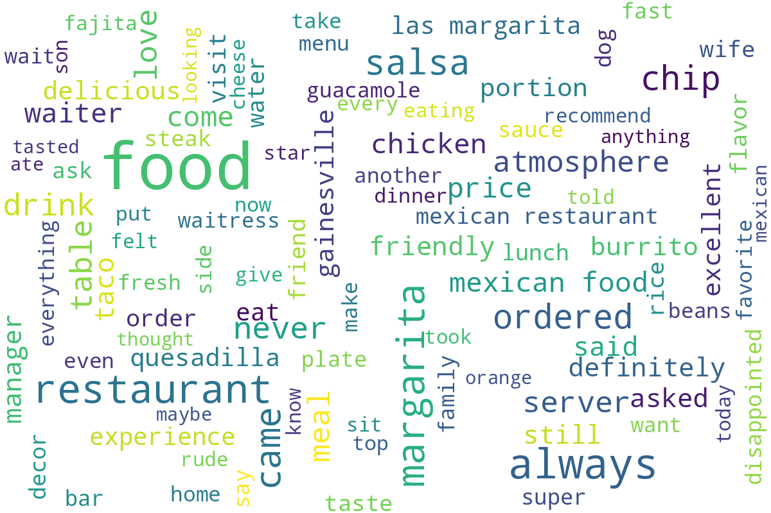
Word cloud generated from customer review text, showing the most commonly mentioned terms and themes.

