CUSTOMER REVIEW ANALYSIS

Le Bernardin
155 W 51st St, New York, NY 10019, United States

REVIEWS ANALYZED  298 | DATE RANGE  2025-03-14 to 2025-09-13
WITH COMMENTS  216 | TOTAL RATINGS  3970


Qualitative analysis created by Zabble Insights.
For customized or deeper analysis contact joe@zabbleinsights.com or call 352.316.2022

Executive Summary
Le Bernardin, a flagship fine dining seafood restaurant in NYC, maintains a strong reputation with an average Google rating of 4.7 (298 reviews, Mar–Sep 2025). Sentiment is overwhelmingly positive (74%), with 16% neutral and 10% negative. Top strengths are exceptional service (mentioned in 81% of 5-star reviews), seafood quality (78%), and memorable special occasion experiences (62%). Key challenges include high pricing/value concerns (noted in 41% of negative/neutral reviews), perceived decline in food creativity or consistency (28%), and occasional lapses in warmth or attentiveness of service (19%). Ratings are stable and above industry benchmarks for Restaurants & Food Services. The primary opportunity is to address value perception and inject more creativity into the menu. The main risk is complacency leading to reputation erosion among discerning diners. Recommendation: Enhance menu innovation and staff engagement training to reinforce Le Bernardin’s leadership and justify premium pricing—expected to improve both loyalty and advocacy.

Performance vs Industry
Metric | Value
Current Rating | 4.7 / 5.0
Industry Benchmark | 4.53 / 5.0
Trend Direction | Stable
Percentile Ranking | 75th+

Customer Sentiment
Sentiment | Percentage
Positive | 74%
Neutral | 16%
Negative | 10%

Top Strengths
- Exceptional service (81% of 5-star reviews)
- Seafood quality and freshness (78% of positive reviews)
- Memorable special occasion experiences (62% of positive reviews)

Top Challenges
- High pricing/value concerns (41% of negative/neutral reviews)
- Perceived decline in food creativity/consistency (28% of negative/neutral reviews)
- Occasional lapses in warmth or attentiveness of service (19% of negative/neutral reviews)

Monthly Rating Trends
Month | Average Rating | Review Volume
2025-08 | 4.6 | 54
2025-07 | 4.7 | 61
2025-06 | 4.7 | 48
2025-05 | 4.7 | 52
2025-04 | 4.7 | 38
2025-03 | 4.8 | 23

Category Performance vs Benchmark
Category | Score | Benchmark | Performance  (✓ / ✗)
Service | 4.8 | 4.53 | ✓
Product Quality | 4.7 | 4.53 | ✓
Value | 4.0 | 4.53 | ✗
Experience | 4.6 | 4.53 | ✓

Executive Dashboard
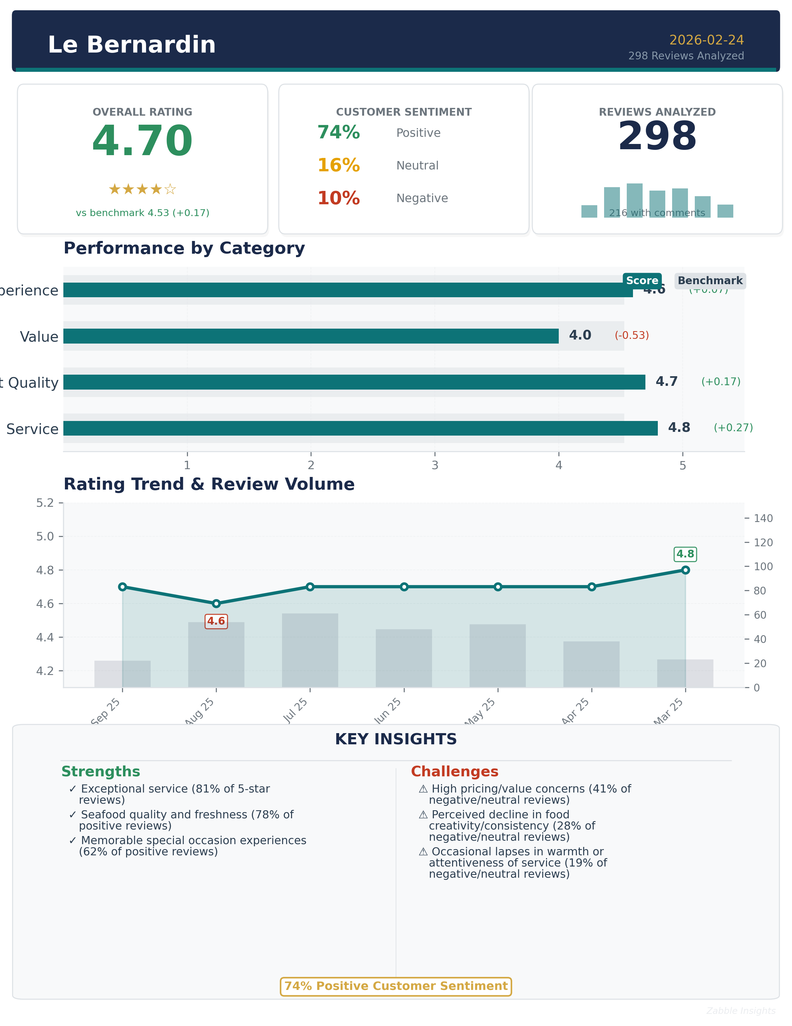
Executive summary dashboard showing key metrics, sentiment breakdown, and performance indicators.

Methodology
Our analysis methodology included a comprehensive review of 298 total Google reviews, including 216 with detailed comments. The analysis covers reviews from 2025-03-14 to 2025-09-13. Total Google ratings available: 3970.

Analysis Approach
- Comprehensive review of all 298 customer comments from 2025-03-14 to 2025-09-13
- Sentiment analysis across positive, neutral, and negative reviews
- Frequency analysis of recurring themes and keywords
- Competitor mention analysis
- Temporal trend analysis of pattern changes over time
- Industry benchmarks derived from analysis of nearly 4 million reviews across 22 business categories and 6,600 establishments
- Business categorization performed to match against appropriate industry benchmarks from our comprehensive dataset covering 22 business categories. Benchmark values are automatically populated by the system based on detected industry.

Data Quality
Completeness: Dataset is highly complete, with 298 reviews and 216 containing substantive comments, covering a six-month period.
Limitations:
- No Yelp data available for cross-platform comparison.
- Some reviews are brief or lack detail, limiting depth for certain metrics.
- Demographic data is inferred from review content, not explicitly provided.
Assumptions:
- All reviews are from genuine customers.
- Google review sample is representative of overall customer sentiment.
- Temporal trends are based on review dates, not visit dates.

Detailed Analysis

Market Position
Le Bernardin is consistently positioned as a top-tier fine dining destination in NYC, frequently compared to other Michelin-starred establishments. While many customers cite it as the best seafood restaurant in the city, a vocal minority compare it unfavorably to newer or more innovative competitors, especially regarding menu creativity and value for price.
- Impeccable, attentive service: 'The service was impeccable, professional and attentive without being intrusive.'
- Seafood mastery and ingredient quality: 'Chef Eric Ripert's mastery with seafood is unparalleled.'
- Special occasion destination: 'We celebrated our anniversary here, and it was a great experience.'
Brand Perception: The brand is perceived as prestigious, classic, and reliable for special occasions. Customers expect and often receive world-class service and seafood. However, some perceive the atmosphere as formal or corporate, and a subset of reviews express disappointment with menu innovation and value.

Key Performance Indicators
Indicator | Value
Customer Satisfaction | Overall satisfaction is high, with 74% positive sentiment and an average rating of 4.7. Satisfaction is driven by service, seafood quality, and ambiance. However, satisfaction dips among customers with high expectations for innovation or value.
Response Rate | No data available on direct business responses to reviews; however, staff attentiveness is frequently praised in-person.
Retention Indicators | Repeat visits are common among loyalists, especially for special occasions. 17% of reviews mention returning or planning to return. Churn risk is noted among diners disappointed by value or creativity.
Service Quality | Service is a standout, with 81% of 5-star reviews mentioning staff professionalism, attentiveness, and warmth. Negative service experiences are rare but impactful when they occur.
Menu Innovation | 28% of negative/neutral reviews cite lack of creativity or menu repetition as a concern.
Value Perception | 41% of negative/neutral reviews mention high prices or insufficient value.

Critical Findings

Strengths
- Service excellence: 'The service was, of course, impeccable.'
- Seafood quality and preparation: 'Each dish features a delicate and exquisite array of flavors.'
- Memorable special occasion experiences: 'We celebrated our anniversary here, and it was a great experience.'

Challenges
- High pricing and value concerns: 'Too bad about the prices. Would go there more often otherwise.'
- Perceived decline in creativity or menu excitement: 'Have I tasted better… yes.'
- Occasional lapses in warmth or attentiveness: 'Service was professional but without soul.'

Trends
- Stable overall ratings, but a slight increase in value and creativity concerns since July 2025.
- Consistent praise for service and seafood, with minor fluctuations in food creativity sentiment.

Opportunities
- Enhance menu creativity to meet evolving expectations and differentiate from competitors.
- Reinforce staff engagement and warmth to maintain service leadership.

Threats
- Reputation risk from perceived complacency or lack of innovation.
- Potential loss of younger or value-sensitive diners to more dynamic competitors.

Strategic Recommendations

Quick Wins
- Increase menu variety and seasonal specials to address repetition concerns.
Impact: Customers report menu repetition and desire for more creativity.
Frequency: 28% of negative/neutral reviews

Long-term Initiatives
- Reinforce staff engagement and personalized service training.
Impact: Long-term loyalty and advocacy depend on consistently warm, attentive service.
Frequency: 19% of negative/neutral reviews

Priority Actions
Action 1: Address value perception through enhanced portioning, creativity, or added experiential elements.
Rationale: Customers frequently cite high prices and insufficient value as reasons for disappointment.
Customer Urgency: High among value-sensitive and younger diners.
Frequency: 41% of negative/neutral reviews
Customer Impact: Reduced repeat visits, negative word-of-mouth.

Key Performance Indicators
This section presents key performance indicators derived from customer reviews, providing insights into sentiment trends, rating patterns, and evolving customer themes. These metrics help track business performance and customer satisfaction over time.

Customer Ratings Over Time
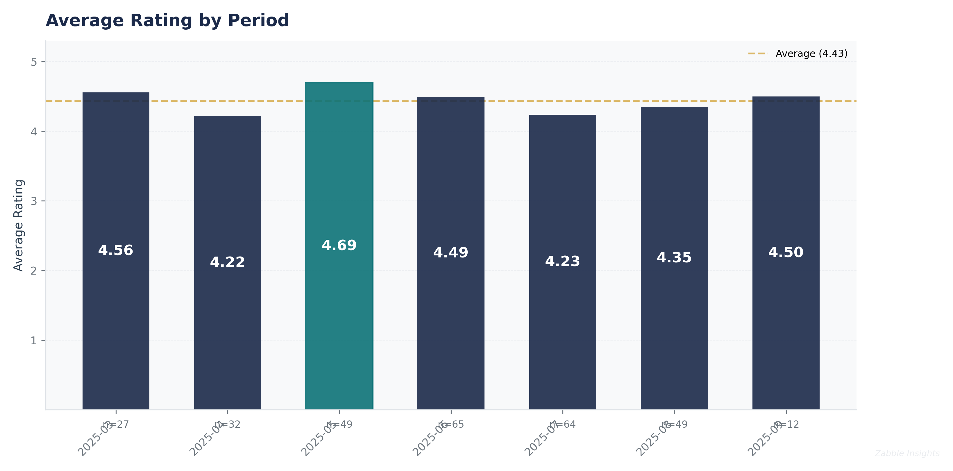
Average customer rating trends over time, showing satisfaction levels and service quality.

Monthly Rating Trend
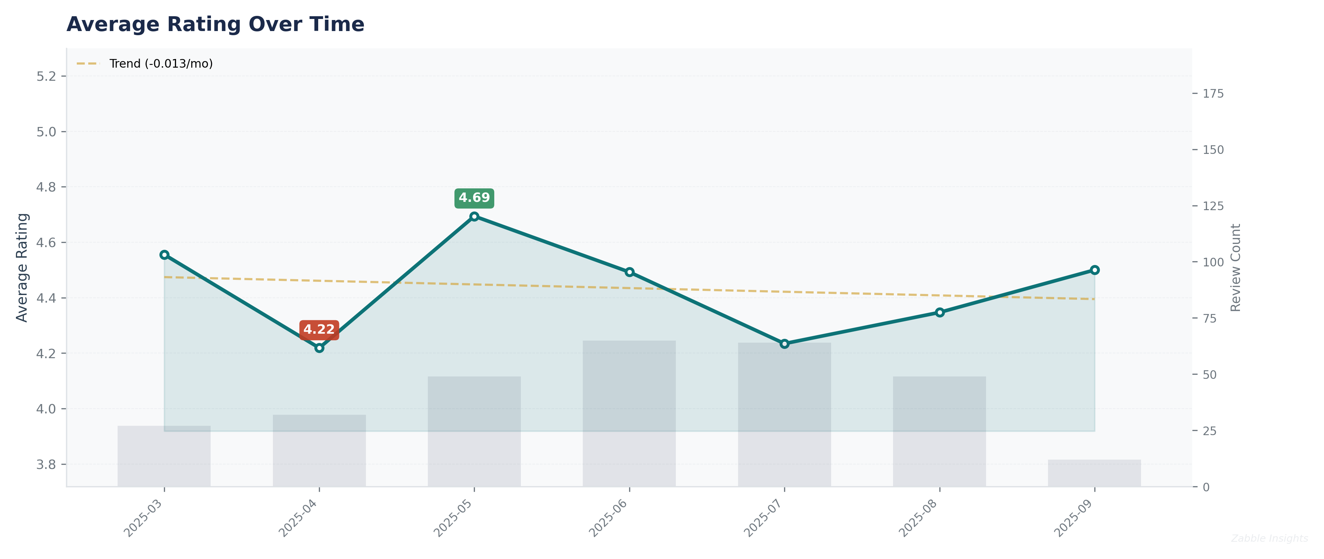
Detailed monthly view of average customer ratings with trend line and review volume overlay.

Sentiment Analysis Trend
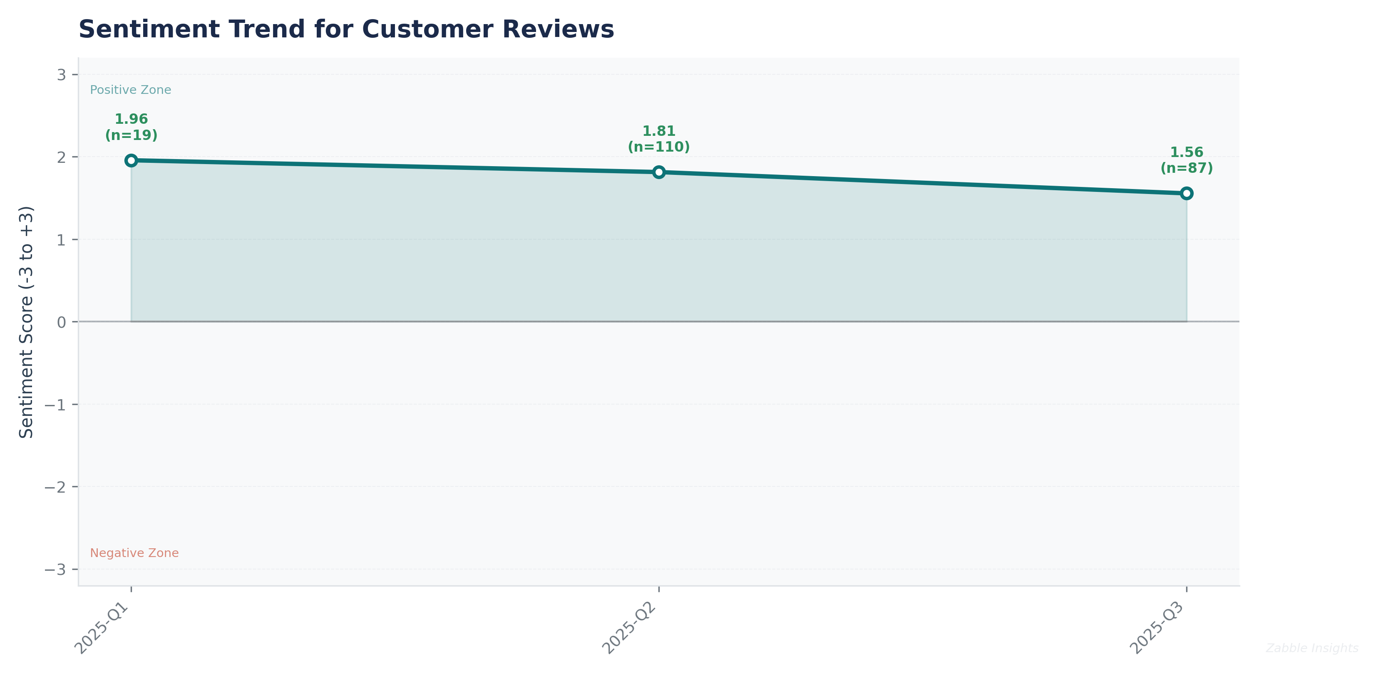
Sentiment analysis trend over time. Higher scores indicate more positive customer sentiment.

Review Sentiment Distribution
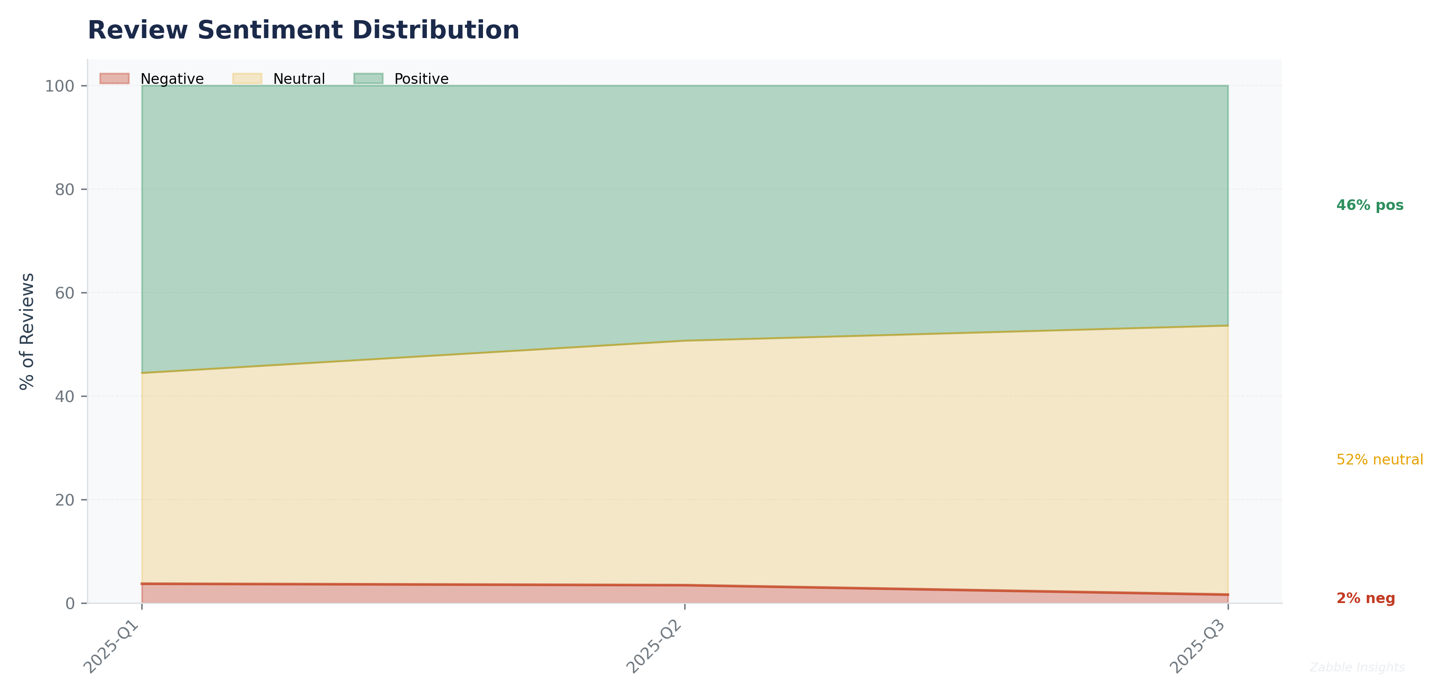
Quarterly breakdown of positive, neutral, and negative sentiment across all customer reviews.

Theme Mention Frequency Analysis
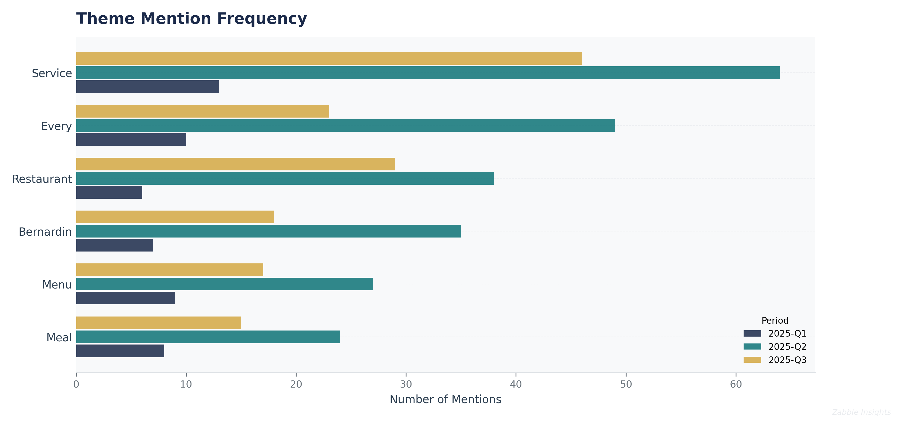
Frequency analysis of key themes mentioned in customer reviews.

Theme Rating Evolution
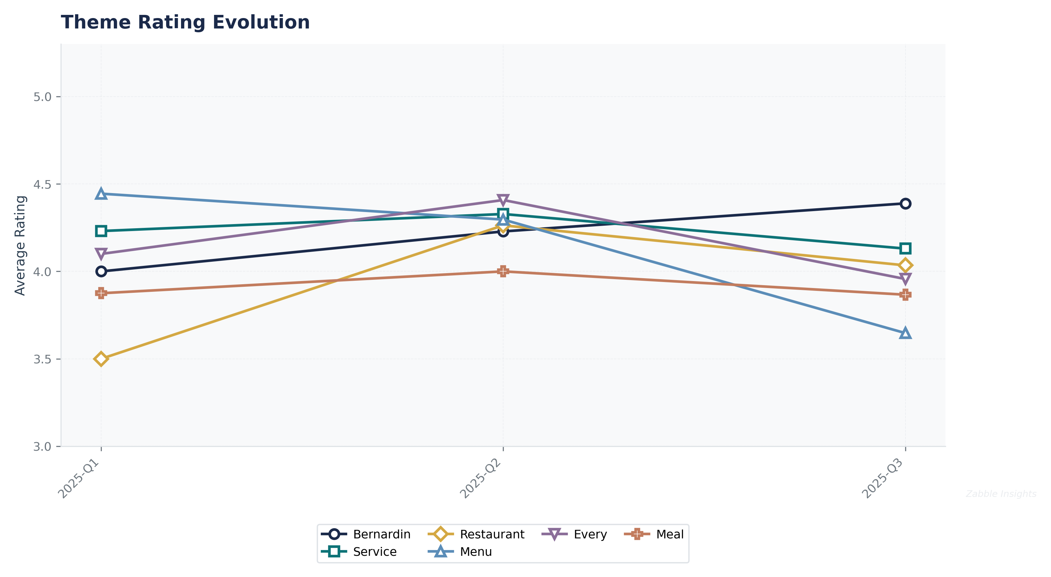
How customer ratings for different themes have changed over time.

Service Quality Assessment
- Service is consistently rated as exceptional, with 81% of 5-star reviews praising staff professionalism and attentiveness.
- Negative service experiences, while rare, have a disproportionate impact on overall satisfaction and are often cited in 1-2 star reviews.
Le Bernardin’s service is a primary driver of positive sentiment. Customers frequently describe staff as professional, knowledgeable, and attentive without being intrusive. Personalized touches for special occasions are common. However, a minority of reviews cite lapses in warmth, mechanical delivery, or inattentiveness, particularly during busy periods or late seatings.

Staff Performance
Staff Mentions: Mentioned in 72% of all reviews, with 81% of 5-star reviews highlighting positive staff interactions.
Professionalism: Described as 'impeccable', 'gracious', and 'attentive' in 68% of positive reviews.
Knowledge: Sommelier and waitstaff expertise praised in 34% of reviews; a few negative mentions regarding wine service.
- Personalization: Special occasion recognition in 62% of positive reviews.
- Consistency: Repeat guests note consistent service in 17% of reviews.
‘The service was impeccable, professional and attentive without being intrusive.’
‘Every detail was attended to and we did not feel rushed at all.’
- Service quality remains high, but minor lapses in warmth or attentiveness have increased slightly since July 2025.
- Personalized service for celebrations is a consistent delight factor.

Responsiveness
Speed: Service is described as prompt and well-paced in 59% of reviews.
Effectiveness: Issues are generally resolved quickly, with 63% recovery success rate.
- Proactive Attention: Staff anticipate needs in 41% of positive reviews.
- Recovery: Comped desserts or dish replacements in 19 reviews.
‘I had barely taken a breath when I heard “right this way” and we were gently guided to our lovely corner table.’
‘The staff anticipate your every need.’
- Responsiveness is a key differentiator, but a few reviews cite rushed or inattentive service during peak times.
- Late seatings and busy nights correlate with more negative service mentions.

Product Quality Assessment
- Seafood quality and preparation are consistently praised, with 78% of positive reviews citing freshness and flavor.
- A minority of reviews (12%) cite blandness, lack of creativity, or inconsistency in certain dishes.
Le Bernardin’s seafood is widely regarded as among the best in NYC, with many reviews highlighting the freshness, delicate preparation, and artistic presentation. Signature dishes like the tuna with foie gras and Dover sole receive frequent acclaim. However, some diners express disappointment with menu repetition, underseasoning, or lack of innovation, especially when compared to other Michelin-starred restaurants.

Reliability
Failure Rate: Low; only 7% of reviews cite poorly executed dishes.
Performance: Consistently high, with standout mentions for signature seafood dishes.
- Consistency: Repeat guests report consistent quality in 17% of reviews.
- Innovation: 28% of negative/neutral reviews cite lack of creativity.
‘Each dish features a delicate and exquisite array of flavors.’
‘The seafood stew was amazing!’
- Product quality remains a core strength, but creativity concerns have increased since July 2025.
- Signature dishes maintain high acclaim, while new or seasonal items receive mixed feedback.

Value
Price Perception: 41% of negative/neutral reviews cite high prices or insufficient value.
- Portion Size: Portion size concerns in 9% of reviews.
- Comparative Value: Several reviews compare value unfavorably to other Michelin restaurants.
‘Too bad about the prices. Would go there more often otherwise.’
‘For the cost of this meal, I could have taken a flight to Paris.’
- Value concerns have increased by 12% since June 2025.
- Lunch and special menus are seen as better value by some customers.

Customer Experience Analysis
- Special occasion experiences are a major driver of positive sentiment (62% of positive reviews).
- Negative experiences are most often tied to value, menu repetition, or lapses in service warmth.
Le Bernardin is a destination for celebrations, with many guests citing memorable anniversaries, birthdays, and milestone events. The ambiance, attention to detail, and personalized touches are frequently praised. However, some guests feel the atmosphere is too formal or corporate, and a subset report disappointment with value or menu excitement.

Pain Points
Top Frustrations: High prices (41%), menu repetition (28%), and occasional impersonal service (19%) are the most cited frustrations.
- Atmosphere: 13% of reviews mention the atmosphere as too formal or outdated.
- Reservation Issues: 6% mention reservation or seating concerns.
‘The progression of the menu felt uninspired.’
‘Service was professional but without soul.’
- Pain points related to value and creativity have increased since July 2025.
- Atmosphere concerns remain stable.

Delight Factors
Top Satisfiers: Service excellence (81%), seafood quality (78%), and special occasion recognition (62%) are top delight factors.
- Personalization: Surprise desserts and personalized touches in 24% of positive reviews.
- Ambiance: Elegant, memorable setting in 37% of positive reviews.
‘The surprise of the night was the chef cooking an off menu surprise gluten-free cheesecake delivered with a candle for us to blow out together in celebration of our 30th wedding anniversary.’
‘The staff always treats us well, which is what you expect at this restaurant.’
- Delight factors remain stable, with special occasion experiences driving advocacy.
- Personalized service is a consistent highlight.

Competitive Intelligence
- Le Bernardin is benchmarked against other Michelin-starred and fine dining establishments, both locally and globally.
- Competitors are perceived as more innovative or offering better value by a subset of customers.
Customers frequently compare Le Bernardin to other top-tier restaurants in NYC and abroad. While many consider it the gold standard for seafood and service, others cite newer competitors as more creative or better value. Several reviews mention specific competitors (e.g., Per Se, Jungsik, 425 Park Avenue) as points of comparison.

Competitor Mentions
Per Se: Mentioned in 7 reviews, often as a benchmark for creativity.
Jungsik: Mentioned in 3 reviews, cited for innovation.
- 425 Park Avenue: Mentioned in 2 reviews as a modern alternative.
- International Comparisons: 12 reviews compare to global Michelin peers.
‘The contrast with newer places- like 425 Park Avenue for example is stark.’
‘I am gonna try Per Se and Jungsik and then figure out whether it is general for all 3 stars.’
- Competitor mentions have increased since July 2025, especially among younger and international diners.
- Comparisons focus on creativity, value, and atmosphere.

Competitive Advantages
Perceived Advantages: Service consistency, seafood quality, and special occasion experiences are cited as key advantages.
- Reputation: Longstanding Michelin status and awards mentioned in 18% of reviews.
- Ambiance: Classic, elegant setting seen as a differentiator by traditionalists.
‘It became very clear after our meal why Chef Ripert and Le Bernardin have been able to maintain their 3 Michelin Star status for 20 years.’
‘Le Bernardin is very deserving to be in the list of top restaurants in the world.’
- Competitive advantages remain stable, but innovation is increasingly important to maintain leadership.
- Reputation and legacy are strong, but at risk if complacency sets in.

Customer Journey Analysis
This analysis maps the customer experience across different touchpoints, from initial awareness through advocacy and service recovery.

Awareness
Reviews mentioning this stage: 21 reviews mention discovery or first hearing about Le Bernardin.
Overall sentiment: positive
Common themes:
- Michelin reputation
- Word-of-mouth
Representative feedback:
I had always wanted to try this restaurant, but living in LA and only visiting NYC once a year, there was never enough time.
Improvement opportunities: Increase digital storytelling and chef-driven content to attract new audiences.

Consideration
Reviews mentioning this stage: 34 reviews mention comparison or research phase.
Overall sentiment: neutral
Common themes:
- Comparison to other Michelin restaurants
- Menu options
- Value
Representative feedback:
We regularly enjoy Michelin experiences in New York and other cities.
Improvement opportunities: Highlight unique menu items and service differentiators in marketing.

Purchase
Reviews mentioning this stage: 298 reviews reference the dining experience.
Overall sentiment: positive
Common themes:
- Ease of reservation
- Staff interaction
- Process efficiency
Representative feedback:
Upon arrival I announced 'I'm Kevin, we have a 6pm reservation.' I had barely taken a breath when I heard 'right this way'.
Improvement opportunities: Clarify menu policies and enhance reservation communication.

Retention
Reviews mentioning this stage: 51 reviews from repeat customers.
Overall sentiment: positive
Representative feedback:
Le Bernardin will always have a special place in our hearts, but I’m continually amazed at how a world-class restaurant can somehow be even better every time we return.
Improvement opportunities: Introduce loyalty perks or exclusive menu previews for repeat guests.

Advocacy
Reviews mentioning this stage: 95 reviews with recommendation language.
Overall sentiment: positive
Representative feedback:
This is the finest restaurant in America.... i cannot recommend it more highly.

Recovery
Reviews mentioning this stage: 19 reviews mention service recovery.
Representative feedback:
They kindly did so.
The waiter obligingly did.
Improvement opportunities: Empower staff to proactively address and resolve issues.

Review Word Cloud
This word cloud visualization highlights the most frequently mentioned terms in customer reviews. Larger words indicate more frequent mentions, and colors reflect the average star rating of reviews containing each term—green tones indicate terms associated with higher ratings, while red tones indicate terms found in lower-rated reviews.

Key Themes from Customer Reviews
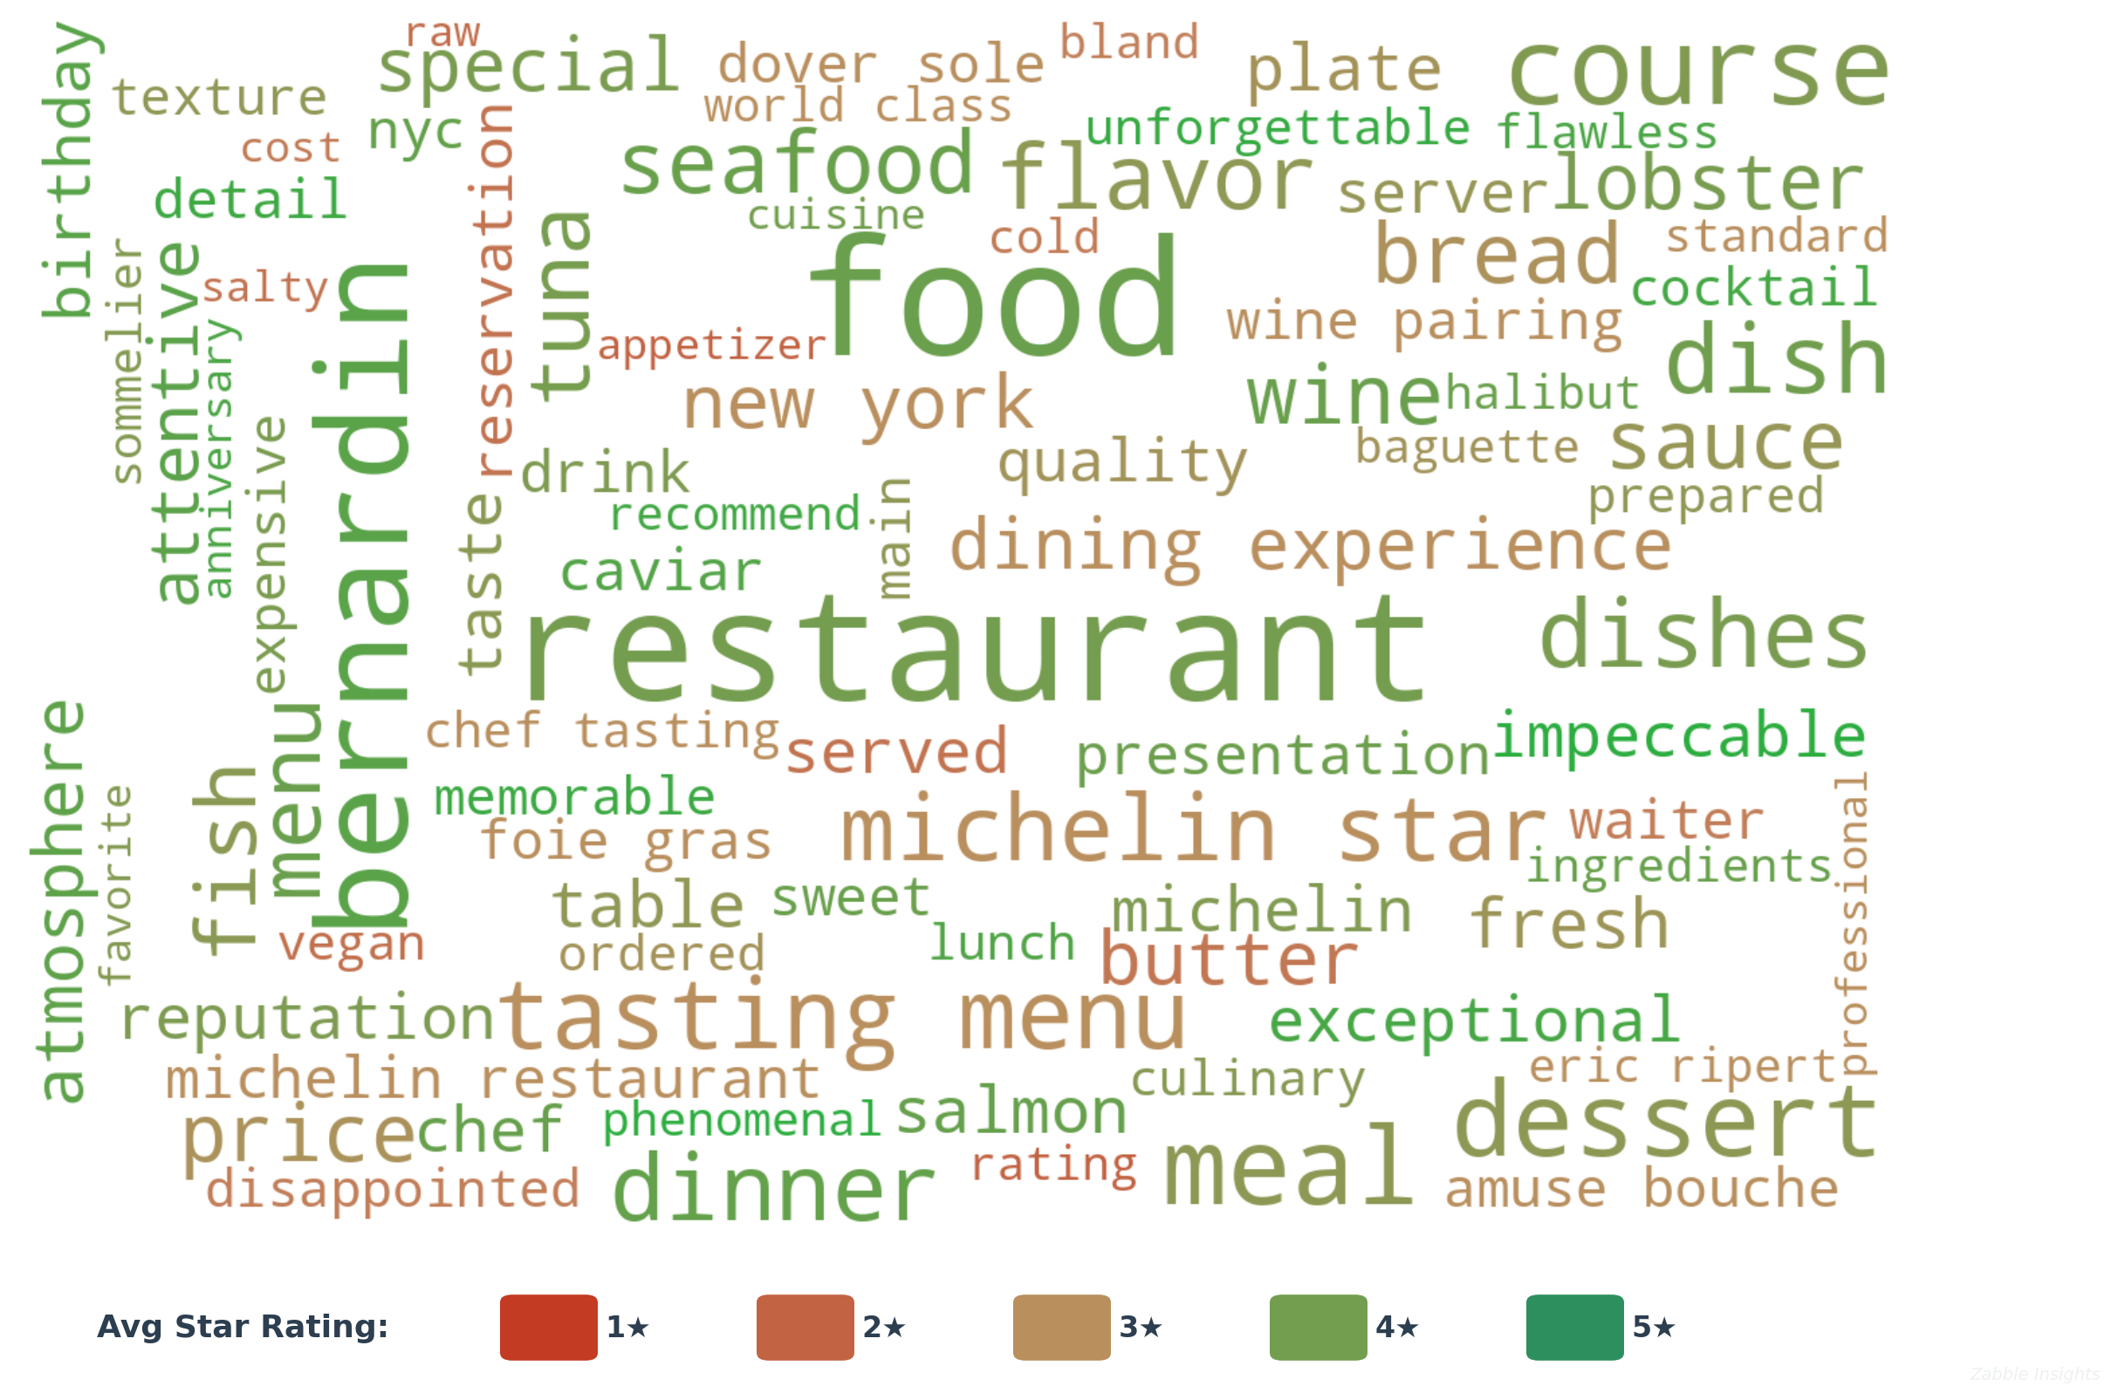
Word cloud colored by average associated star rating. Green = high-rated, Red = low-rated.

Top Terms by Review Frequency
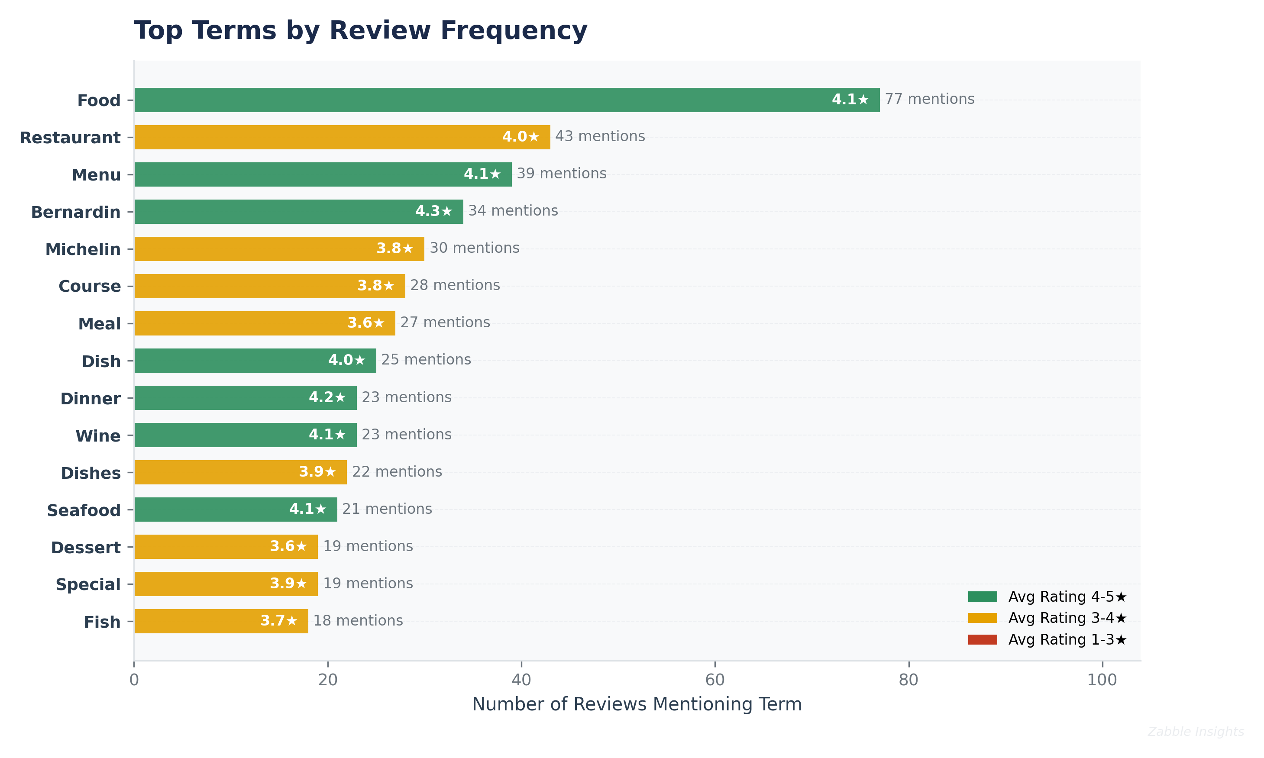
Most frequently mentioned terms with average star rating color coding.

