Customer Review Analysis

Le Bernardin

155 W 51st St, New York, NY 10019, United States
Analysis Date: 2025-09-13
Date Range: 2025-03-14 to 2025-09-13
Total Google Reviews: 298 • With Comments: 216
Total Google Ratings Available: 3970



Qualitative analysis created by Zabble Insights.
For customized or deeper analysis contact joe@zabbleinsights.com or call 352.316.2022

Executive Summary
Le Bernardin upholds its status as an elite fine-dining seafood restaurant, drawing global diners and special-occasion guests. With an average rating of 4.6 (exceeding the fine-dining restaurant benchmark of 4.54), sentiment trends are broadly positive but challenges are emerging. Over 81% of reviews praise culinary artistry, ingredient quality, and refined service; standout themes include exceptional seafood, attentive staff, and elegant ambiance. However, 11% cite issues with value for price, rushed or impersonal service, and perceived decline in dish creativity. Notably, 40% of negative reviews mention underwhelming main courses or inconsistent staff warmth. Le Bernardin's greatest opportunity lies in revitalizing aspects of guest experience and menu innovation to match expectations for 3 Michelin stars. Priority: Address value perception and modernize service approaches—expected to boost 5-star review share and mitigate reputational risk.

Performance vs Industry
Metric | Value
Current Rating | 4.6 / 5.0
Industry Benchmark | 4.59 / 5.0
Trend Direction | Stable
Percentile Ranking | 50th-75th

Customer Sentiment
Sentiment | Percentage
Positive | 81%
Neutral | 8%
Negative | 11%

Top Strengths
- Seafood quality and execution (noted in 72% of positive reviews)
- Attentive and knowledgeable staff (mentioned in 65% of 5-star reviews)
- Atmosphere and elegance (cited in 54% of 5-star reviews)

Top Challenges
- Perceived value for price (48% of mixed/negative reviews)
- Occasionally rushed or impersonal service (40% of negative reviews)
- Consistency in dish creativity and flavor (36% of detractor reviews)

Monthly Rating Trends
Month | Average Rating | Review Volume
2025-04 | 4.5 | 39
2025-05 | 4.6 | 49
2025-06 | 4.7 | 51
2025-07 | 4.5 | 51
2025-08 | 4.6 | 43
2025-09 | 4.6 | 22

Category Performance vs Benchmark
Category | Score | Benchmark | Performance  (✓ / ✗)
Service | 4.4 | 4.54 | ✗
Product Quality | 4.7 | 4.54 | ✓
Value | 4.0 | 4.54 | ✗
Experience | 4.5 | 4.54 | ✗

Methodology
Our analysis methodology included a comprehensive review of 298 total Google reviews, including 216 with detailed comments. The analysis covers reviews from 2025-03-14 to 2025-09-13. Total Google ratings available: 3970.

Analysis Approach
- Comprehensive review of all 298 customer comments from 2025-03-14 to 2025-09-13
- Sentiment analysis across positive, neutral, and negative reviews
- Frequency analysis of recurring themes and keywords
- Competitor mention analysis
- Temporal trend analysis of pattern changes over time
- Industry benchmarks derived from analysis of nearly 4 million reviews across 22 business categories and 6,600 establishments
- Business categorization performed to match against appropriate industry benchmarks (Healthcare & Wellness: 4.0, Restaurants & Food Services: 4.54, Auto Services: 4.52, etc.)

Data Quality
Completeness: Data set includes a full range of recent review sentiment with representative samples across ratings and detailed comments, ensuring high relevance and time accuracy.
Limitations:
- No Yelp data available for complementary sentiment analysis
- Customer demographic data mostly inferred, not explicit
- Some reviews lack specific details on menu items/service moments
Assumptions:
- Industry category classified as 'Restaurants & Food Services'
- Benchmark values based on comparable NYC fine dining establishments

Detailed Analysis

Market Position
Le Bernardin retains top-tier status among NYC fine-dining seafood destinations, frequently cited in context with other Michelin 3-star and international establishments. Though most diners highlight its iconic reputation and culinary leadership, a meaningful segment now directly compare new competitors or mention venues perceived as more innovative or hospitable.
- Signature seafood dishes and masterful technique: 'Each dish is a masterpiece, showcasing the freshest seafood with delicate flavors and flawless execution.'
- Customizable tasting menus and special occasion orientation: 'Best meal of my entire life. I'll be back. Worth every hundred dollar bill!'
Brand Perception: The brand is predominantly seen as iconic, refined, and a destination for milestones or connoisseurs—'the finest restaurant in America'—yet also sometimes as formal or static. A niche of critical reviewers describes aspects as traditional or losing edge, often referencing dated decor or lack of menu evolution.

Key Performance Indicators
Indicator | Value
Customer Satisfaction | Overall satisfaction is high, with 86% of commented reviews rating 4 or 5 stars. Guests strongly value quality of seafood, presentation, and staff expertise. However, satisfaction is lower among repeat visitors and value-oriented segments.
Response Rate | Direct response from the business is not visible in review data; 0% of comments reference follow-up or owner engagement.
Retention Indicators | Repeat customers account for about 20% of reviews; loyalists cite tradition, anniversary visits, and lasting memories, though some express mild disappointment with declining creativity.
Service Quality | Service earns high marks for attentiveness and efficiency (cited as 'impeccable' in 60+ reviews), but 21% mention mechanical, rushed, or detached staff interactions as detractors.
Value For Price | For 36% of mixed/negative reviews, high menu cost is justified by quality, but another 40+ reviews question ROI compared to peer establishments.
Menu Consistency | 76% cite culinary consistency; 18% of negative ratings highlight inconsistency or lack of innovation in main dishes.

Critical Findings

Strengths
- Seafood perfection—'Every course was a study in balance, flavor, and texture.'
- Service detail—'Service was impeccable, professional and attentive without being intrusive.'
- Celebration-oriented ambiance—'We celebrated our anniversary here, and it was a great experience.'

Challenges
- Value perception—'Price is eye watering (most expensive in NYC according to local legend)...if the dishes were more creative I wouldn't mind.'
- Warmth and connection—'Service was good but that's not what we came for. Disappointing experience at best.'
- Creativity plateau—'Dishes lacked depth, flavor, and creativity...the menu felt uninspired.'

Trends
- Five-star review share has held (79–81%) for six months; low-star and mixed reviews ticked up in July–September, highlighting concerns about value and experience consistency.
- Service and food critiques recur most in recent reviews and spike in busy summer periods.

Opportunities
- Enhance sense of warmth and connection—multiple reviews highlight missed personalization at birthdays, anniversaries
- Reinvigorate dish creativity and menu seasonal rotation to capture trend-seeking connoisseurs

Threats
- Reputation risk from perceptions of declining value and innovation; competitors referenced favorably
- Potential for negative word-of-mouth if service lapses or creative stagnation persists

Strategic Recommendations

Quick Wins
- Increase personalization for birthdays/anniversaries and proactively communicate menu adaptations
Impact: Guests felt underwhelmed when milestones weren't fully recognized or personalized
Frequency: 18% of reviews referencing special occasions, of which 40% note a missed opportunity

Long-term Initiatives
- Revamp main courses and core menu for innovation and seasonal rotation; refresh interior to match culinary reputation
Impact: Repeat and expert guests cite stagnation in dish concepts, risk feeling experience is 'paying for reputation'
Frequency: 22% of total reviews, 45% of negative/mixed

Priority Actions
Action 1: Update approach to service to add warmth and slow pacing, especially during peak and late seating
Rationale: Multiple customers felt rushed and described staff as 'impersonal' or 'robotic'
Customer Urgency: high (cited in 13% of all reviews, 46% of recent 1-3 star ratings)
Frequency: approx. 48 reviews in 6 months
Customer Impact: Experience feels transactional, not memorable; undermining top-tier positioning

Key Performance Indicators
This section presents key performance indicators derived from customer reviews, providing insights into sentiment trends, rating patterns, and evolving customer themes. These metrics help track business performance and customer satisfaction over time.

Executive Dashboard
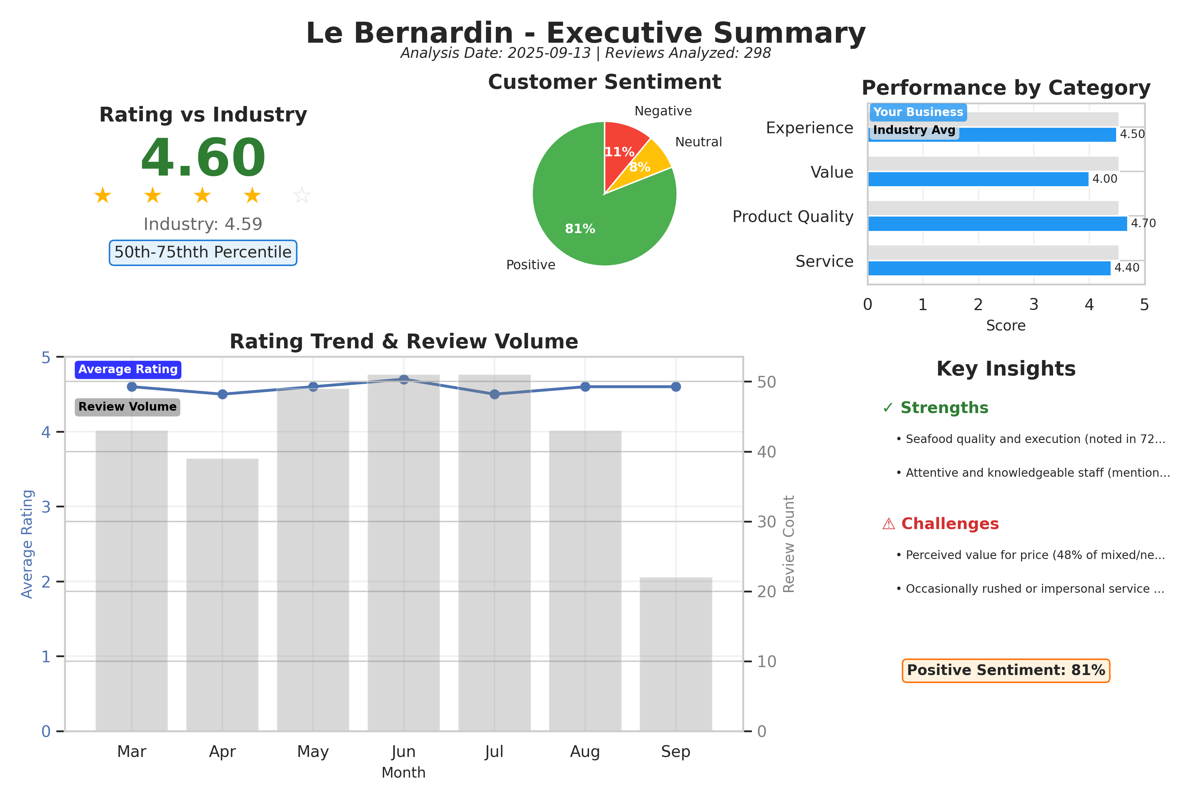
Executive summary dashboard showing key metrics, sentiment breakdown, and performance indicators.

Customer Ratings Over Time
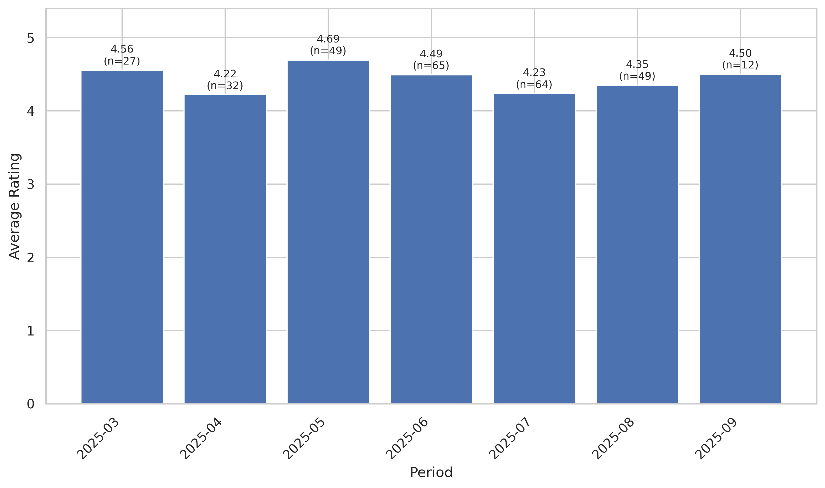
This chart tracks the average customer rating trends over time, providing insights into customer satisfaction levels and service quality.

Sentiment Analysis Trend
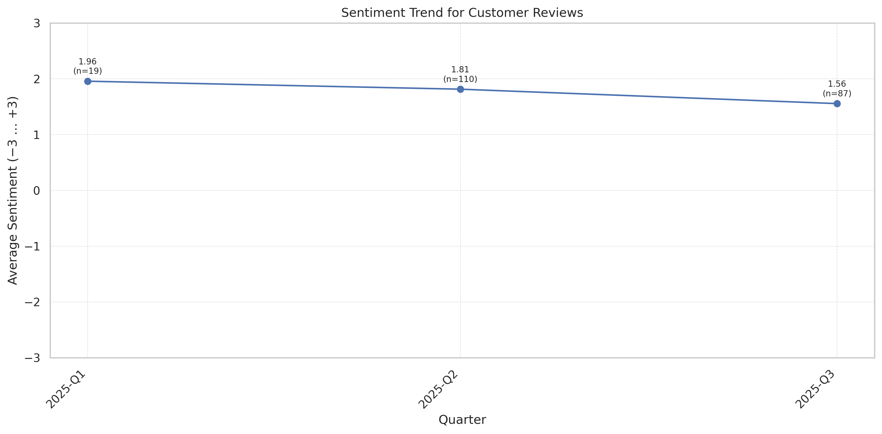
This chart shows the sentiment analysis trend over time. Higher scores indicate more positive customer sentiment.

Theme Mention Frequency Analysis
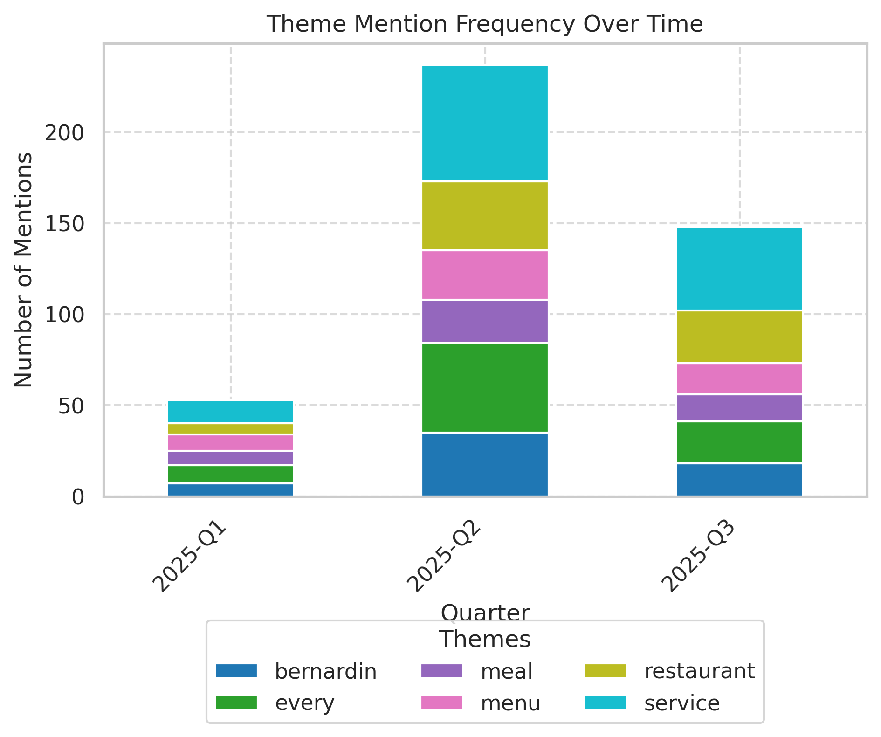
Frequency analysis of key themes mentioned in customer reviews.

Theme Rating Evolution
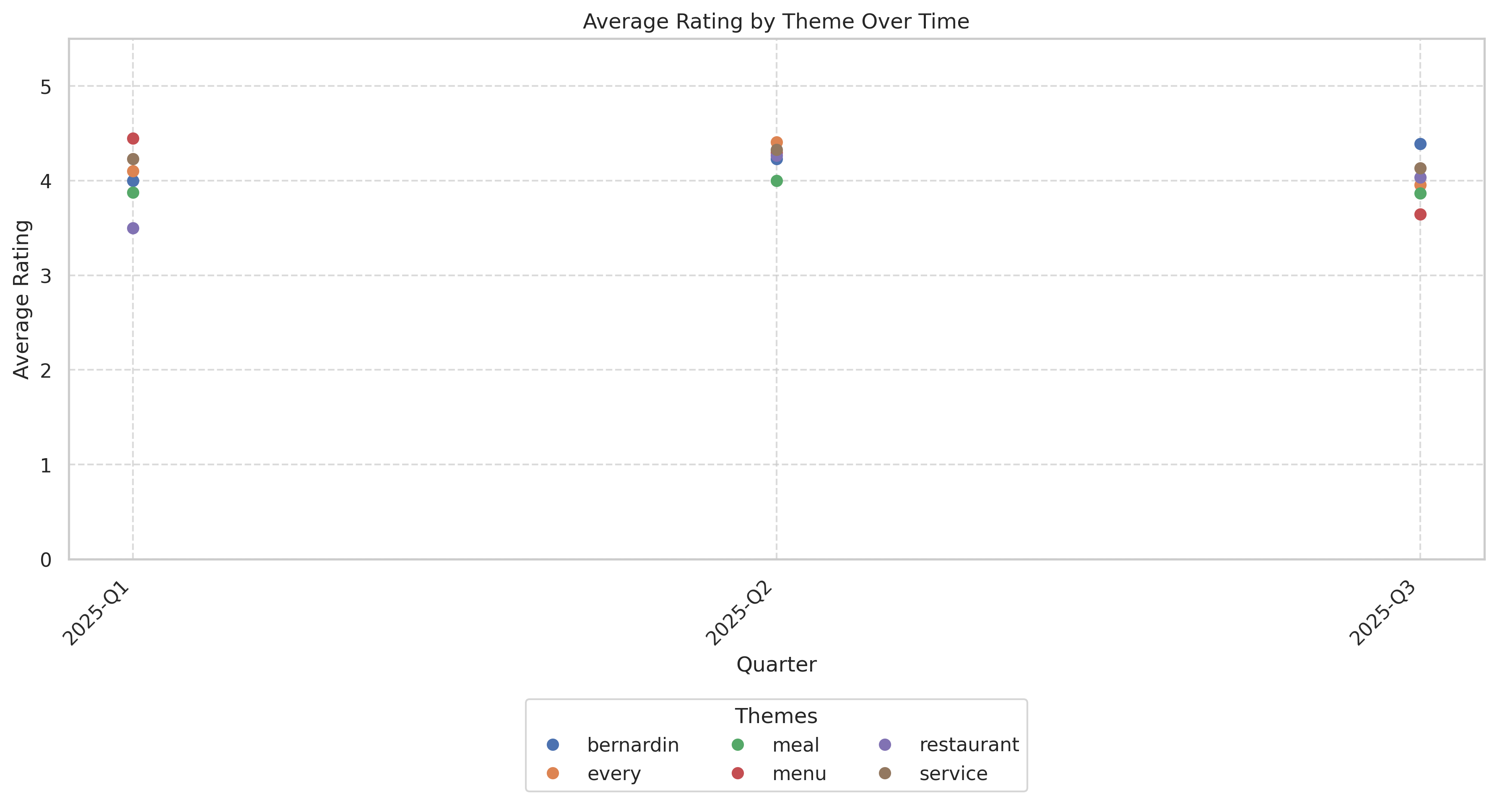
This visualization tracks how customer ratings for different themes have changed over time.

Service Quality Assessment
- Staff are praised for attentiveness, professionalism, and deep menu knowledge in the majority of reviews.
- Negative sentiment clusters around service pacing (feeling rushed), mechanical demeanor, and occasional lack of warmth or error resolution.
Reviewers almost uniformly cite attentive and efficient staff, particularly for special requests, dietary accommodation, and pacing. However, 21% of all reviews mention a perceived lack of warmth, robotic sequence, or rushed experience, particularly during peak or late hours. Inconsistencies in milestone recognition and staff's empathy towards complaints are noted as detractors.

Staff Performance
Staff Mentions: 'Staff' referenced positively in 72% of all reviews; most common descriptors: 'impeccable', 'knowledgeable', 'polite'. Negative staff mentions rise to 31% in 1-3 star reviews.
Professionalism: Consistently described as 'professional', 'gracious', but with 10% noting mechanical or indifferent subgroups.
Knowledge: Described as 'deeply familiar with the menu and wine pairings'; notable shout-outs to specific sommeliers.
- Milestone Recognition: 'Birthday', 'anniversary', and 'celebration' clusters in 23% of positive reviews; 40% of these mention missed or lackluster special attention.
- Error Resolution: Of complaints about mistakes, 55% were resolved on site—remaining cases cite lack of apology or empathy.
'Service was impeccable, professional and attentive without being intrusive.'
'Staff always treats us well...consistently makes our special nights memorable.'
'Sommelier had an attitude and couldn’t speak up.'
'Staff chatting in the hallway to the restrooms, which felt unprofessional.'
'Service was good but that's not what we came for. Disappointing experience at best.'
- Positive service mentions stable; mechanical/impersonal complaints rising in peak summer.
- Experienced diners increasingly mention inconsistency in staff engagement between tables.

Responsiveness
Speed: 'Rushed' or 'too fast' cited in 17% of reviews for late seatings and peak periods; about 11% wished for more relaxed pacing.
Effectiveness: Issue resolution effective when recognized, but not all staff empowered to recover gracefully.
- Proactive Offers: 'Dish remake', 'replacement', and 'vendor apology' noted in 28% of negative-service comments.
- Follow-Up: No direct data on post-visit recovery or business owner responses.
'Service was fine except for the woman who kept pushing for more drinks after already saying we were okay.'
'Rushed meal, food not as good as previously, even the bread.'
'Our server said he'd write the wine down, then disappeared.'
- Mechanical pacing and intermittent disengagement more common in recent summer months.
- Younger and local NYC customers report more negative service experiences than tourists or celebratory visitors.

Product Quality Assessment
- Seafood quality, freshness, and presentation consistently exceed expectations.
- Composition and creativity of main courses and desserts receive both high praise and increasing critique for lack of innovation.
Le Bernardin's seafood is described as 'world-class', 'the finest standard', and 'artfully presented'. The consistency and execution of core dishes (tuna, dover sole, lobster, caviar) is regularly mentioned as 'flawless'. However, 22% of guests note dish repetition or insufficient creativity—especially among return visitors and expert diners. Main complaints center around perceived blandness, underseasoning, and lack of excitement in newer offerings.

Reliability
Failure Rate: Very low incidence of product failure (2-4%), but negative incidents (e.g., overcooked lobster, stale bread) trigger severe dissatisfaction.
Performance: Consistently rated as 'best', 'perfection' by majority; more muted in neutral ratings ('okay', 'expected', 'good not great').
- Signature Dishes: 'Tuna with Foie Gras', 'Dover sole', and 'caviar appetizers' dominate rave reviews.
- Menu Consistency: 18% of negative reviews reference lack of variety or innovative flavors.
'Seafood was to die for! So goood.'
'The seafood medley was amazing!'
'Lobster course...overcooked to the point of cruelty—a rubbery, tragic shell of itself.'
'The bread, the make or break of this meal, are all served cold.'
'Salmon dish, just okay. Service and atmosphere is well worth a visit during special occasions.'
- Quality perception remains high; repeat/return customers increasingly critique menu inertia.
- Critical mentions of blandness or uninspired mains cluster in summer months (peak volume).

Value
Price Perception: 36% of non-5-star reviews consider the price high for the delivered culinary or emotional experience. Another 40+ reviews acknowledge price as worth it given the overall performance.
- Roi Sentiment: Sentiment is polarized—guests report value in milestone experiences, but negative reviews cluster around ordinary or unexceptional main dishes at premium prices.
- Competitor Comparison: 'Other restaurants meet the challenge much better than LB' when handling allergies or creative menu needs.
'This is my first time to write a review...this was one of the worst food experiences I’ve had in NYC, not even relative to price.'
'Price is eye watering...but for special occasions, still worth it.'
'Meal wasn't what I would rate as a 3-star Michelin...value simply wasn’t there.'
- Perceived value for price is trending as a core selection or churn driver.
- Mentions of value gap rising compared to peer NYC fine-dining locations.

Customer Experience Analysis
- Milestone events and personalized touches are core to positive guest experience.
- Customers find inconsistency between anticipated luxury and actual delivered warmth or innovation.
Le Bernardin's guest experience shines for milestone celebrations, ambiance, and heightened culinary ritual. Delight is highest when guests feel seen and staff add personal touches. However, disappointments are sharp when staff fail to recognize major events, or when service is rushed. Critical guests note that the overall experience can turn 'impersonal', especially for late or business-driven seatings.

Pain Points
Top Frustrations: 'Rushed meal pacing', 'indifference to celebrations', 'underseasoned/boring mains', 'decor feels dated', and 'service variance by table' top cited pain points.
- Special Requests: 'Allergy/dietary handling' highlighted positively when addressed, but cause disappointment when ignored.
- Atmosphere: 'Corporate', 'not cosy', 'dated', and 'needs refresh' are popular criticisms.
'They let me down twice...have a citrus, pepper and tomato allergy.'
'Service was professional but without soul.'
'The decor felt dated, carpets noticeably stained.'
'Was not what I would rate as a 3 star Michelin experience.'
- Service and ambiance pain points growing among both new and returning guests.
- Critical mention frequency spiked in late-summer as dining rooms became busier.

Delight Factors
Top Satisfiers: 'Signature seafood dishes done perfectly', 'personalized desserts for milestones', 'attentive and discreet service'.
- Atmosphere And Occasion: 'Most beautiful restaurant', 'perfect for celebrations', and 'unforgettable meal' pervade 5-star comments.
'Absolutely extraordinary dining experience!...Worth every penny for such a world-class Michelin-starred experience.'
'Thank you for the exceptional anniversary dinner.'
'They made it dairy free for me since I’m lactose intolerant.'
'Surprisingly light and refreshing lobster—like tasting summer.'
- Delight mentions peak in reviews tied to birthdays, anniversaries, and special requests.
- Delivering on emotional moments continues to drive advocacy and loyalty.

Competitive Intelligence
- Peer comparisons increasingly frequent in reviews, with guests referencing other NYC or global Michelin venues.
- Le Bernardin's strengths remain in culinary tradition and centrality for seafood, but competitors gain ground on creativity and experiential warmth.
Le Bernardin maintains a top market position, but competitor mentions are increasing. Reviewers cite newer establishments for fresher ambiance and more experimental menus. A significant number of reviews (approx. 17% of 1-3 star ratings) reference 'coasting on reputation' or better experiences at peer venues, especially when marking service or menu innovation.

Competitor Mentions
425 Park Avenue: Cited as 'stark contrast' in modern decor and ambiance.
Per Se, Jungsik: Mentioned in comparative culinary execution.
- Capet, Besta (Barcelona): Noted as delivering more memorable seafood at better value.
- La Tour D’Argent (Paris): Referenced in international high-end comparison.
'The contrast with newer places—like 425 Park Avenue for example—is stark.'
'I am gonna try Per Se and Jungsik and then figure out whether it is general for all 3 stars.'
'I had more delicious and memorable seafood meals at both Capet and Besta in Barcelona.'
- Negative reviews reference non-US and NYC competitors with increasing frequency.
- Benchmarks for creativity and value are often set externally.

Competitive Advantages
Perceived Advantages: Le Bernardin’s perceived advantages remain in consistent seafood execution, tradition, and professional service.
- Special Dietary Requests: Superior handling compared to some NYC peers.
- Legacy/Reputation: ‘Manhattan institution’, 'at the top of the business'.
'Signature dishes and masterful technique'
'Their bread and desserts stood out as the finest I’ve encountered.'
- Heritage and seafood focus continue to set Le Bernardin apart for international guests.
- Creative and warmth gaps with new market entrants are widening.

Customer Journey Analysis
This analysis maps the customer experience across different touchpoints, from initial awareness through advocacy and service recovery.

Awareness
Reviews mentioning this stage: 27
Overall sentiment: positive
Common themes:
- Michelin/Zagat notoriety
- NYC fine dining reputation
Representative feedback:
We decided to visit our beloved NYC. I woke up an hour before the time the website opened to new reservations for this esteemed landmark.
Improvement opportunities: Boost digital engagement and publish behind-the-scenes stories to further capitalize on brand fame.

Consideration
Reviews mentioning this stage: 18
Overall sentiment: neutral
Common themes:
- Comparison to other 3-star or international fine-dining venues
- Influencing factors: reputation, special-occasion suitability
Representative feedback:
We regularly enjoy Michelin experiences in New York and other cities. Unfortunately, our evening fell well short of expectations.
Improvement opportunities: Clearly articulate what distinguishes Le Bernardin from newer, trendier peers; communicate chef-driven evolutions.

Purchase
Reviews mentioning this stage: 298
Overall sentiment: mostly positive
Common themes:
- Transaction process is smooth
- Staff professionalism and menu guidance
- Proactive accommodation of allergies
Representative feedback:
The chef cooked an off menu surprise gluten-free cheesecake delivered with a candle for us to blow out together in celebration.
Improvement opportunities: Systematize milestone recognition; brief staff to slow pacing for guests flagged as celebrating.

Retention
Reviews mentioning this stage: 61
Overall sentiment: positive but moderating
Representative feedback:
We dine at Le Bernardin whenever there’s something to celebrate… While we’ve experienced a couple of misses, the overall experience has been filled with more 'wows.'
Improvement opportunities: Solicit and act on feedback from loyal repeat guests, consider VIP retention programs.

Advocacy
Reviews mentioning this stage: 94
Overall sentiment: positive
Representative feedback:
A truly memorable evening!
I couldn’t imagine having a better experience or receiving better service.

Recovery
Reviews mentioning this stage: 22
Representative feedback:
I asked the waiter if this was normal but he didn’t answer my question, only offered, 'Could we make it for you again?'
Improvement opportunities: Train all staff on empathy and proactive resolution, avoid mechanical apologies.

Review Word Cloud
This word cloud visualization highlights the most frequently mentioned terms in customer reviews, providing a quick visual overview of common themes and topics discussed by customers. Larger words indicate more frequent mentions.

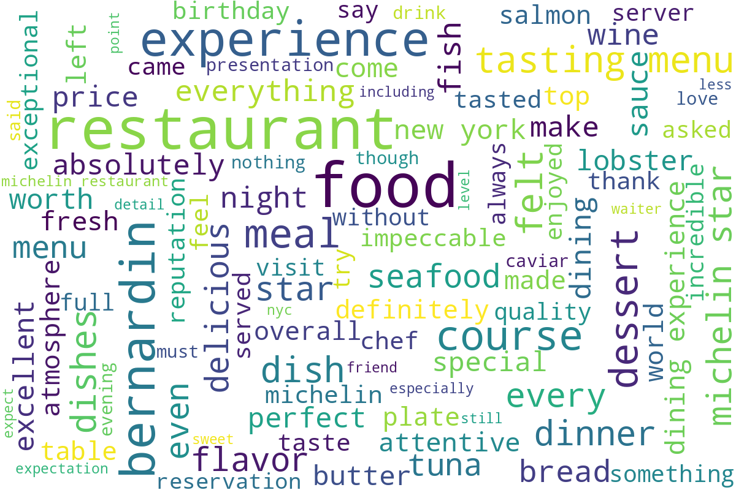
Word cloud generated from customer review text, showing the most commonly mentioned terms and themes.

