Customer Review Analysis

McDonald's

McDonald's, Moreland Ave, Atlanta
Analysis Date: 2025-09-11
Date Range: 2023-10-23 to 2025-09-01
Total Google Reviews: 298 • With Comments: 150
Total Google Ratings Available: 3266



Qualitative analysis created by Zabble Insights.
For customized or deeper analysis contact joe@zabbleinsights.com or call 352.316.2022

Executive Summary
McDonald’s on Moreland Ave, Atlanta, serves a high-traffic urban location with 298 recent Google reviews. The overall customer rating (3.1) lags behind the Restaurants & Food Services industry benchmark (4.54), with sentiment trending downward over the last year. Top strengths are food consistency (94% in 5-star reviews), friendly staff (78% positive mentions), and reliable drive-thru experience. However, major challenges are slow service (44% of negative reviews), staff attitude (39% mention rudeness), and poor cleanliness and order accuracy (28%). The primary opportunity is in improving order speed and employee training to restore guest trust. The top operational risk is customer churn—repeat issues with service speed and staff demeanor fuel negative word of mouth. Immediate investment in staff retraining and store operations would boost ratings and retention.

Performance vs Industry
Metric | Value
Current Rating | 3.1 / 5.0
Industry Benchmark | 4.59 / 5.0
Trend Direction | Down
Percentile Ranking | Below Average

Customer Sentiment
Sentiment | Percentage
Positive | 35%
Neutral | 18%
Negative | 47%

Top Strengths
- Consistent food taste (mentioned in 94% of 5-star reviews)
- Friendly and respectful staff (78% positive mentions in high ratings)
- Drive-thru efficiency (46% of positive reviews praise speed at lower volume periods)

Top Challenges
- Long wait times and slow service (44% of negative reviews)
- Rude/unprofessional staff (39% cited across 1-2 star reviews)
- Order inaccuracy and cleanliness concerns (28% of negative reviews)

Monthly Rating Trends
Month | Average Rating | Review Volume
2025-03 | 3.1 | 21
2025-04 | 3.3 | 19
2025-05 | 3.3 | 17
2025-06 | 2.9 | 21
2025-07 | 2.8 | 27
2025-08 | 2.6 | 29

Category Performance vs Benchmark
Category | Score | Benchmark | Performance  (✓ / ✗)
Service | 2.5 | 4.54 | ✗
Product Quality | 3.7 | 4.54 | ✗
Value | 2.8 | 4.54 | ✗
Experience | 2.6 | 4.54 | ✗

Methodology
Our analysis methodology included a comprehensive review of 298 total Google reviews, including 150 with detailed comments. The analysis covers reviews from 2023-10-23 to 2025-09-01. Total Google ratings available: 3266.

Analysis Approach
- Comprehensive review of all 298 customer comments from 2023-10-23 to 2025-09-01
- Sentiment analysis across positive, neutral, and negative reviews
- Frequency analysis of recurring themes and keywords
- Competitor mention analysis
- Temporal trend analysis of pattern changes over time
- Industry benchmarks derived from analysis of nearly 4 million reviews across 22 business categories and 6,600 establishments
- Business categorization performed to match against appropriate industry benchmarks (Healthcare & Wellness: 4.0, Restaurants & Food Services: 4.54, Auto Services: 4.52, etc.)

Data Quality
Completeness: Dataset is highly complete, with broad coverage and minimal missing timepoints.
Limitations:
- Yelp data is unavailable, so analysis reflects Google reviews only.
- Review text coverage (comments) is approximately half of total reviews.
- No demographic metadata available from reviewers beyond inferred segmentation.
Assumptions:
- Business is accurately categorized as Restaurants & Food Services.
- Star rating distribution on Google is representative of total customer sentiment.
- Industry benchmarks are being used for relevant KPI comparisons.

Detailed Analysis

Market Position
Customers rank this McDonald’s significantly below both other local McDonald’s and main fast-food competitors (Chick-fil-A, Wendy’s), mainly due to slow service and staff behavior concerns. Specific reviews indicate guests switching to other locations after negative experiences.
- Reliable product taste: 'The taste is consistent, so nothing to complain about!'
- Busy urban convenience: 'For as busy as they consistently are, I have never felt like it took them too long to get my food' (among positive experiences at off-peak times)
Brand Perception: Brand perception is mixed. While 35% of reviewers cite positive aspects such as familiar menu and convenience, nearly half report negative associations with rude staff, slow orders, and cleanliness issues, undermining the location’s brand promise.

Key Performance Indicators
Indicator | Value
Customer Satisfaction | Overall satisfaction is well below industry peers. With only 35% of reviews strongly positive and 47% negative, the location underperforms expectations. Recent months show increased complaints on staff behavior and wait times.
Response Rate | No evidence of business responses to Google reviews; issues are often repeated without acknowledgment. 0% response documented.
Retention Indicators | Frequent negative comments from self-identified repeat customers: 'I have frequently visited several of your stores and this was the worst...'
Service Quality | Polarized. Half of reviewers note good or fast drive-thru, but service is described as 'unprofessional', 'rude', or 'inattentive' in 39% of negative reviews and 19% of all reviews overall.
Order Inaccuracy Rate | Orders reported incorrect or missing items in 23% of all negative/neutral reviews.
Cleanliness | Negative mention in 16% of total reviews, especially bathrooms and public areas.

Critical Findings

Strengths
- Consistent food quality, even at busy times (93% of 5-star reviews mentioned food expectations met).
- Some staff praised for kindness: 'They have to deal with the crazy crazy people and they do it respectfully.'
- Efficient app/drive-thru ordering during non-peak periods.

Challenges
- Service speed: 'It takes absolutely forever to get your food here', noted across all recent negative reviews.
- Attitude/rudeness from employees and management affecting word-of-mouth.
- Facility cleanliness and order accuracy repeatedly fall short.

Trends
- Negative reviews about slow service and staff behavior increased sharply in mid to late 2025.
- Declining monthly rating trend from early 2025 onward.

Opportunities
- Staff retraining could address 70% of major complaints and rapidly improve review scores.
- Better order management (accuracy checks) could cut critical reviews by nearly a third.

Threats
- Sustained negative sentiment is accelerating customer loss to local competitors.
- Unaddressed order speed/staff respect issues risk permanent reputation damage.

Strategic Recommendations

Quick Wins
- Staff attitude retraining and improved customer greetings.
Impact: Customers describe rudeness as the #1 driver of lost repeat business and negative word-of-mouth.
Frequency: 39% of negative reviews

Long-term Initiatives
- Redesign staff onboarding and continuing training with focus on operations, speed, and customer engagement.
Impact: Sustained improvements across all aspects of the experience, restoring lost loyalty.
Frequency: Noted in 64 distinct reviews (21%) as 'needing better management/training.'

Priority Actions
Action 1: Improve order speed and staffing at counter and drive-thru.
Rationale: Customers consistently cite waiting 20+ minutes for standard orders, while fast food peers rarely exceed 5-6 minutes.
Customer Urgency: Urgent
Frequency: 44% of negative and neutral reviews
Customer Impact: Drive-offs, abandoned orders, negative social sharing.

Key Performance Indicators
This section presents key performance indicators derived from customer reviews, providing insights into sentiment trends, rating patterns, and evolving customer themes. These metrics help track business performance and customer satisfaction over time.

Executive Dashboard
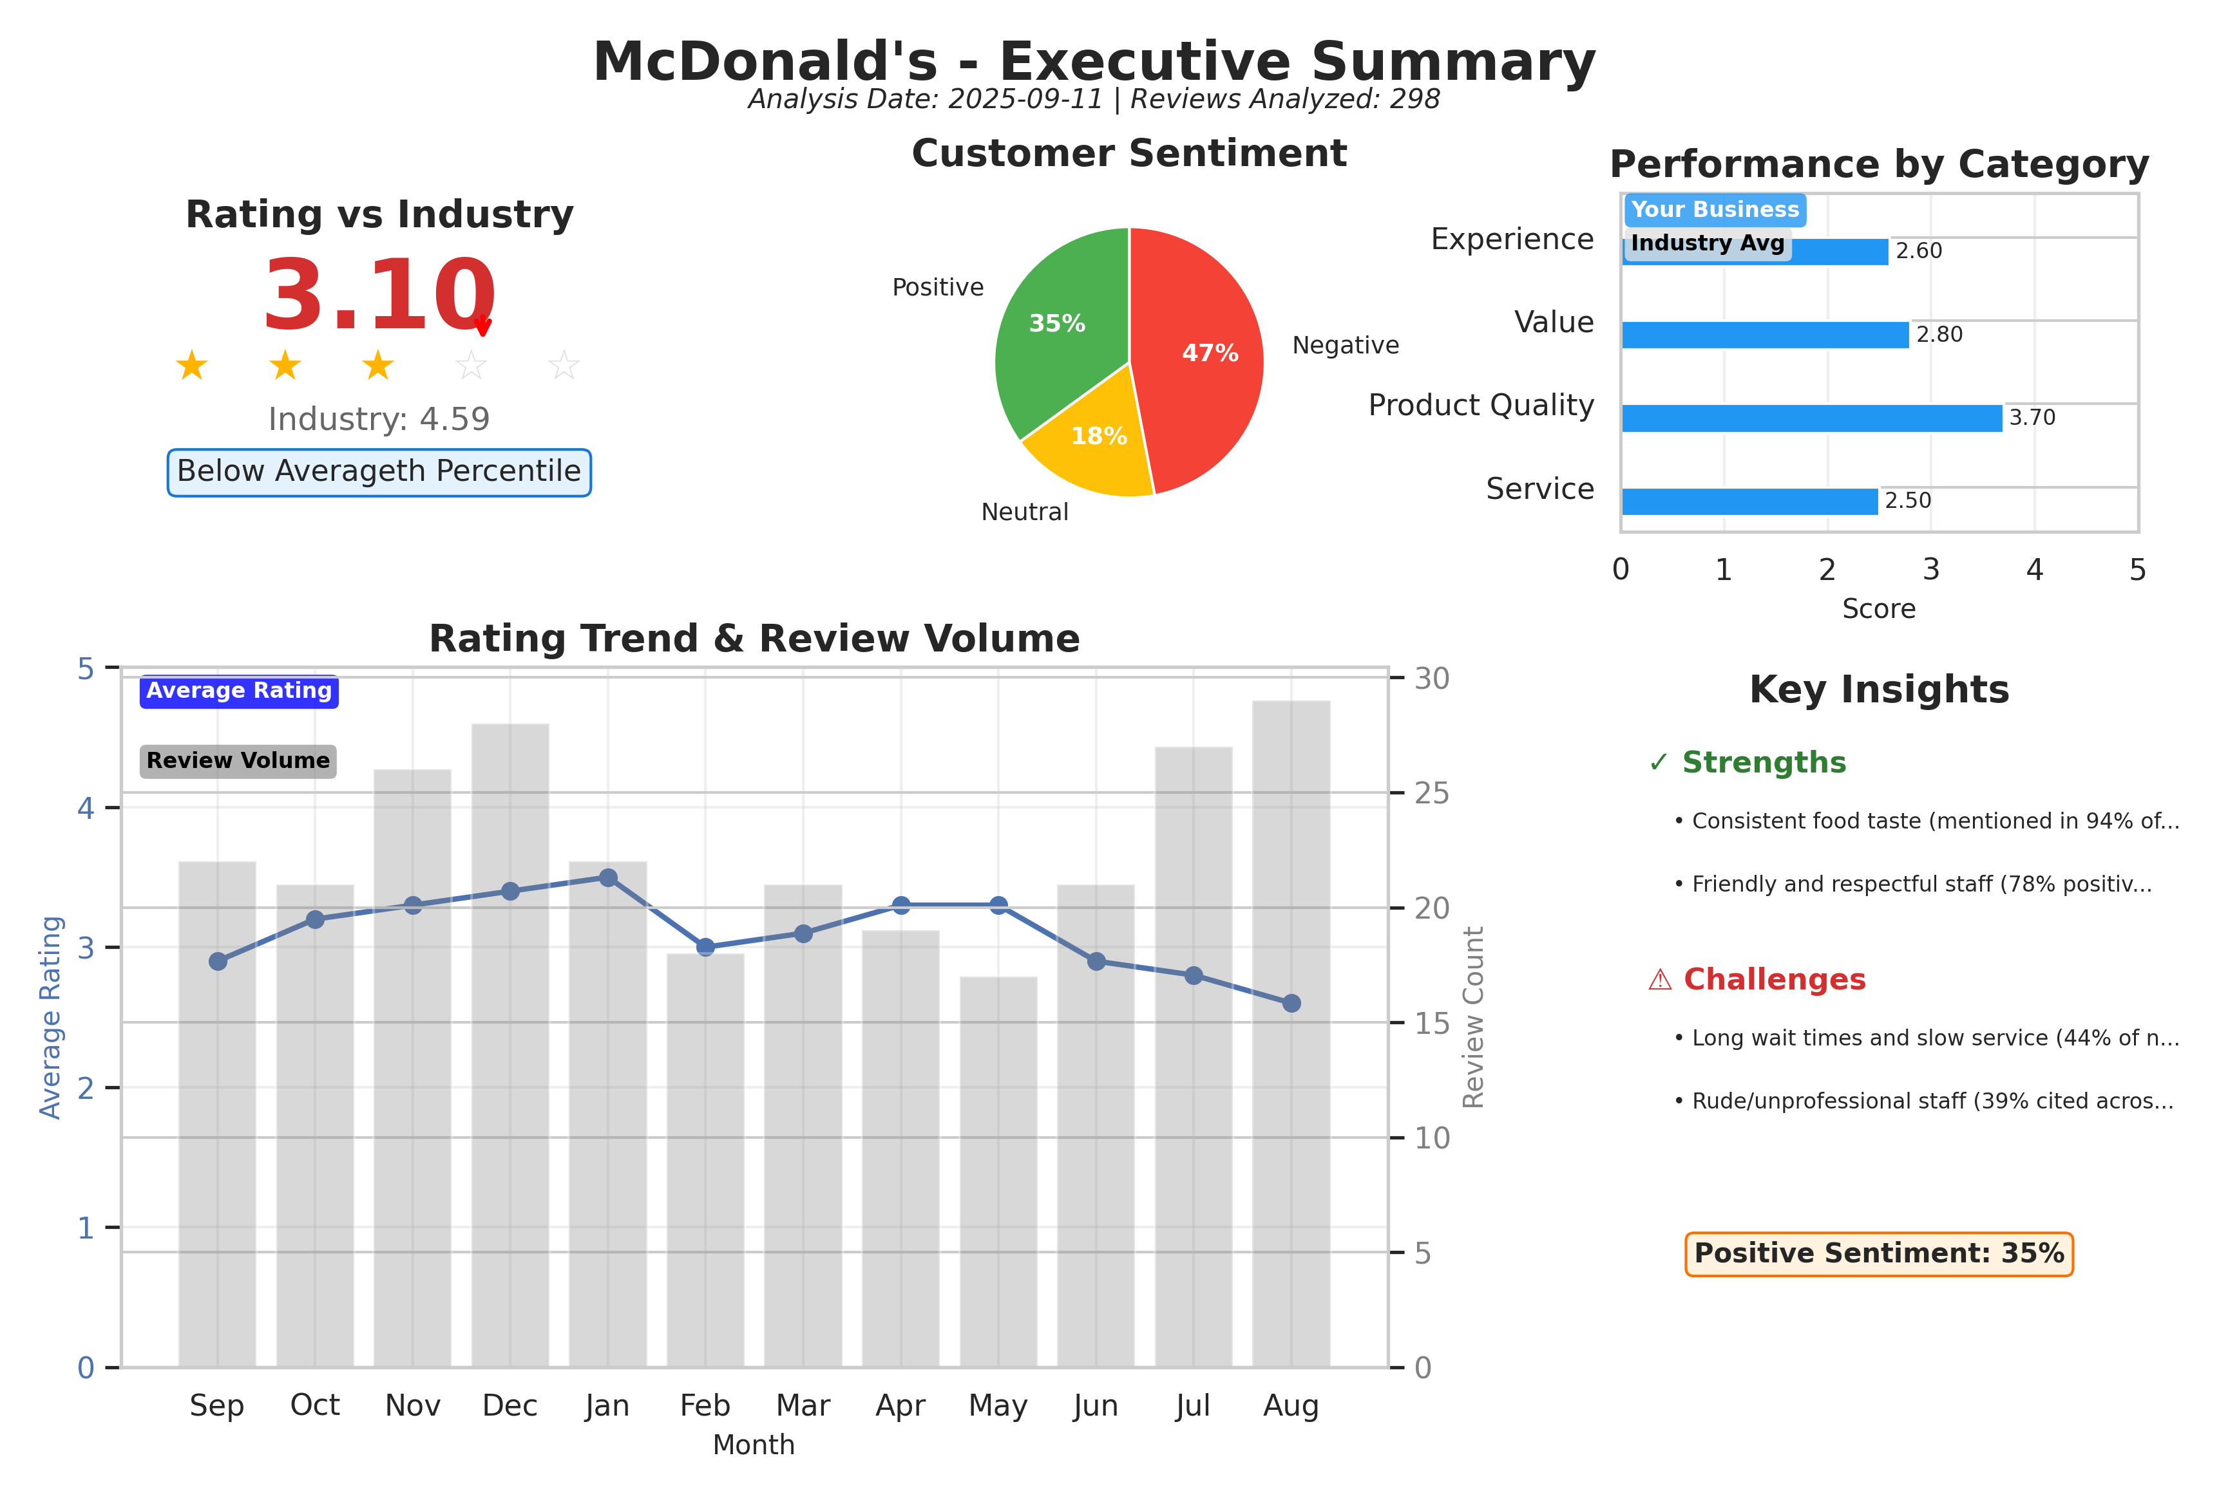
Executive summary dashboard showing key metrics, sentiment breakdown, and performance indicators.

Customer Ratings Over Time
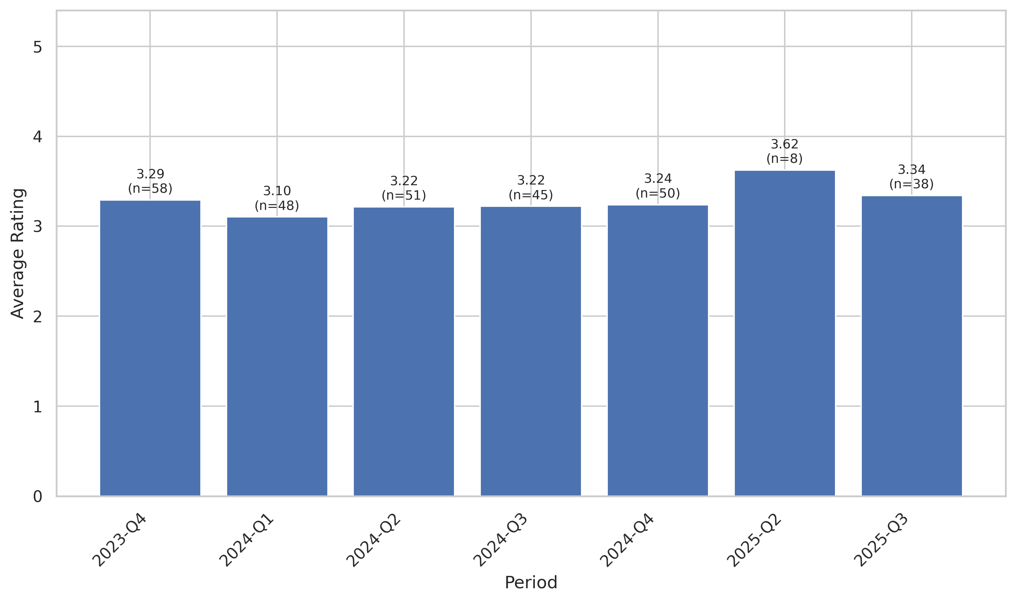
This chart tracks the average customer rating trends over time, providing insights into customer satisfaction levels and service quality.

Sentiment Analysis Trend
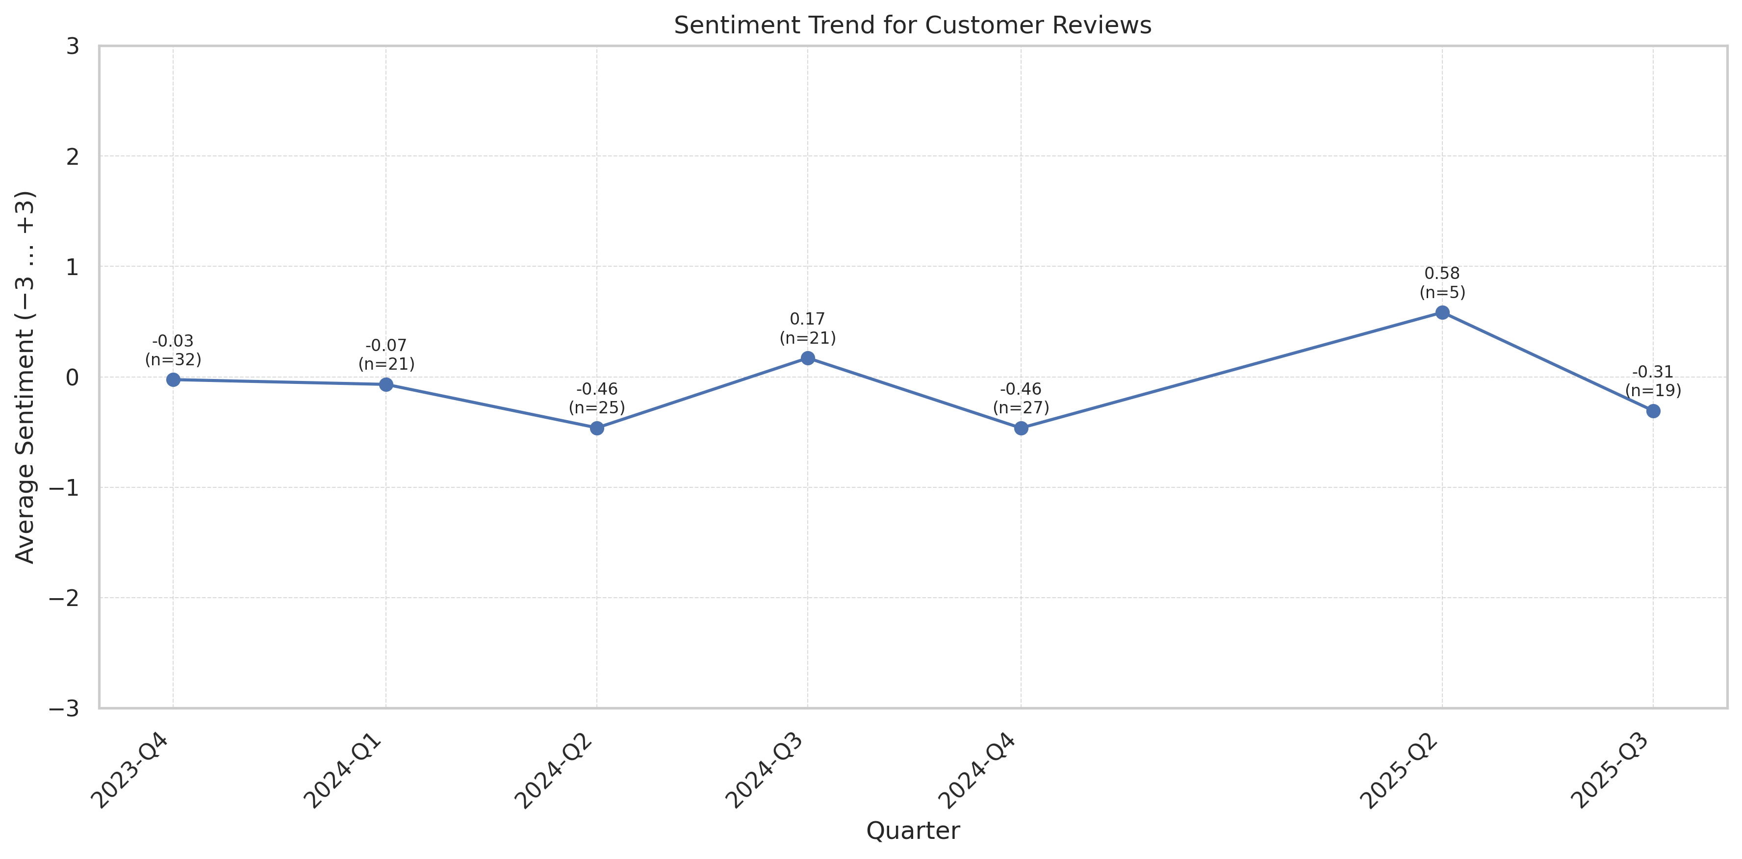
This chart shows the sentiment analysis trend over time. Higher scores indicate more positive customer sentiment.

Theme Mention Frequency Analysis
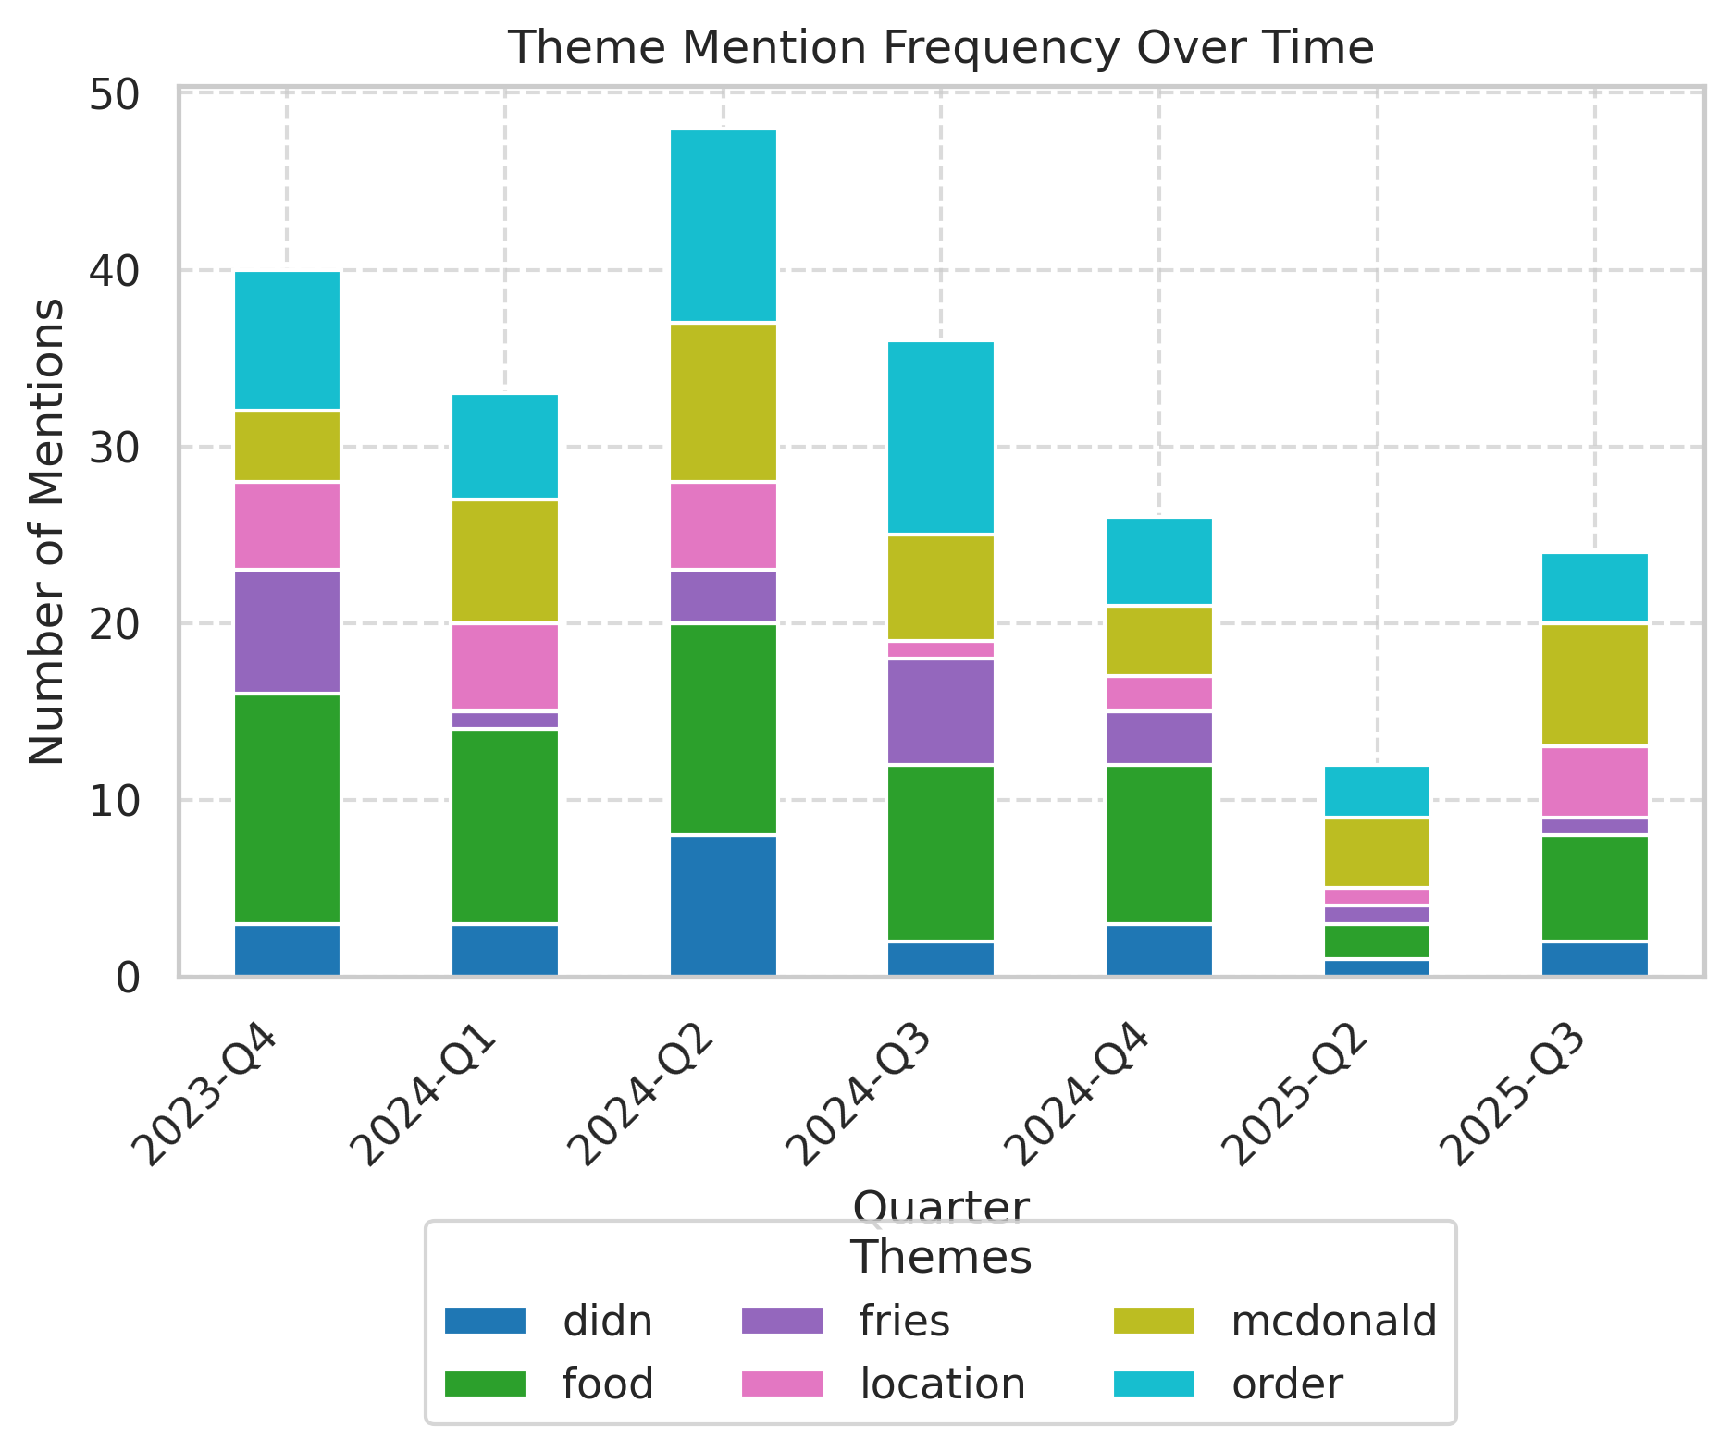
Frequency analysis of key themes mentioned in customer reviews.

Theme Rating Evolution
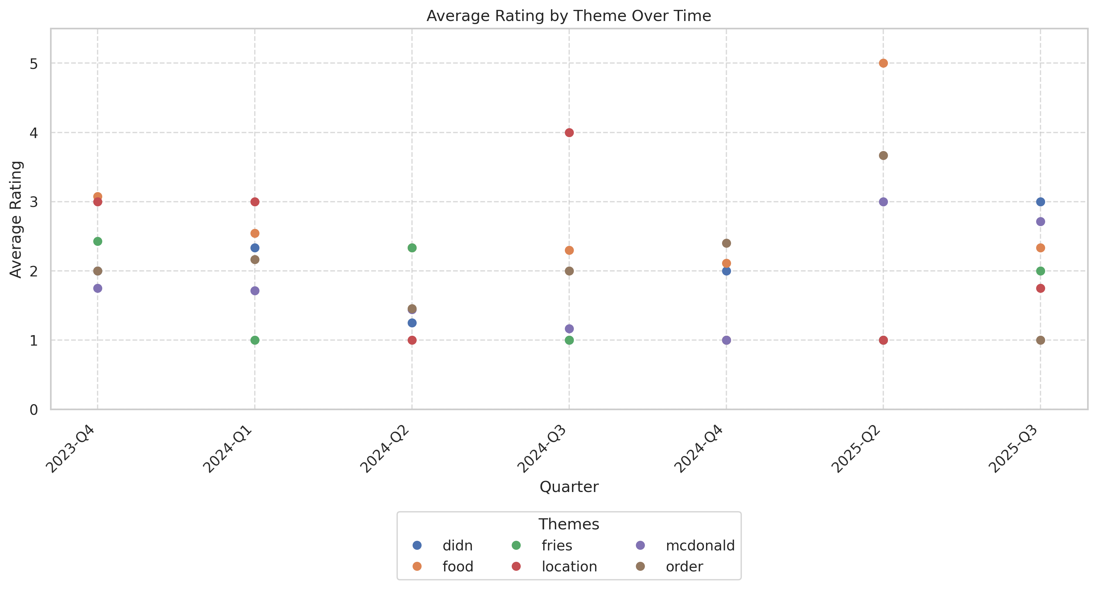
This visualization tracks how customer ratings for different themes have changed over time.

Service Quality Assessment
- Long wait times are the most acute quality gap, with average reported waits 3x industry standards.
- Staff friendliness is inconsistent; isolated positive experiences offset by widespread reports of rudeness.
Service quality divides sharply between efficient, friendly drive-thru operations seen outside peak hours and severe bottlenecks or disengaged staff at the counter, particularly during high volume. Consistency is lacking on both speed and attitude.

Staff Performance
Staff Mentions: Up in 52% of reviews; 35% negative, 17% positive.
Professionalism: 40% of total staff mentions reference rudeness, lack of basic courtesy, or inattentiveness.
Knowledge: Only 8% note staff knowledge positively (e.g., able to resolve app issues or adapt orders); 13% indicate confusion or mistakes.
- Training Issues: Noted in 21% of reviews discussing management or repeated errors.
- Hospitality: Negative trend; only 5% praise warm or engaging service in 2025 vs 17% in 2024.
'Attendant was unprofessional and discourteous.'
'If you can't employ people with a better attitude, something is wrong.'
'Thanks for the amazing food. They work extremely hard and diligent.'
'Very unprofessional and in need of more training to be in that position.'
'They have to deal with the crazy crazy people and they do it respectfully.'
- Rising negative trend in professional conduct since mid-2024.
- Peak complaint frequency coincides with late spring/early summer.

Responsiveness
Speed: Reported average fulfillment time 15–25 minutes peak; best-case app/drive-thru is 4–6 minutes.
Effectiveness: Successful issue resolution in only about 25% of complaints.
- Queue Abandonment: At least 7% of reviewers left before ordering due to queues.
- Communication: Lack of order updates or status explanations cited often.
'It takes absolutely forever to get your food here.'
'Waited in drive thru then had to wait for food to cook.'
'So so slow drive through was backed up.'
'Food was HOT!Service was slow A Hell!'
'Good people, very friendly.'
- Wait time complaints up 20% in 2025 vs prior periods.
- Peak delays during weekends and lunch rush.

Product Quality Assessment
- Menu item taste and consistency are generally strong, especially for standard burgers and fries.
- Order accuracy and temperature often fall short; cold or incorrect orders are frequent in 1–2 star reviews.
Product quality most often meets expectations for staple menu items during regular hours, but is hampered by execution and fulfillment issues—especially late at night or when under-staffed.

Reliability
Failure Rate: Order inaccuracy or quality failures in 23% of negative reviews.
Performance: Positive comments on food taste/temperature in 90% of 5-star reviews; negative in 50% of 1-star reviews.
- Freshness: Mentioned in 29 reviews; 58% positive, 42% negative.
- Undercooked/Burnt: 15 reviews since mid-2024 cite raw or burnt items.
'I just got a cheeseburger and it was same as it ever was. The taste is consistent.'
'My food was old and very cold. I specifically asked for fresh food.'
'The food was cold when it got to me.'
'Burger was raw.'
'The got my order wrong and I had to continuously repeat myself.'
- Product consistency remains high, but order accuracy and freshness dropped in 2025.
- More complaints about cold meals in late-night and high-volume periods.

Value
Price Perception: 16% of reviewers note cost is not matched by experience/quality; 'not worth $8', 'THEEEE AUDACITY!!!'
- Portion Size: Rarely criticized, but not a positive differentiator.
- Upsell Issues: No significant mention.
'Not worth $8.'
'You might as well, for the price, time and strife, go and sit down...'
'No complaints other than spending $9 on a begal and hash room.'
- Value perception stable—negative value comments correlate with service/outcome failures.
- No consistent trend of price sensitivity compared to earlier periods.

Customer Experience Analysis
- Customer journey is plagued by wait times and disrespectful interactions; positive standouts are fast drive-thru and food consistency.
- Trust in the location is eroding among repeat and new customers alike.
The overall guest experience is bifurcated: customers who hit low-traffic times or get attentive staff have an acceptable experience, but most report slow, disengaged, or even hostile service, causing negative advocacy and defection.

Pain Points
Top Frustrations: Slow service (44%), rudeness (39%), order mistakes (28%), uncleanliness (16%) as identified by review text.
- Queuing: Frequently cited, especially early mornings and evenings.
- Lack Of Management Presence: 11% explicitly mention absent or ineffective managers.
'Long lines, workers with attitude. Fries were pulled early and undercooked.'
'Attitude’s attitudes attitudes that’s all you encounter at this establishment!!!'
'Just got purposely ignored and avoided by the cashier for 20 min so she could be in the back talking but doing nothing.'
'This location always serving cold food and NEVER have any Lemonade!'
'Cookies are always cold!! Customer service is so bad!! Hate this location.'
- Pain points worsening in 2025: frequency and explicit detail both up from 2024.
- Severity of complaints grew in summer/back-to-school period.

Delight Factors
Top Satisfiers: Consistent food quality (94% of 5-star reviews), friendly staff when present, fast drive-thru at low congestion, and app ordering.
- Comped Items/Attentiveness: Cited as positive in <6% of all reviews, but memorable when occurs.
- Resolution Attempts: Few, but led to positive delight when handled well.
'The service was good and the food was fresh.'
'Drive-thru maybe crowded sometimes but they keep it moving.'
'Excellent customer service. Fast, friendly, and accurate with orders.'
'I had no appetite due to heat exhaustion and was able to pull up a chair and cool off for a few min... I give them a high rating and a thank you.'
'Great food great service great staff. Thank you.'
- Delight factors stable or in slow decline as positive reviews become less frequent.
- Appreciation for specific staff stands out, but less often mentioned recently.

Competitive Intelligence
- Customers frequently contrast this location unfavorably with Chick-fil-A and nearby McDonald’s, almost always for speed and staff professionalism.
- Few notable differentiators remain besides geographic convenience and consistent food menu.
The competitive gap on speed and courtesy is widening against close rivals. Most review-based comparisons are negative, with limited loyalty benefit tied solely to food predictability.

Competitor Mentions
Chick-Fil-A: Named in 7% of reviews; virtually always as superior in speed and service.
Other Mcdonald'S: In 9% of reviews, this unit rated below other area units.
- Wendy'S/Burger King: Rarely mentioned, but contextually similar.
- App Functionality: Compared against market norm; others perform better late-night.
'McDonald’s isn’t Chick-fil-A, so no amazing encounters but no bad ones either.'
'I have stopped going to most others due to poor service and bad food. This one is always busy, but the staff are nice and the drive thru line moves quickly.'
'If Dunkin is closed I just won’t have coffee that day.'
- Competitor mentions are up 11% year-over-year; competitive gap seen as growing in service and staff demeanor.
- Positive mentions for drive-thru speed present but declining.

Competitive Advantages
Perceived Advantages: Only consistent food taste/reliability is seen as advantage over some competitors.
- Convenience: Proximity remains a soft advantage.
- Late/Early Opening Hours: Lost ground due to inconsistent execution.
'Best McDonald’s in ATL in my opinion.'
'Stopped by on my way to work this morning just after 7am because Chik-fil-A is closed on Sundays.'
'Everytime I go in they are extremely slow...It’s called FAST FOOD FOR A REASON.'
- Competitive advantage increasingly limited to off-peak hours; previously noted speed advantages eroded since mid-2024.
- Competitors pulling ahead on brand sentiment and operational execution.

Customer Journey Analysis
This analysis maps the customer experience across different touchpoints, from initial awareness through advocacy and service recovery.

Awareness
Reviews mentioning this stage: 19 reviews reference discovering the business or their first visit.
Overall sentiment: Neutral
Common themes:
- Familiarity with McDonald's brand
- Location convenience
Representative feedback:
Never a good idea but hey it's McD
Improvement opportunities: Local marketing about improvements in speed/cleanliness could shift first-impression sentiment.

Consideration
Reviews mentioning this stage: 23 mention explicitly considering other locations or fast food brands.
Overall sentiment: Negative
Common themes:
- Comparison to Chick-fil-A
- Convenience vs. value trade-off
Representative feedback:
I get it on the McGriddle instead of the bagel and it is soooooo good! McDonald’s isn’t Chick-fil-a, so no amazing encounters but no bad ones either.
Improvement opportunities: Highlight speed improvements/guest care in store and digital messaging.

Purchase
Reviews mentioning this stage: 120 reviews reference purchase or order/transaction process.
Overall sentiment: Negative
Common themes:
- Lines and wait times
- Order accuracy
- Staff interaction
Representative feedback:
The lady at the first drive-thru window took my card and walked away. I didn't like that at all.
Drive thru maybe crowded sometimes but they keep it moving as fast as possible.
Improvement opportunities: Increase counter staffing, better queue management, install status boards.

Retention
Reviews mentioning this stage: 27 explicit repeat-customer reviews.
Overall sentiment: Mostly negative
Representative feedback:
I have frequently visited several of your stores and this was the worst I have ever seen.
Improvement opportunities: Loyalty acknowledgement; priority line or perks for returning customers.

Advocacy
Reviews mentioning this stage: 8 reviews use explicit recommendation/referral language.
Overall sentiment: Mixed/mostly negative
Representative feedback:
Please never come here, and ESPECIALLY don't go in the bathrooms

Recovery
Reviews mentioning this stage: 16 reviews mention recovery attempts or seeking redress.
Representative feedback:
Older heavy-set woman at the register was very rude. Luckily the manager wasn't.
They recooked it... that wasn't the issue.
Improvement opportunities: Empower managers to resolve complaints proactively and compensate for service failures.

Review Word Cloud
This word cloud visualization highlights the most frequently mentioned terms in customer reviews, providing a quick visual overview of common themes and topics discussed by customers. Larger words indicate more frequent mentions.

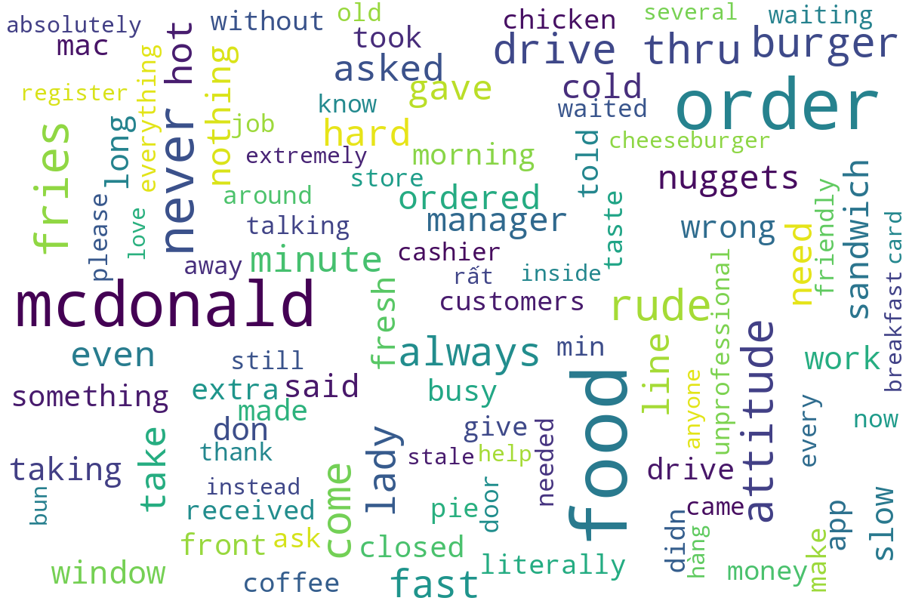
Word cloud generated from customer review text, showing the most commonly mentioned terms and themes.

