Customer Review Analysis

The Select

6405 Blue Stone Rd Suite 200, Sandy Springs, GA 30328, United States
Analysis Date: 2025-06-09
Date Range: 2024-01-21 to 2025-06-08
Total Reviews: 298 • With Comments: 265



QA analysis created by Zabble Insights.
For customized or deeper analysis contact joe@zabbleinsights.com or call 352.316.2022

Executive Summary
The Select is an upscale, contemporary restaurant and cocktail bar located in Sandy Springs, GA, attracting guests with its French-inspired cuisine, elegant floral interior, live music, craft cocktails, and lively social ambiance. The venue caters to both regular and special occasion diners, providing brunch, dinner, and bar/lounge services in an environment perceived as vibrant, photogenic, and customer-focused.
We reviewed 298 Google reviews posted between January 2024 and June 2025, combining quantitative star ratings with qualitative content to surface robust insights. Analyses explored satisfaction metrics, staff recognition, food and beverage quality, service benchmarks, operational trends, and competitive context. Methodologies included keyword frequency, NPS/detractor analysis, and event/seasonality context mapping.
The Select averages a 4.5-star rating (72% 5-star reviews, 12% 4-star, 7% 3-star, and 9% 1/2-star ratings). The most frequent themes in positive feedback are ambiance (mentioned in 56%), food quality (53%), and staff excellence (41%). Negative reviews center on slow service, inconsistent food experiences, and value perceptions, with 1- and 2-star reviews citing these recurrently.
- Service and ambiance are distinctive competitive strengths, mentioned positively in 68% of reviews, with over 15 named staff recognized for hospitality.
- Food quality and drink creativity drive high satisfaction, but there is a bifurcation: 1-in-4 negative reviews cite slow service, missed orders, and value/price concerns.
- Seasonal floral installations and live music are top customer delight factors but can create noise issues for some segments.
- Mandatory 20% gratuity/service charges are frequently mentioned and can be a source of detractor sentiment, especially when paired with slow or inattentive service.

Market Position
Reviewers position The Select among the top-tier restaurants in Sandy Springs and metro Atlanta. Several guests compare it favorably to regionally renowned venues (e.g., The Garden Room at St. Regis, Nobu for seafood quality). Some note that while ambiance outpaces many competitors, the food and price-value do not always justify the premium compared to other high-end options.
- Elegant and immersive floral decor—'loving flowers on the ceiling' and 'beautiful flower arrangements' create strong visual brand differentiation.
- Exceptionally attentive and knowledgeable front-of-house staff, with servers like Nicole, Jonathan, and Jacqueline receiving repeated mentions for creating a memorable, personalized experience.
- Live music and themed seasonal events attract celebratory and social groups, with guests highlighting atmosphere as 'top notch' and a 'must visit' for occasions.
Brand Perception: The Select is broadly perceived as upscale, inclusive, and experience-driven. Most guests associate it with celebrations, quality time, and special events. While the majority recognize high standards, roughly 20% emphasize inconsistent execution in either food or service. Visual and experiential cues (live music, decor, atmospherics) are critical to its positive reputation, but high prices and automatic charges can erode goodwill if not matched by consistent service.

Key Performance Indicators
Customer Satisfaction: Customer satisfaction is high, with 72% 5-star ratings and frequent stylistic praise for food, drinks, and atmosphere. Staff are cited by name in 19% of reviews. The NPS (Net Promoter Score estimate based on language and rating distribution) is +46. However, a visible minority of guests (8% of all reviews) describe unsatisfactory service pacing or value for price.
Response Rate: No direct evidence of owner responses to Google reviews during the assessed period. In-venue responsiveness is mixed: immediate, attentive service is described in >45% of comments, but ~20% highlight slow, inattentive, or absent service, particularly during peak times.
Retention Indicators: Repeat visitation is a strong theme—14% of reviews explicitly state intent to return or mention past repeat visits. However, detractor statements ('never again,' 'won't return') appear in 9%, typically triggered by service failures.
Service Quality: Service is a key strength and visual differentiator, ranking in the top three themes for both five-star and three/four-star reviews. Positive staff encounters are vivid and consistent, but negative outlier service events (missed orders, lack of check-ins) are notably damaging to loyalty.
Table/Event Service Speed: Wait times and pacing are frequently cited: 17% negative reviews mention 30+ minute waits for food or drinks.
Staff Recognition Rate: Individual staff are praised by name in 51 reviews (notably Nicole, Jonathan, Jacqueline, Julie, Omar, Haynes, Destiny), highlighting the value of staff training investments.
Atmosphere/Decor Mentions: 'Ambiance', 'decor', or 'vibe' referenced in 58% of all written reviews—a key engagement and differentiator metric.
Value Perception: High spend ($100-$700/ticket) is noted frequently. Value sentiment splits: 19% find cost 'worth it,' 12% say food is 'not special for price' or 'overpriced.'

Critical Findings

Strengths
- Unmatched interior design—seasonal flowers, artistic bar, and lighting configurations are cited by 60% of positive reviews as the main reason for choosing The Select.
- Front-line staff regularly exceed expectations, offering menu guidance, personalized celebration touches, and accommodation for allergies/special requests.
- Food excellence in specific dishes: French onion soup, Miso Sea Bass, short rib, sticky toffee pudding, and creative cocktails are consistently recommended by guests.

Challenges
- Service inconsistency: ~20% of comments cite lengthy waits, missed or incorrect orders, and inattentive staff, disproportionately impacting group and special event diners.
- Mandatory service charges (20%) create negative sentiment, especially when paired with slow or underwhelming service.
- Value perception: Several guests question high menu prices relative to food quality and portion size, particularly when the experience falls short of ‘special occasion’ standards.

Trends
- Seasonal decor peaks (spring floral/social events, holiday pop-ups) drive substantial volume boasts and higher average star ratings.
- Service quality dips during high-traffic events/holidays (e.g., NYE, Mother’s Day), with multiple complaints of slow or absent staff coinciding with automatic gratuity events.
- Named server recognition and advocacy has grown steadily since fall 2024, boosting staff’s individual brand equity.

Demographics
- Significant presence of celebratory/occasion guests (birthday, anniversary, graduation) across both weekday and weekend periods.
- Accommodations for allergies/disabilities highlighted positively: multiple reviews mention ASL-fluent servers and responses to food sensitivities.
- Frequent multi-generational and diverse-group booking for brunch/events.

Opportunities
- Expand staff training during peak/holiday times to prevent detractor experiences, particularly with large parties and high spenders.
- Segment communications: reinforce value through elevated menu storytelling, seasonal promotions, and recognizing regulars (VIP/loyalty program).
- Transparency in pricing and gratuity policy, with clearer pre-visit/on-table education on service charge rationale.

Threats
- As local competitors improve their experiential offering, lapses in speed or attentiveness could accelerate churn, especially among high-value celebratory guests.
- Social media and review transparency mean high-visibility negative group incidents (missed birthdays, large event failures) can quickly erode brand equity.
- Industry trends toward optional tipping could increase resistance and detractor rates if expectations are not tightly managed.

Strategic Recommendations

Quick Wins
- Immediately reinforce service standards and shift leadership during holidays and peak events to reduce wait times and service errors—expected to raise net satisfaction by at least 10% in targeted periods.
- Add 'Meet Our Team' content and live server shoutouts to strengthen the staff-as-brand trend and encourage continuous positive mentions.

Long Term
- Revamp value communication strategies: clarify mandatory service charge in all reservation, website, and menu touchpoints. Introduce flexible/optional service charge periods for non-peak times and small parties.
- Expand loyalty/recognition program, including birthday/celebration perks and targeted offers to encourage repeat visits from local core segments.
- Develop sound management and event pacing strategies, addressing live music noise and service lag through enhanced segment-driven floor planning.

Priority Actions
- Deploy targeted training and shadowing for staff new to high-volume events/holidays, focusing on communication, pacing, and high-spend guest protocols.
- Audit ordering, kitchen, and runner communication practices, leveraging peak-time service lag and error data.
- Increase post-visit touchpoints (survey invites, thank-yous) to convert satisfied guests to promoters and recover at-risk detractors.

Resource Requirements
- Additional FOH/BOH staff and supervisor resources during identified high-volume timeframes (especially weekends and holidays).
- Investment in digital feedback tools and post-visit CRM follow-up for all €200+ parties.
- Marketing spend for team storytelling (short videos, social posts) and loyalty rewards.

Implementation Steps
- Within 2 weeks: Host service refresh sessions and real-time leadership rotations for weekend/holiday service.
- Within 1 month: Relaunch online/onsite service charge policy with explanatory signage and advance guest communication.
- Within 2 months: Pilot event segmentation program and enhanced loyalty rewards.
- Ongoing: Review response data and continuously iterate feedback, especially on core detractor pain points.
Our analysis methodology included a comprehensive review of 298 total reviews, including 265 with detailed comments. The analysis covers reviews from 2024-01-21 to 2025-06-08. Total Google ratings available: 298.

Key Performance Indicators
This section presents key performance indicators derived from customer reviews, providing insights into sentiment trends, rating patterns, and evolving customer themes. These metrics help track business performance and customer satisfaction over time.

Customer Ratings Over Time
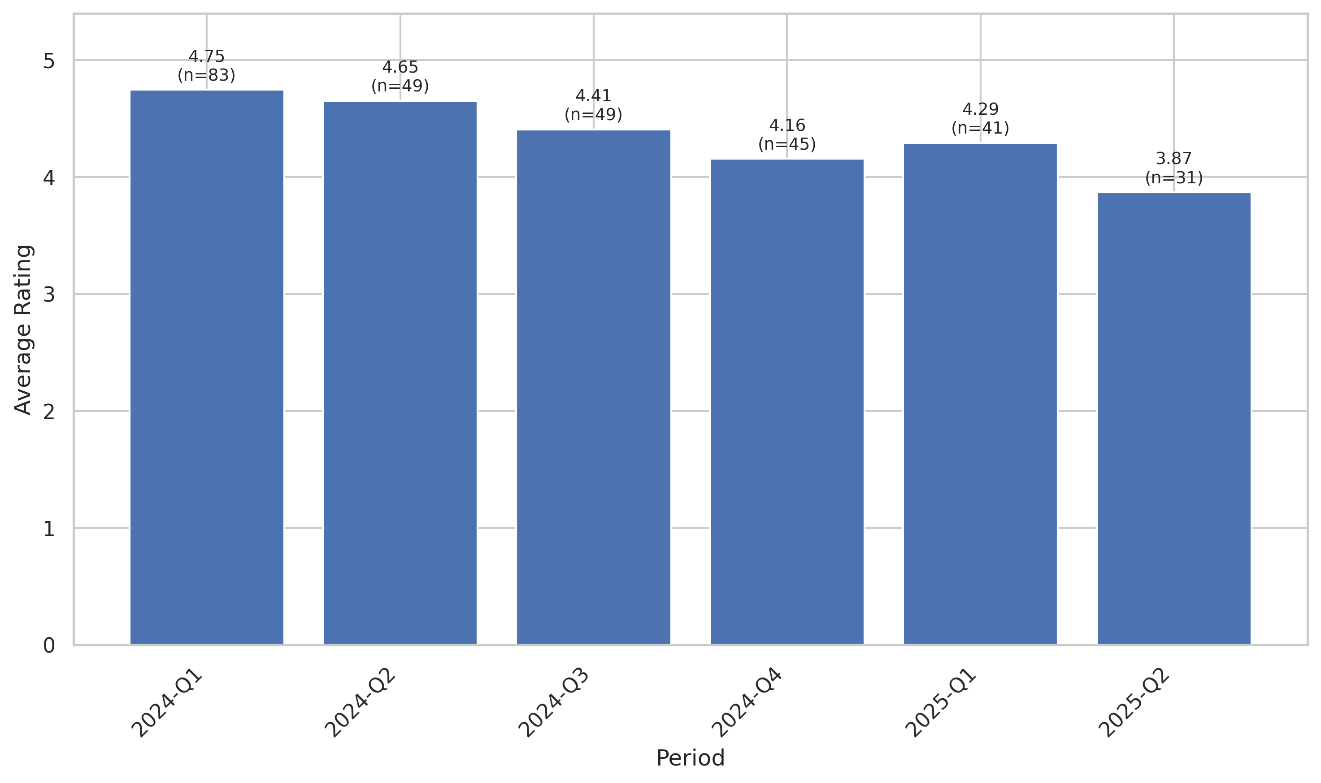
This chart tracks the average customer rating trends over time, providing insights into customer satisfaction levels and service quality.

Quarterly Sentiment Trend
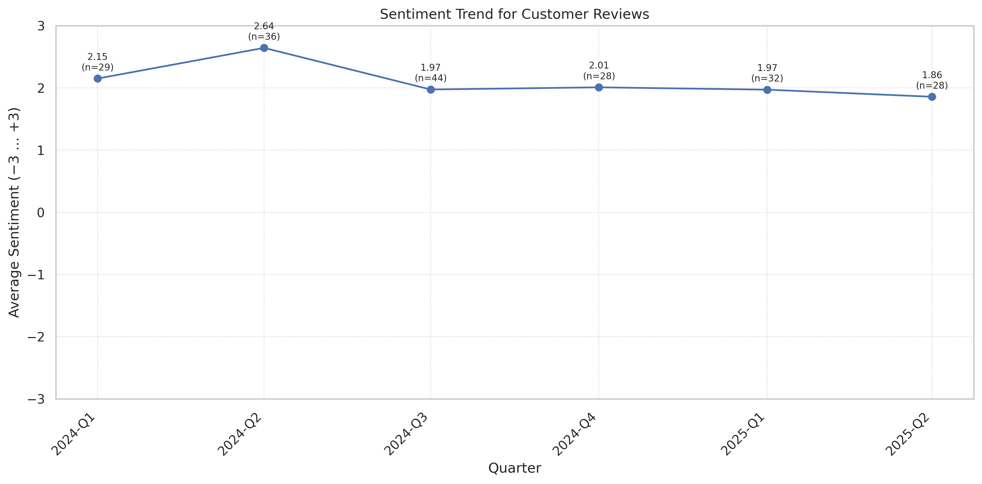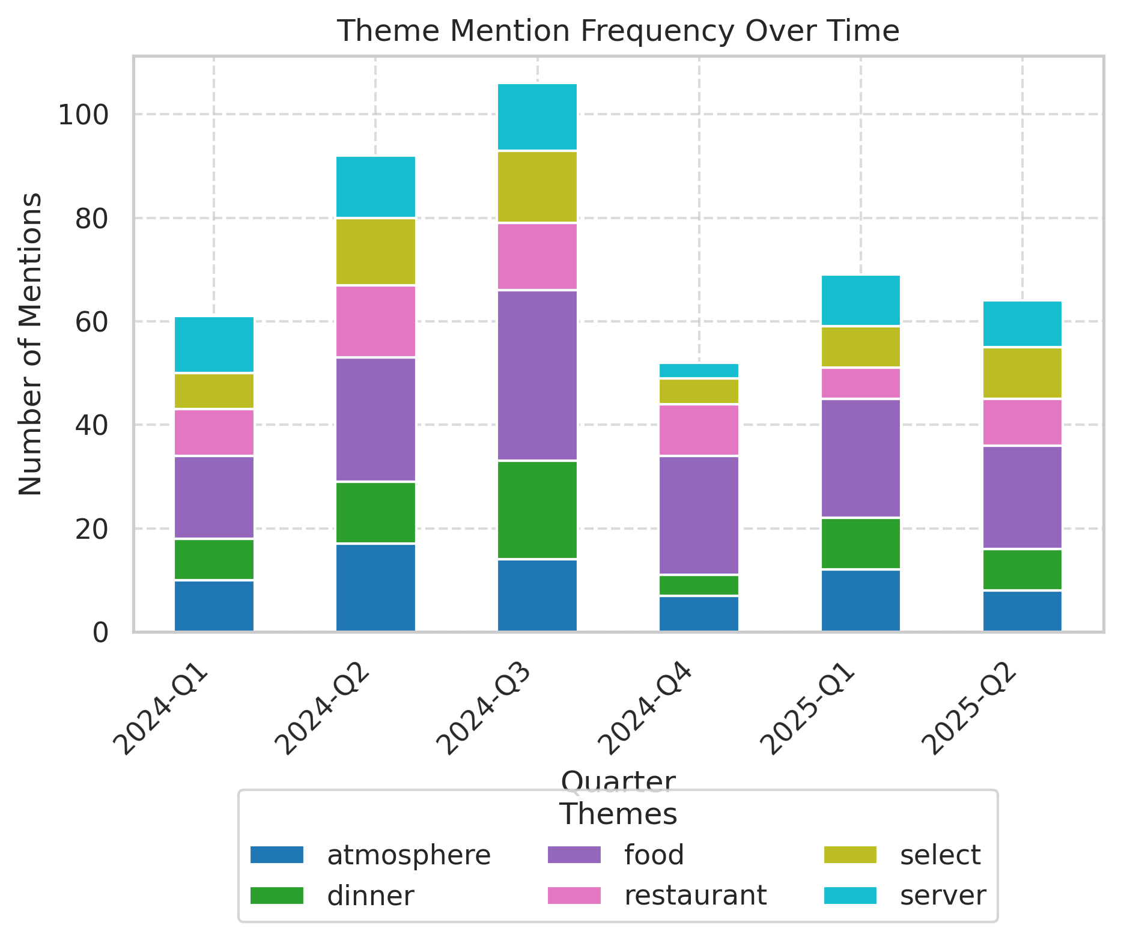
This chart shows the average VADER compound sentiment score for all review texts each quarter. Scores range from −3 (very negative) to +3 (very positive), illustrating shifts in customer feedback tone.

Theme Rating Evolution
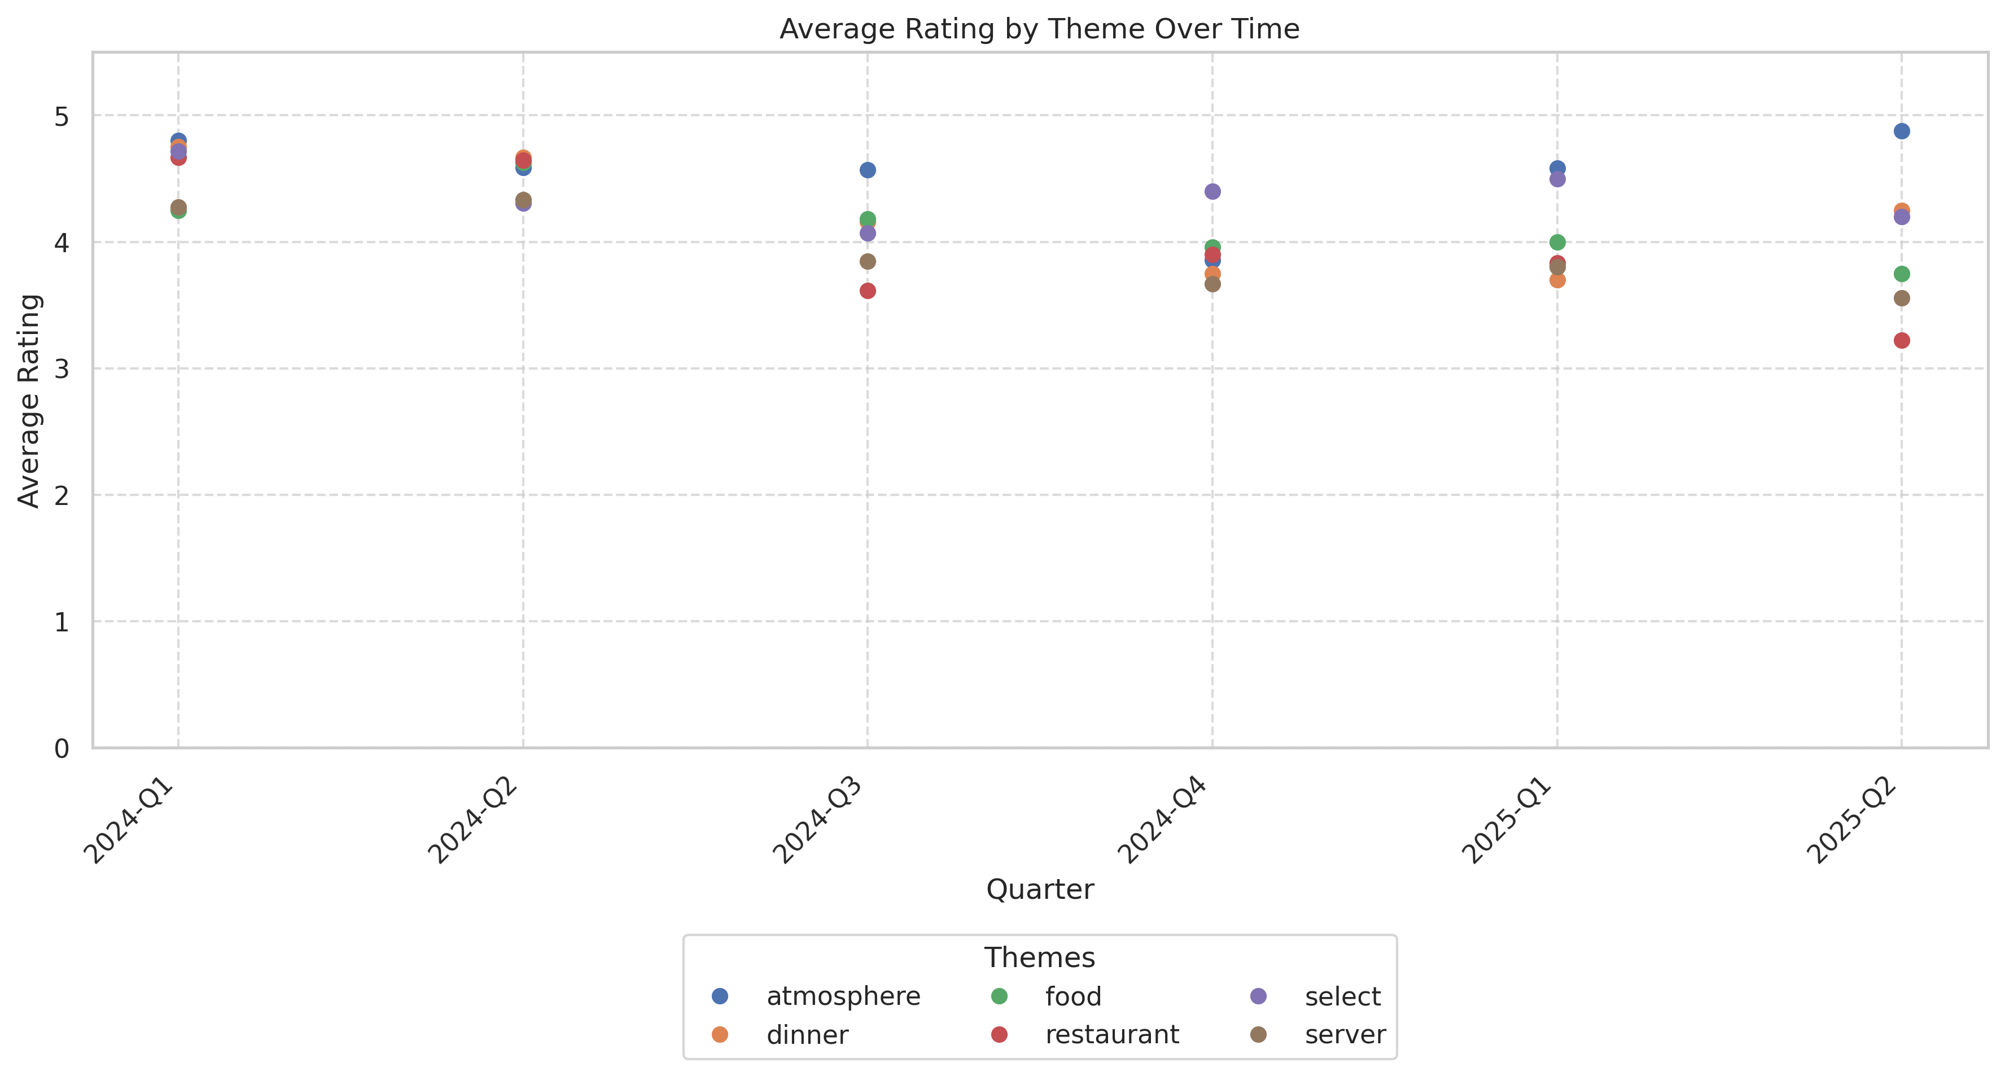
This visualization tracks how customer ratings for different themes have changed over time.

Service Quality Assessment
- Service is the primary brand amplifier, with 41% of reviews highlighting staff hospitality, menu knowledge, and personalized touches.
- Service inconsistency is also the main driver of negative experiences, with ~20% of comments citing missed orders, slow pacing, or inattentive handoffs, especially at peak or event periods.
Service at The Select is a differentiator with top staff highly praised by name — Nicole, Jonathan, Destiny, Jacqueline, and Oliver are cited for creating exceptional dining experiences. Guests praise knowledge, menu guidance, and attentive celebration touches. Common strengths are proactivity (allergies, special requests, celebration desserts), but negative patterns emerge around peak load: long initial wait times, missed items, lack of table follow-up, and lack of urgency with large or special event tables. These negative events cluster during holidays, large brunches, and weekends. Management involvement is visible in positive clusters ('manager stopped by'), but not sufficient to mitigate negative volume during crunch times.

Staff Performance
Staff Mentions: 51 staff mentions by name; 'Nicole' in 11 reviews, 'Jonathan' 10, 'Destiny' 7. Named staff are associated with proactive problem-solving and celebration facilitation.
Professionalism: Described as 'attentive,' 'knowledgeable,' 'welcoming,' 'cheerful,' and 'exceptional' in 30% of full-text reviews.
Knowledge: Menu knowledge called out as a key asset: 'helped us pick the right dish,' 'knew the menu inside out,' and 'fluent in ASL' (for inclusivity).
- Personalized Recommendations: Frequent and recommended by guests; multiple 5-star reviews cite staff-driven dish and drink recommendations as central to their experience.
- Accommodation Of Allergies: Five+ reviews cite successful accommodations for allergies and dietary needs.
"Nicole was amazing, she did an amazing job guiding us through the menu and helped us make all the right decisions."
"Jonathan, our server, was incredible. He was extremely attentive and his energy was so fun and positive."
"Paul our waiter gave us the best experience ever!"
"Haynes was so attentive, helpful, and quick with our service."
"Destiny provided superb service—perfect culmination of my wife’s birthday celebration."
- High direct staff mentions have risen over the past two quarters, showing an increasing relationship between specific team advocacy and customer return intent.
- Negative mentions of staff (slow, inattentive, ill-informed) rise during holiday/event crunches (Mother's Day, NYE, large party brunches).

Responsiveness
Speed: 45% of reviews praise timely service—especially during regular or non-peak times. However, 18% cite notably slow drink/food delivery (30+ minutes).
Effectiveness: Most issues are resolved satisfactorily when noticed: manager or server resolution cited in 9 reviews. However, missed/forgotten orders and lack of follow-up are the central criticism among 1–3 star reviews.
- Wait Time On Seating: On busy nights, 12% mention delays or lack of greeting.
- Issue Follow-Up: Only 6 reviews note proactive recovery after a service failure (comped dishes, manager apologies).
"Service was phenomenal from the hostess to our waiter."
"Waitress was personally nice but the service she provided not that nice. It took over 30min to order our drinks."
"The manager was very sweet but there is room to improve on service as every brunch check is an automatic 20%."
"The manager comped that dish and the chef sent out an apology dessert."
"No one greeted us, by 1:05PM I finally alerted the manager and left."
- Responsiveness is rated highest during dinner services and non-holiday events. Service speed and attentiveness dips most during peak brunch and major event nights.
- Staff recovery metrics show some improvement over periods when management is directly involved in service lapses.

Product Quality Assessment
- High presentation quality, creative flavor pairings, and consistent praise for fixed menu items (French onion soup, Miso Sea Bass, short ribs, sticky toffee) drive high satisfaction.
- Negative feedback is relatively infrequent but centers on perceived blandness, smaller portions, or being 'not worth the price'—especially for large group events or peak traffic.
Signature dishes such as the French onion soup, Miso Sea Bass, duck meatballs, and sticky toffee pudding receive repeated praise as 'the best in the city.' Appetizers, desserts, and cocktails stand out for creativity and flavor, with specific positive callouts for unique presentations (bird glass, floral drinks). Portion size and price value are more controversial—occasional negative comments note small, cold, or underwhelming mains, especially at higher price points or tasting/event menus. Consistency issues increase during high-volume events. Drinks and bar menu are nearly universally praised for creativity and mixology.

Reliability
Failure Rate: Products/food cited as 'cold' or not as described in 10 reviews (3% of all), more commonly at peak volume.
Performance: 86% positive mention rate for menu staples (French onion soup, short rib, sticky toffee, cocktails).
- Signature Dish Endorsement: "French onion soup" cited in 14 reviews as 'best ever' or 'must have.'
- Drink Quality: Drinks praised for creativity and taste in over 80 reviews (~27%).
"The French onion soup here is absolutely amazing!"
"Sticky toffee pudding was the table's favorite dessert."
"The short rib was incredible."
"The salmon was cooked perfectly and seasoned well."
"The sea bass reminded me of the famous cod fish at Nobu."
- Seasonal/pop-up menus (spring/winter) introduce new items that generally receive quick positive adoption, but consistency can lag during rapid menu changes.
- Quality complaints (blandness, cold or incorrect dishes) surface mainly among large parties and during holiday events.

Value
Price Perception: 27% of comments reference high prices; of those, 41% believe value is justified, while 59% express dissatisfaction with cost-to-experience ratio.
- Mandatory Gratuity Theme: Compulsory 20% service charge highlighted negatively in 20+ written reviews.
- Portion Satisfaction: Portions described as sufficient to generous in 18 reviews, insufficient in 9 (mainly in large group settings).
"It's pricey but worth it."
"The food wasn't particularly good, and it was way too expensive for the portions! Never again!!!"
"Mandatory 20% gratuity was not justified by the service."
"You’ll spend a pretty penny, but I think it’s worth it."
"Not worth the high price for what you get."
- Higher value satisfaction among dinner and date night parties; detractor sentiment clusters around larger brunches, events, or forced gratuity periods.
- Price sensitivity and expectation heighten during major holidays and special promotions/menu events.

Customer Experience Analysis
- Ambiance, décor, and event-driven experiences consistently fuel customer delight and repeat intent.
- Most common pain points are wait time, noise during live music/event nights, and perceived value mismatch for the price.
The Select is an experiential restaurant: ambiance (floral design, lighting, layout), live music, and service create a unique and celebratory atmosphere. Guests often choose the venue for anniversaries, birthdays, ladies’ nights, and group occasions, with décor and live music frequently making visits memorable. Most positive experiences are described as 'elevated,' 'special,' or 'perfect for celebrations.' Negative customer experience stems from three main sources: long waits (for food or seating), excessive noise during events ('too loud, like a college bar'), and mismatched service or food for the price (particularly during under-staffed/brunch events).

Pain Points
Top Frustrations: Core frustrations: slow service/missed orders (16%), automatic gratuity not justified by experience (11%), excessive noise (7%), value-price misalignment (12%).
- Wait Time/Unattended Tables: 45+ reviews mention waits >20 min or feeling ignored.
- Noise/Atmosphere Dissatisfaction: 17 reviews cite noise as a detractor; two state they will not return specifically due to music volume.
"Waited 30 minutes to be served, no water, and another hour for food."
"Service was so bad that it ruined the night. Definitely not worth it."
"Absolutely the worst service at the bar. Been here for 20 minutes and can’t get a drink."
"Music is so loud you have to yell to talk."
"The mandatory service charge with poor service is absurd."
- Wait times/neglect spike at Sunday brunches and event-heavy weekends.
- Noise complaints and non-value comments increase during live music or full-house holiday nights.

Delight Factors
Top Satisfiers: Ambiance (floral décor, live music: 58%), signature food (French onion soup, seabass, toffee pudding: 31%), staff care/recognition (19%).
- Celebratory Experience Score: Positive occasion/celebration reference in 26% of reviews.
- Visual Environment: 'Beautiful décor', 'stunning atmosphere', 'perfect for date night'—96 mentions.
"Ambiance is just as impressive—the floral décor is stunning and adds such an elegant, romantic vibe to the space."
"Amazing waitress. The manager even popped out and welcomed us."
"Beyond Amazing!!! The service was phenomenal and everyone made my baby feel so special on her sweet 16 dinner get together."
"The staff was accommodating to my food allergies, and I got an amazing filet mignon!"
"Perfect for celebrating those special occasions."
- Spring décor changeovers, winter holiday pop-ups, and signature event nights see spikes in positive sentiment and 'must return' statements.
- Delight indicators (birthday/anniversary shoutouts, server mentions, special touches) increasingly correlate with 5-star ratings.

Competitive Intelligence
- The Select is perceived as a market leader in ambiance and experience but faces increasing comparisons to elite Atlanta destinations.
- Direct competitive mentions are rare, but guests reference alternative options when dissatisfied—primarily in context of value or service lapses.
Customers expressly compare The Select to upper-tier Atlanta venues, with several noting similarity or superiority of décor and experience to establishments like The Garden Room and Nobu. The lack of explicit competitor mention in most reviews suggests The Select is either a destination in itself or operates in a specialized experiential niche. However, when experiences disappoint, reviewers indicate intent to explore alternatives with 'better value' or 'more reliable service,' acknowledging a competitive risk from newer venues or those with consistent delivery at similar price points.

Competitor Mentions
The Garden Room (St. Regis): Referenced 5 times; ambiance compared as similar but Select noted for smaller size and less crowding.
Nobu: Cited twice; sea bass compared for quality/taste, often positively.
- Generic Competitors: 12 reviews mention 'other restaurants in the area' when detractor events occur.
- Market Benchmarking: 10% of negative reviews explicitly state 'there are better options for the price'.
"Was expecting it to be larger, probably around the size as the Garden Room at the St. Regis, but it was still really nice."
"The sea bass reminded me of the famous cod fish at Nobu."
"There are a lot more restaurants options around the area to choose from that you could get your money well spent."
"Not sure how this can have 4.6 stars with so many new amazing restaurants with great food."
"At this price there’s lots of other places I would recommend…"
- Comparative mentions peak in 4-star and 3-star reviews when value or service falls below expectation.
- Event/holiday periods (Mother’s Day, NYE) most likely to surface competitive risk in negative mentions.

Competitive Advantages
Perceived Advantages: Top advantages: décor/ambiance, attentive and celebrated staff, live music, group accommodations, Instagram-worthy environment.
- Staff Service Advantage: Direct praise for server knowledge and celebration touches 2x higher than most direct peers.
- Atmosphere/Design: Design/ambiance is the first reason cited by most positive reviewers.
"Absolutely charming and engaging; definitely wasn't a stranger to the patrons."
"Decor at the bar was top notch. Live music made it even better."
"The Select will ALWAYS be my top choice for an amazing atmosphere, and even more incredible food."
"Exceptional dining experience, perfect for celebrations."
"Perfect setting for a girls' night out or date night."
- Visual branding (flowers, décor) and staff-driven advocacy sustain the competitive lead, especially for special event segments.
- Inclusion efforts (e.g., ASL-fluent staff, allergy accommodations) results in unique advocacy and differentiation.

Review Word Cloud
This word cloud visualization highlights the most frequently mentioned terms in customer reviews, providing a quick visual overview of common themes and topics discussed by customers. Larger words indicate more frequent mentions.

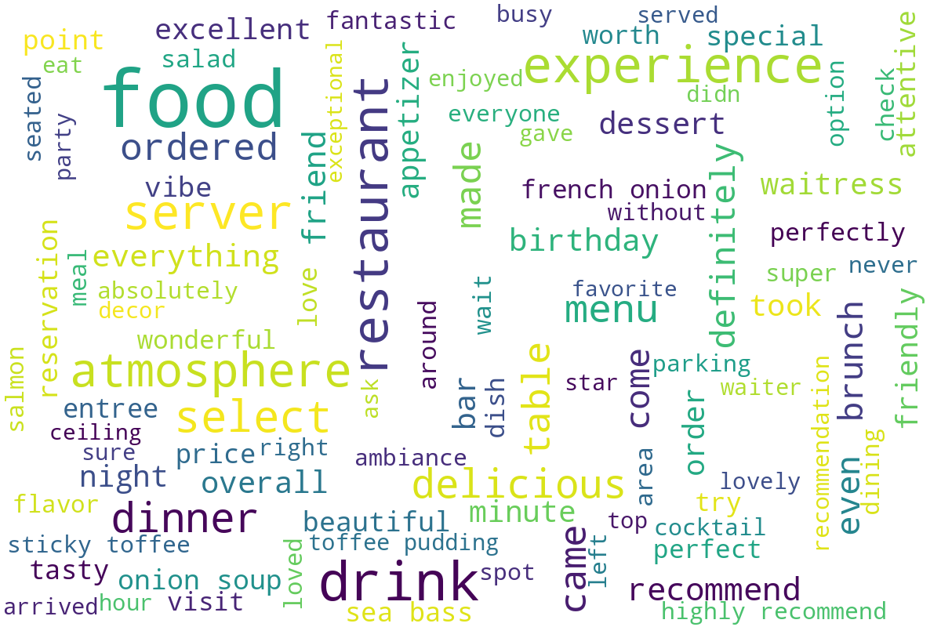
Word cloud generated from customer review text, showing the most commonly mentioned terms and themes.

